004 Daily routines basic
Keys
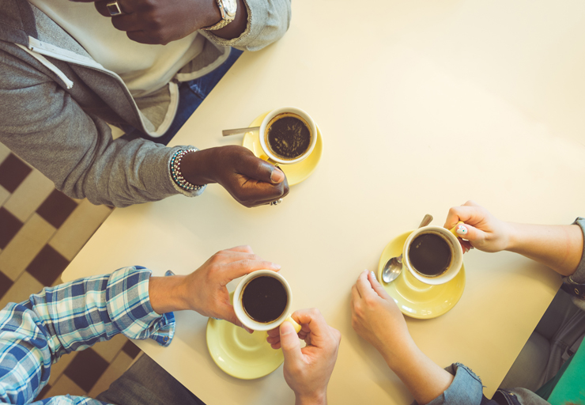
Exercise 1
Match up the sentence with the picture
I usually get up at 7 am.
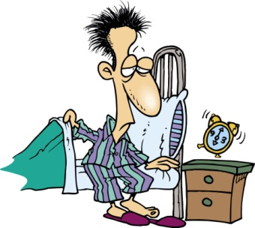

I take a shower.
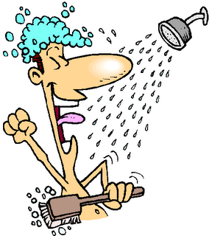

I get dressed.

I have breakfast.
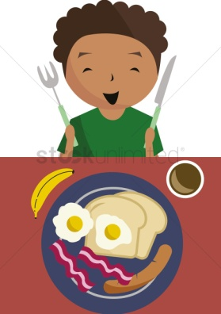

I usually leave home at 8 am.
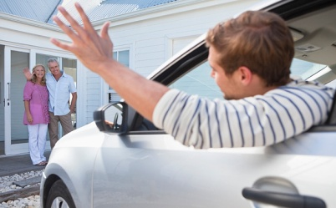

I get to work at 8.30 am.
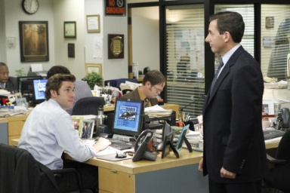

I finish work at 5 pm.

I have dinner at 8.15 pm.

I go to bed at 11.30 pm.

I sleep seven hours a night.
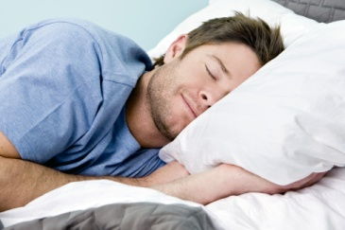

Exercise 2
Choose the right answer
What time do you usually get up in the morning?
Do you get dressed before or after breakfast?
Do you take a shower in the morning?
What time do you leave home in the morning?
Who do you have dinner with?
What time do you normally go to bed?
Exercise 3
Complete the sentences
- Do you want to go shopping?
- Come over to my apartment after work.
- I can’t play tennis this weekend.
- Do you want to go out this Saturday?
- During the week I usually stay in.
- I’m really tired today because I went to bed late last night.
- What are you doing at the weekend?
- I go to the gym twice a week because I like to exercise.
- I often do the shopping very early, at 8 am.
- We often go and see a movie on Sunday.

