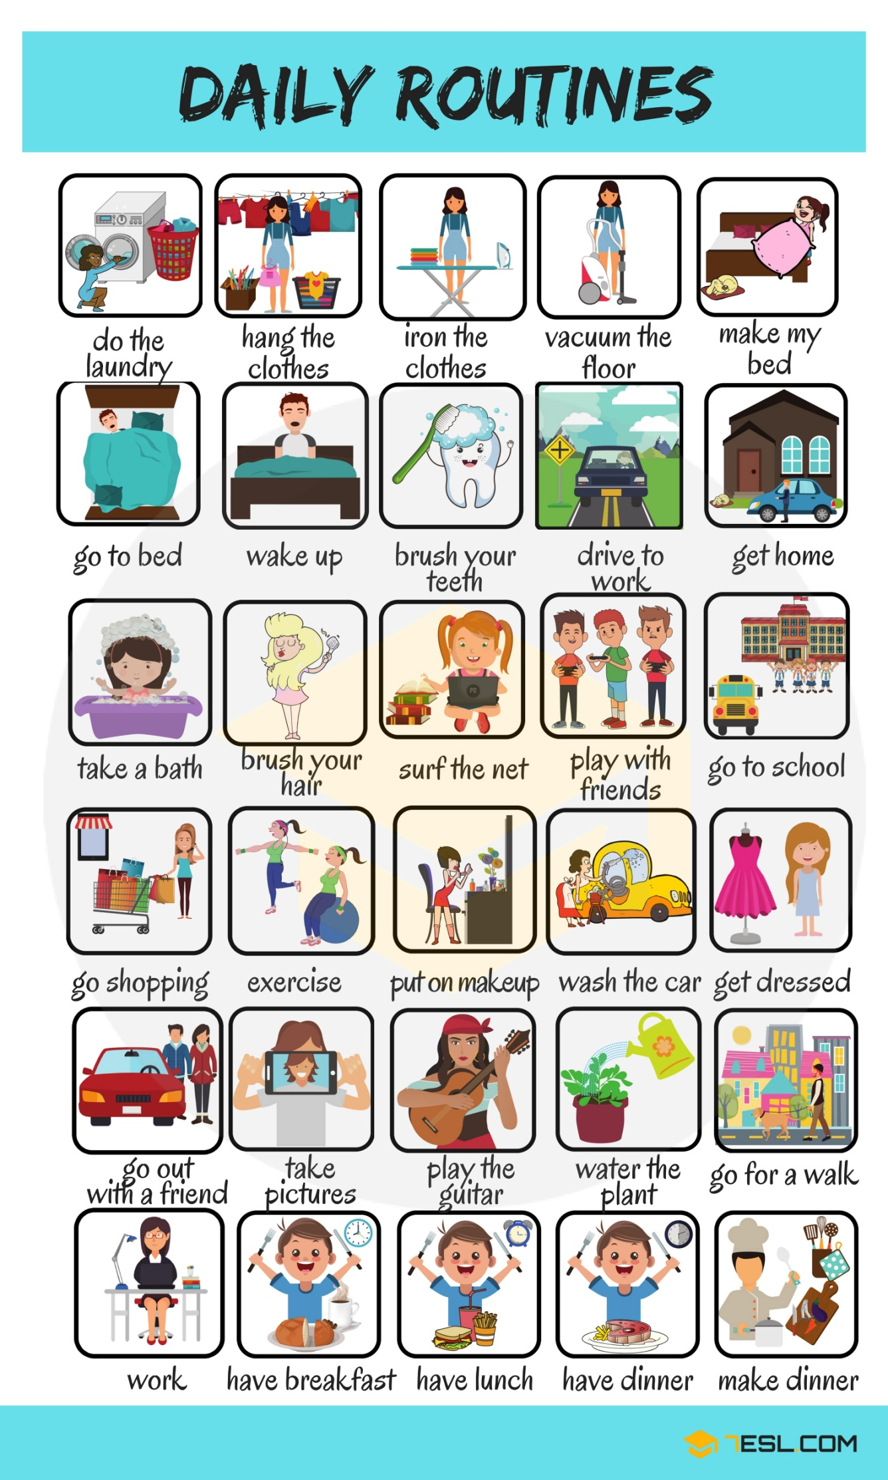

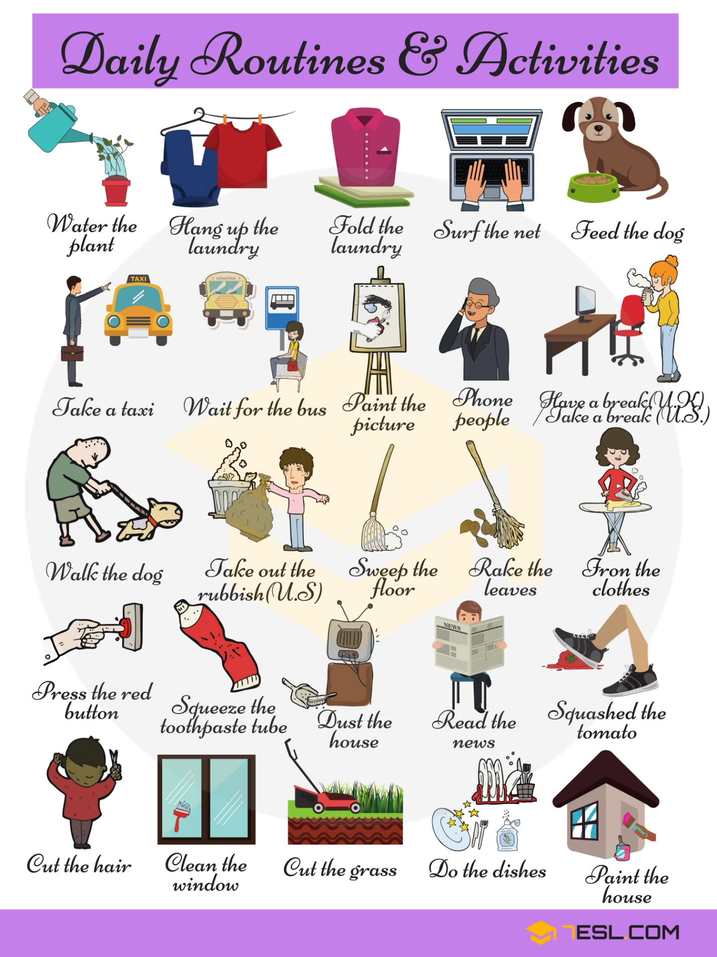

I. Look at the picture and tell about the child’s day schedule.
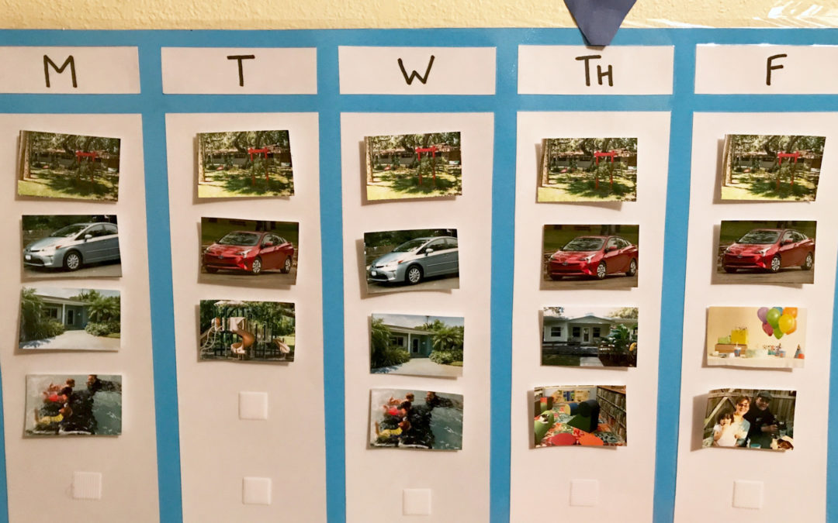

II. Listen and write the missing letters to complete the words.
http://gamedata.britishcouncil.org/lep25_embed/MjA5NjI=/le

III. Complete the sentences.
http://gamedata.britishcouncil.org/lep25_embed/MjA2MjI=/le

IV. Write the base form of the past simple verb forms.
http://gamedata.britishcouncil.org/lep25_embed/MjA5NjM=/le

V. Put the actions in the order of a normal day.
http://gamedata.britishcouncil.org/lep25_embed/MjA5NjA=/le

VI. Put the words in alphabetical order.
http://gamedata.britishcouncil.org/lep25_embed/MjA5NjE=/le

