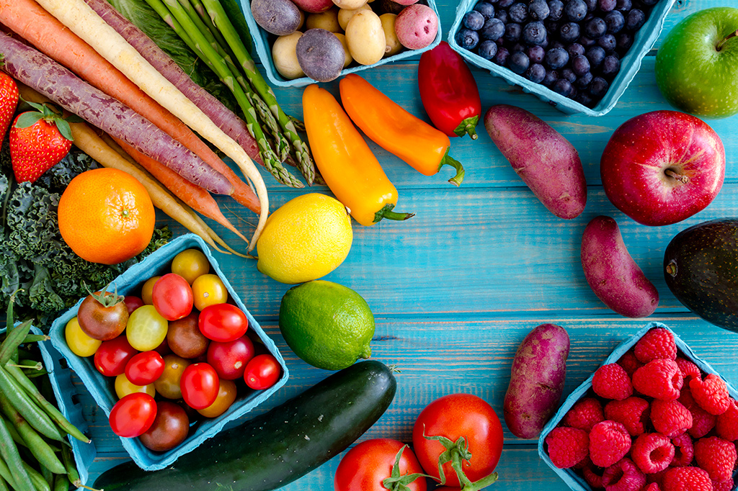
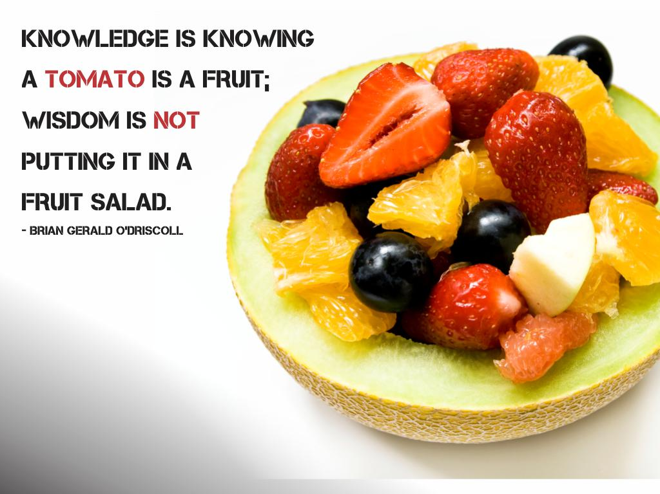

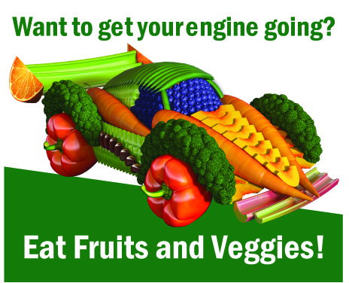
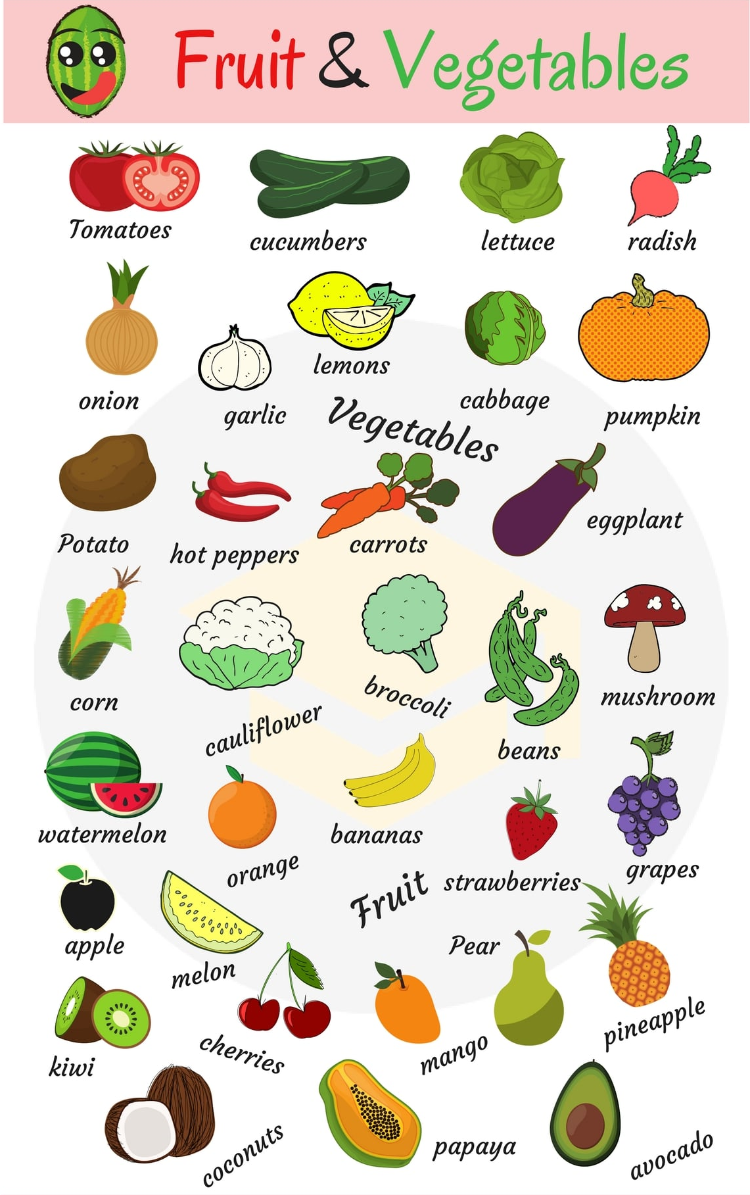

I. Vocabulary.
1. Quizlet.
https://quizlet.com/305214958/beginner_lesson_6_fruit-and-vegetables-flash-cards/

2. Video.
https://www.youtube.com/watch?time_continue=155&v=yAbUCDqVypc

<iframe width="560" height="315" src="https://www.youtube.com/embed/yAbUCDqVypc" frameborder="0" allow="autoplay; encrypted-media" allowfullscreen></iframe>

II. Match the words and pictures.
http://gamedata.britishcouncil.org/lep25_embed/MTA2ODY=/teens

III. Match the words and pictures.
http://gamedata.britishcouncil.org/lep25_embed/MTA5Mjk=/teens

IV. Match the words with the definitions.
http://gamedata.britishcouncil.org/lep25_embed/MTg4OTA=/teens

V. Fill the gaps with the correct word from the box.
http://gamedata.britishcouncil.org/lep25_embed/MTg4MzM=/teens
VI. Write the words to fill the gaps.
http://gamedata.britishcouncil.org/lep25_embed/MTg4OTI=/teens

VII. Write the words to fill the gaps.
http://gamedata.britishcouncil.org/lep25_embed/MTg4MzQ=/teens

