006_basic_video
Food and drinks
Fruit and vegetables

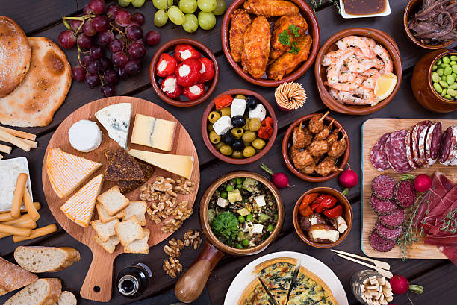

What do you think of as typical British food? Roast beef? Fish and chips? Tea and cakes? Or maybe there's more to British food than that?

Video 1- https://www.youtube.com/watch?v=aKbIilKwJwg&frags=pl%2Cwn

Exercise 1
Find the right answer

What is the boy's name? (Nick)
How old is he? (12)
Where does he live? (Cambridge)
What is a typical thing for them in the morning? (to hurry)
What kind of lunch do they have at school?(packed lunch)
When do they eat their lunch? (at about 12:30 pm)
What kind of fruit does the girl ask for? (a banana)
What does the girl have for breakfast? (toast)
What does Molly order for dinner?(curry, Indian food is her favorite)
What does Nick order for dinner? (fish and chips)
What dressing does Nick ask for at dinnertime?(ketchup)
What do they make before going to a supermarket?
What are they going to have for lunch on Sunday? (roast beef and Yorkshire pudding)
What is dad going to make for dinner? (vegetable lasagna)
What do they have for dessert? (apple crumble and custard)
What can't mom eat? Why?(meat, she's a vegetarian)

Quizlet- https://quizlet.com/305018544/006_basic_video-flash-cards/
Video 2 - http://learnenglishteens.britishcouncil.org/uk-now/video-uk/food-britain
Script
Carmen: The Chinese introduced oriental food to Britain. But before the Chinese, immigrants from all around the world came to live in London.
British people enjoy a huge range of food and flavours from other countries.
This is Borough Market, London’s oldest food market. Today, you can find food here from all over the world.
This is Italian cheese. Each group of settlers brought their own food and styles of cooking and people here embraced the exciting new flavours… maybe because British food wasn’t very good.
Restaurants from all around the world can be found on most British high streets. Indian, Chinese, Greek, Italian, Spanish, Persian... the list goes on.
But just what are the UK’s favourite dishes?
On the Street: My favourite meal is Thai green curry.
On the Street: One of my favourite meals is... cottage pie with peas.
On the Street: My favourite food is... Chinese ... Chinese.
On the Street: What’s my favourite meal? Still full English breakfast.
......
Chef: This is a full English breakfast. Tomato, black pudding, sausage, bacon, egg, mushroom.
......
Carmen: A big fried breakfast might not be to everyone’s taste. But in Britain, there is something for everyone.
Celia Brooks Brown is a food writer and knows all about food and the future of food in the UK, today.
Mmm! It looks good. What have we got here, Celia?
Celia: Well, this is a British tomato salad with a Yorkshire-made sheep’s cheese. And here we have a Barnsley lamb chop with new potatoes and a mint hollandaise sauce.
Carmen: So is this a sign of developments in British cooking?
Celia: Yes, people want to know where their food comes from. Chefs in restaurants like these are reinventing classic British dishes. They’re using ingredients that are locally sourced and locally grown.
Carmen: So what about world cuisine?
Celia: Well, anything goes. Chefs love to experiment with ingredients from different cultures. And we live in a globalised society, it’s very exciting.
Carmen: OK, Celia, if you were cooking these dishes at home, what ingredients from different cultures would you use?
Celia: Well, I might use something like this. This is a Moroccan spice mix called Ras el Hanout. Have a sniff.
Carmen: Hmm. That’s really strong.
Celia: Lovely, isn’t it? Now, this might make a lovely spice rub for that lamb chop.
Carmen: I can’t wait to taste this.
......
Carmen: The food in Britain reflects the many different cultures here. But some of the old favourites are here to stay. I’m off for my favourite, fish and chips. Want a chip?

Exercise 2- http://gamedata.britishcouncil.org/lep25_embed/MjA5MzQ=/teens
Exercise 3- http://gamedata.britishcouncil.org/lep25_embed/ODE2MA==/teens
Exercise 4- http://gamedata.britishcouncil.org/lep25_embed/ODEMQ==/teens
Exercise 5 (Fruit)- http://gamedata.britishcouncil.org/lep25_embed/MjAzNjM=/kids
Exercise 6 (Vegetables)- http://gamedata.britishcouncil.org/lep25_embed/MjAxODI=/kids

