007_basic_reading
Food and drinks
Meat and fish
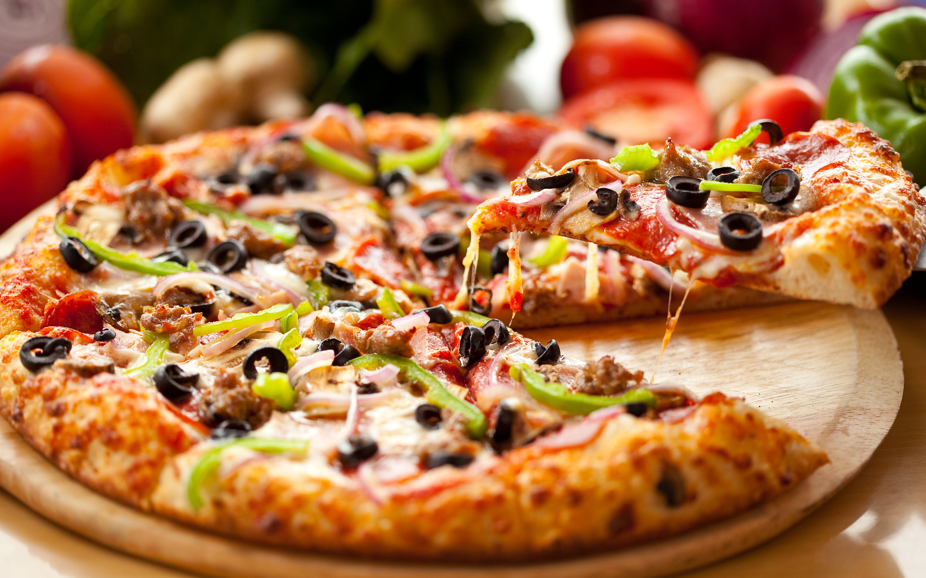
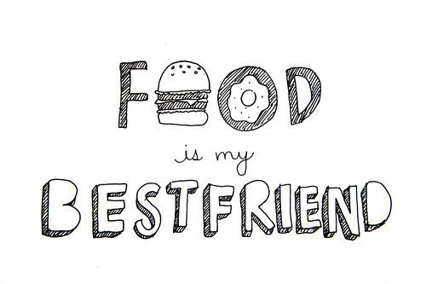

Quizlet - https://quizlet.com/305112775/007_basic_reading_peanut_butter-flash-cards/
Peanut Butter
Americans love to eat peanut butter. But what is peanut butter? It is a thick, creamy paste. You buy it in a jar at the grocery store. Manufacturers roast peanuts and take off the skin. Then they grind them into a thick paste--that's peanut butter!
The peanut is not really a nut, but a pea. It is a strange pea because it grows underground. But peanut plants also have green vines with yellow flowers. These vines or stems grow above the ground and are quite long. Peanuts are very healthy for you. They have more protein than a steak and they have many vitamins, too.
The peanut comes from South America, but peanut butter is a food that is truly "American." Peanut butter started in 1890 in St. Louis. A doctor made some peanut butter. He gave it to patients who could not eat regular food. Later, peanut butter was popular as a healthy food.
Peanut butter is very popular with children in the United States. Perhaps their favorite way to eat it is in a sandwich. Many children add jelly to their peanut butter sandwiches. This makes a favorite snack or lunchtime meal.

Choose the right answer
- Where can you buy peanut butter?
a. At the grocery store
b. At the pharmacy
c. At the gift shop
2. Where do the peas for peanut butter grow?
a. On the tree
b. On the bush
c. Under the ground
3. How do the peanuts affect our health?
a. They are very dangerous.
b. They are poisonous.
c. They are very healthy.
4. Where do peanuts come from?
a. From South Africa
b. From South Europe
c. From South America
5. Who made the peanut butter for the first time?
a. A doctor
b. A farmer
c. A child
6. In what way do children like to it peanut butter?
a. With their hands
b. With a sandwich
c. With a juice
7. What is the synonym for the word ‘snack’ (paragraph 4)?
a. Light meal
b. Breakfast
c. Taste
d. Flavor

Quizlet- https://quizlet.com/305114695/007_basic_reading_the_hamburger-flash-cards/
The Hamburger
The hamburger has no connection to ham. It got its name from the German town of Hamburg, which was famous for its ground steak. German immigrants to the United States introduced the "hamburger steak."
At the St. Louis World's Fair in 1904, hamburger steaks were served on buns for the first time. Hamburgers on buns were convenient and tasted good and became the usual way of eating hamburgers.
How did the hamburger become the most popular, most typical American food? The introduction of the bun is an important part of the answer. Another important part is McDonald's, the fast- food restaurant.
The first McDonald's was opened in San Bernadino, California, in 1949. Hamburgers were the main item on its menu. People liked the restaurant's fast service. By the 1960s there were many McDonald's restaurants. McDonald's was a part of nearly every community in the United States. There were also other fast-food restaurants that sold hamburgers. McDonald's alone sold millions of hamburgers a year. Today, of course, there are McDonald's restaurants around the world. The food they serve is considered typically American. And, although McDonald's has expanded its menu, the main item on that menu is--as always--the hamburger.

Choose the right answer
- Why did hamburgers get their name?
a. Because of German city
b. Because of ham
c. Because of the person who made it.
2. When were the hamburgers served at first?
a. In the 19th century
b. In the 20th century
c. In the 21st century
3. Why did the hamburgers become so popular?
a. Because of their buns
b. Because of their unforgettable taste
c. Because of their shape
4. Where was the first McDonald’s opened?
a. In Germany
b. In California
c. In Florida
5. Where can you find hamburgers?
a. In restaurants
b. In cafés
c. In fast-food restaurants
6. How are the hamburgers connected with McDonald’s?
a. Hamburgers were the first dish in it.
b. Hamburgers are sold only in it.
c. Hamburgers are the main item in it.
7. What is the synonym for the word ‘convenient’ (paragraph 2)?
a. Practical
b. Tasteful
c. Pretty
d. Fresh

Do you agree or disagree with the quote «You are what you eat»?
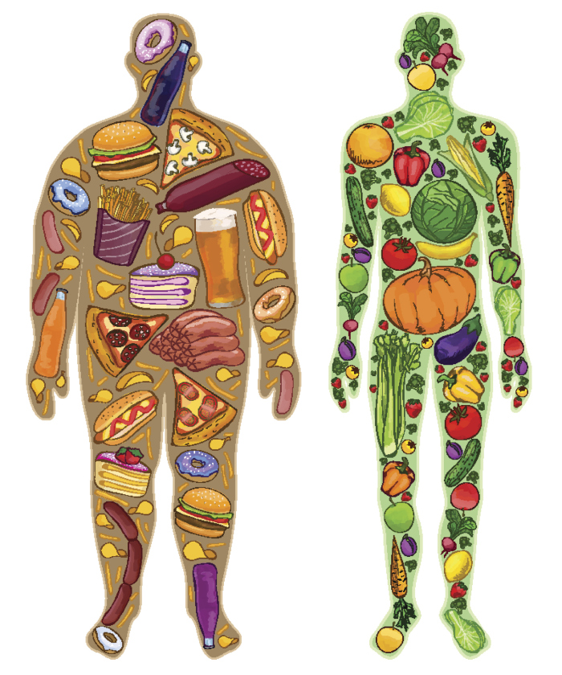

Exercise 3

http://gamedata.britishcouncil.org/lep25_embed/MjA0MDA=/kids

Exercise 4

http://gamedata.britishcouncil.org/lep25_embed/MjA0MDE=/kids

