007_basic_reading
Food and drinks
Meat and fish
Keys

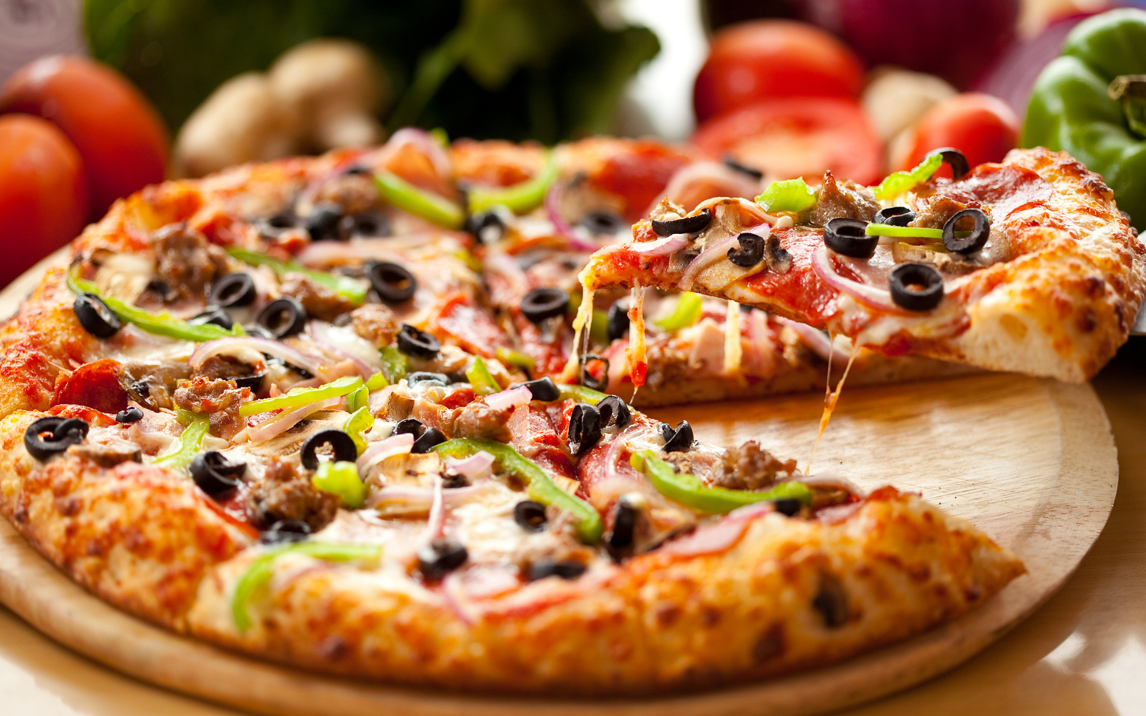
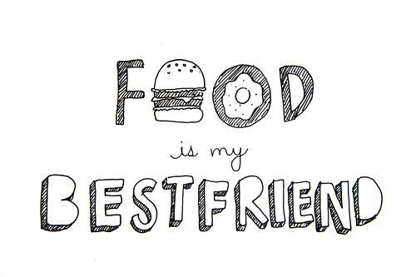

Peanut butter
- Where can you buy peanut butter?
a. At the grocery store
b. At the pharmacy
c. At the gift shop
2. Where do the peas for peanut butter grow?
a. On the tree
b. On the bush
c. Under the ground
3. How do the peanuts affect our health?
a. They are very dangerous.
b. They are poisonous.
c. They are very healthy.
4. Where do peanuts come from?
a. From South Africa
b. From South Europe
c. From South America
5. Who made the peanut butter for the first time?
a. A doctor
b. A farmer
c. A child
6. In what way do children like to it peanut butter?
a. With their hands
b. With a sandwich
c. With a juice
7. What is the synonym for the word ‘snack’ (paragraph 4)?
a. Light meal
b. Breakfast
c. Taste
d. Flavor

The Hamburger
- Why did hamburgers get their name?
a. Because of German city
b. Because of ham
c. Because of the person who made it.
2. When were the hamburgers served at first?
a. In the 19th century
b. In the 20th century
c. In the 21st century
3. Why did the hamburgers become so popular?
a. Because of their buns
b. Because of their unforgettable taste
c. Because of their shape
4. Where was the first McDonald’s opened?
a. In Germany
b. In California
c. In Florida
5. Where can you find hamburgers?
a. In restaurants
b. In cafés
c. In fast-food restaurants
6. How are the hamburgers connected with McDonald’s?
a. Hamburgers were the first dish in it.
b. Hamburgers are sold only in it.
c. Hamburgers are the main item in it.
7. What is the synonym for the word ‘convenient’ (paragraph 2)?
a. Practical
b. Tasteful
c. Pretty
d. Fresh

Exercise 3
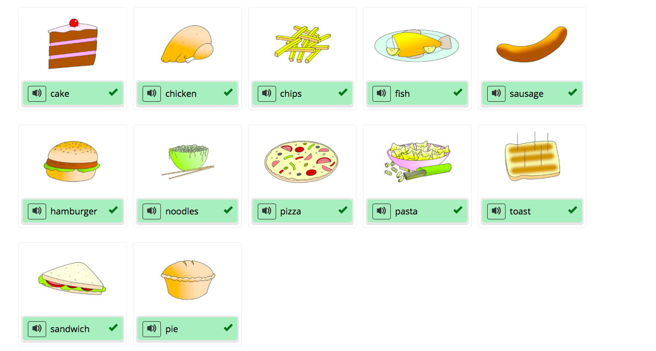

Exercise 4

