Lesson 8-Food and Cooking-Speaking
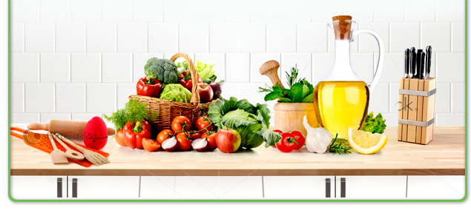

- Exercise 1

- Are you a good cook?
- Did you eat breakfast today?
- Do you drink tea or coffee every day?
- Do you have dinner every day?
- Do you like to eat at fast food restaurants?
- Do you like to eat cakes?
- What is your favorite food?
- Do you often eat out?
- Do you prefer fish or meat?
- Do you prefer to eat at a restaurant or at home?
- Have you ever been on a diet? If so, how long did keep it?

- Exercise 2
- Play the game
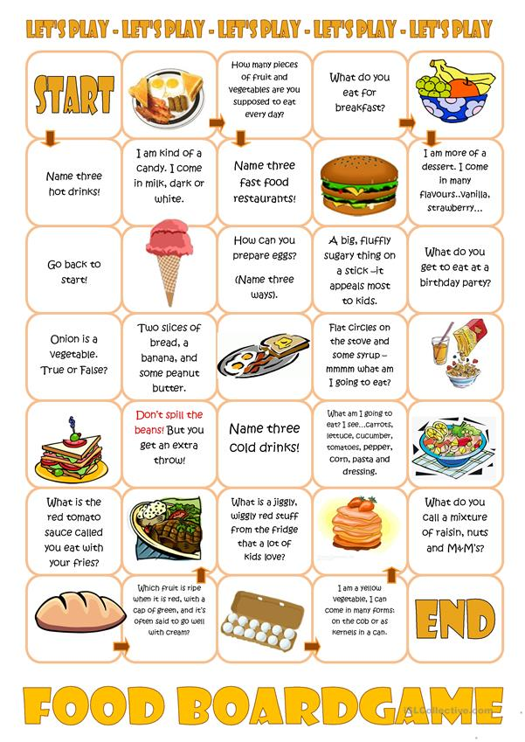

Exercise 3
Play the game «Guess what»

Each of the players picks up any word, which is connected to the topic «Food and cooking». This word must be guessed by your opponent who can ask only yes/no questions. If the answer is «Yes», the opponent can ask the question one more time. If the answer is «No», it’s turn of the other player to ask question. The winner is the player who guessed which word was picked up to him.

Exercise 4

  - How many meals do you usually eat every day?
  - How much do you eat when you are sad or happy?
  - How often do you go shopping for food?
  - Is there any food that you really dislike to eat?
  - What are some foods that are considered unhealthy?
  - What country's food do you like the most?
  - What do you eat for breakfast every day?
  - What do you eat when you feel sad?
  - What food can you cook the best?
  - What food do you hate?
  - What food do you love?
  - What food have you tasted which you will never forget for the rest of your life?
  - What fruit do you eat the most often?
  - What is the cheapest place to eat that you know?
  - What is the food you like about your country.
  - What is the most expensive meal you have ever eaten?
  - What's your favorite restaurant? Why do you like it?
  - What's your favorite snack?
  - Which do you eat more often, rice, bread or potatoes?
  - Which fast food restaurants do you eat at the most often?

Exercise 5
Play Jeopardy
https://jeopardylabs.com/play/food2913

