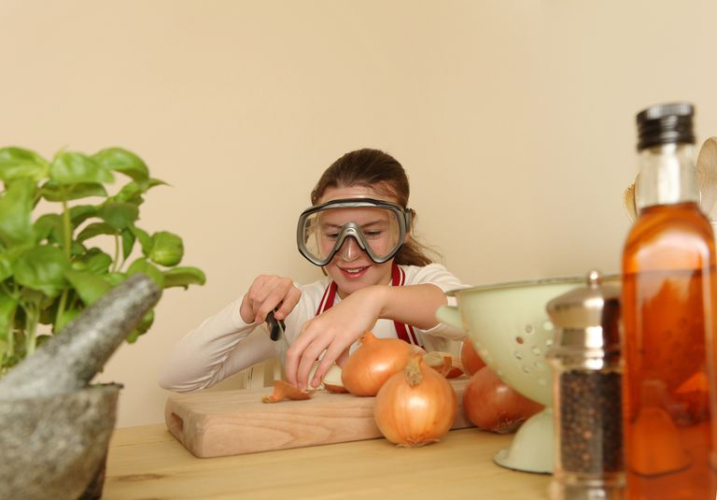
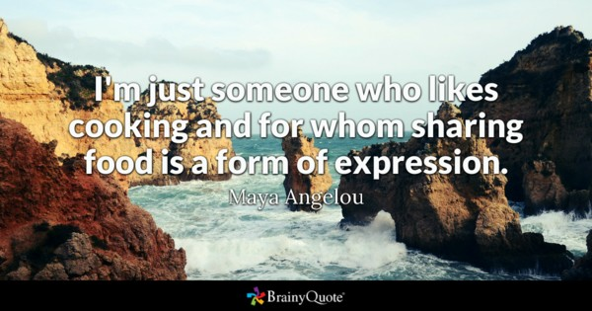
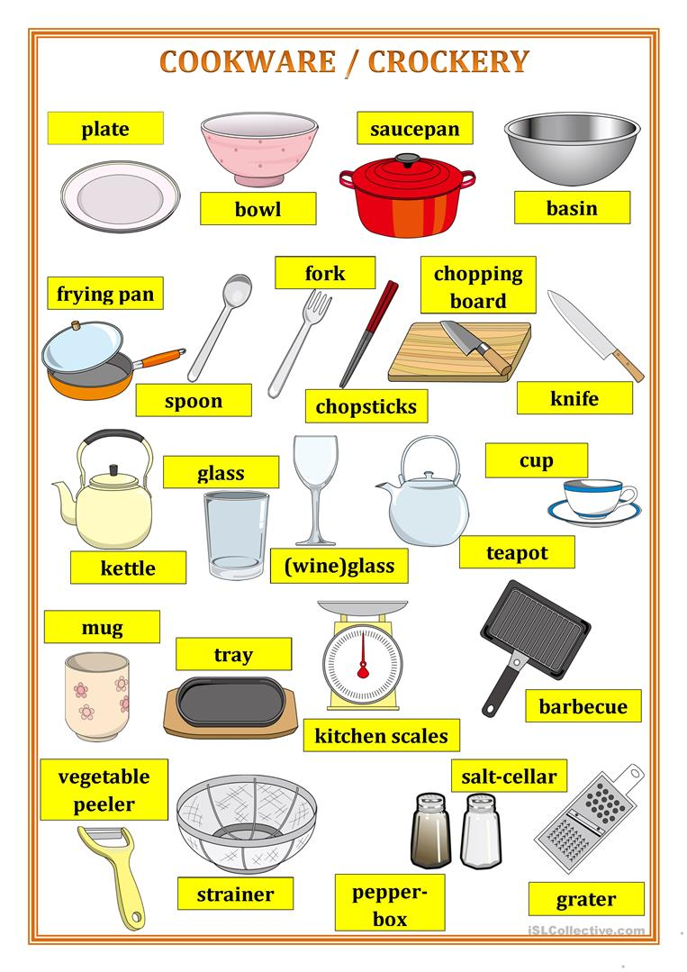

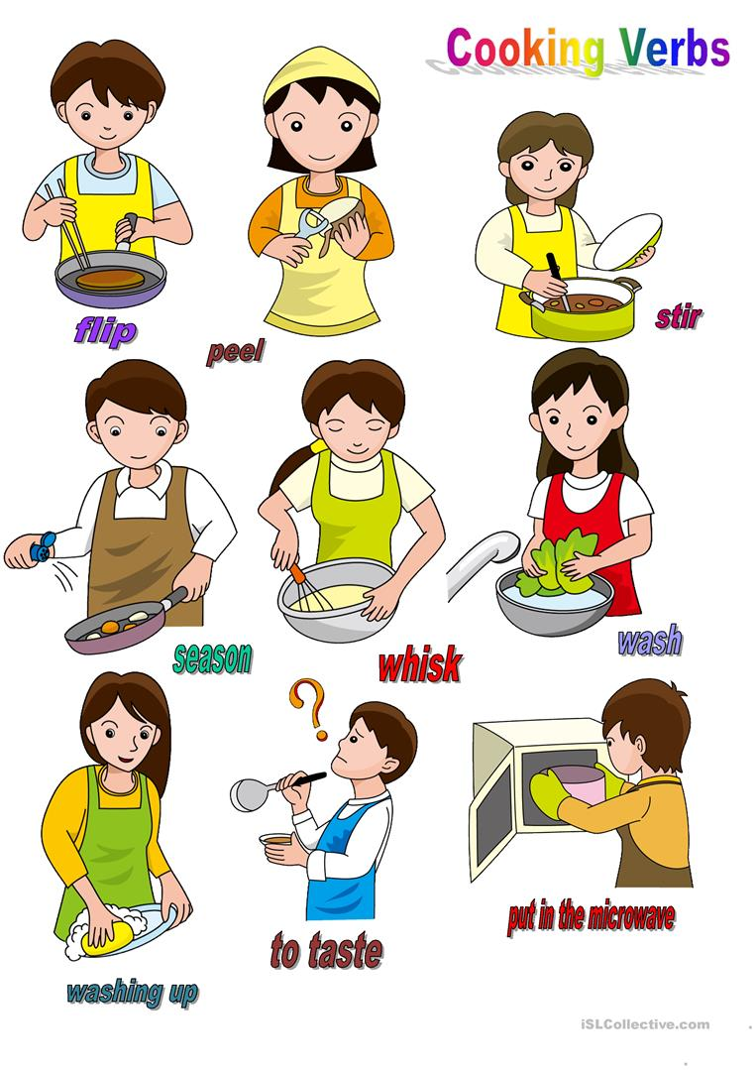
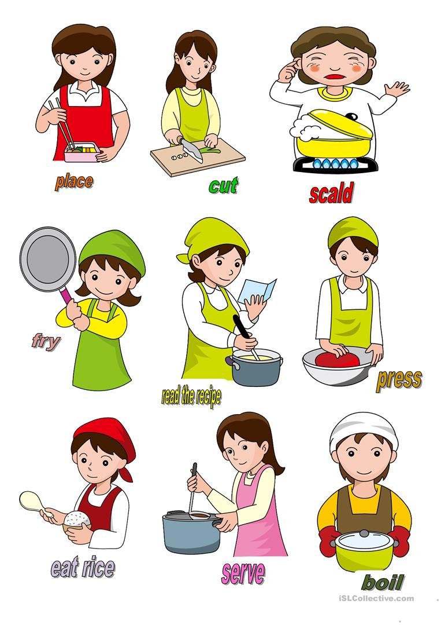
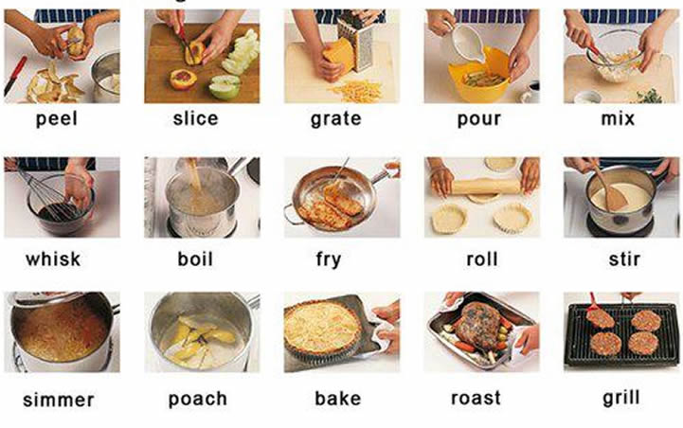

I. Vocabulary.
https://quizlet.com/39865232/english-cooking-flash-cards/

II. Match the words and pictures.
http://gamedata.britishcouncil.org/lep25_embed/MTA4OTQ=/teens

III. Read the sentences and choose the correct answer.
http://gamedata.britishcouncil.org/lep25_embed/MTg4MjE=/teens

IV. Put the chunks in order to make sentences.
http://gamedata.britishcouncil.org/lep25_embed/MjE3OTM=/le

V. Choose the best answer.
http://gamedata.britishcouncil.org/lep25_embed/MjE3OTQ=/le
VI. Listen and put the letters in order to spell the words.
http://gamedata.britishcouncil.org/lep25_embed/MjE3ODQ=/le

VII. Write the words to complete the sentences.
http://gamedata.britishcouncil.org/lep25_embed/MjA2NDM=/le

VIII. Write the words to fill the gaps.
http://gamedata.britishcouncil.org/lep25_embed/MTg4MjQ=/teens

