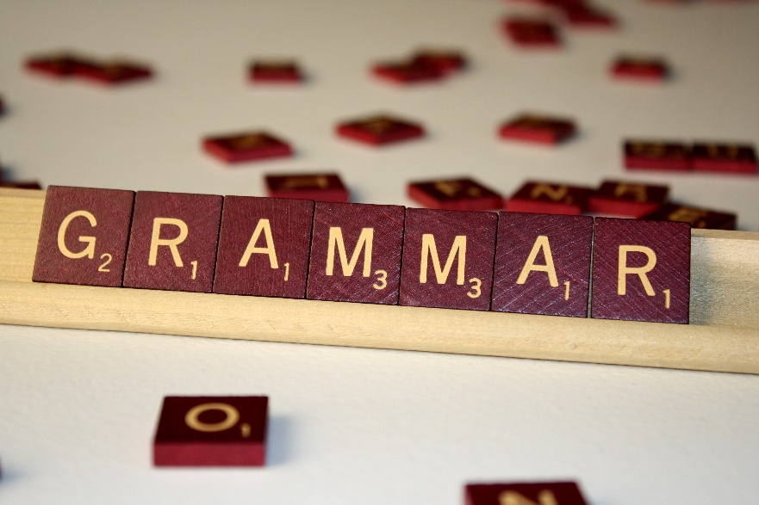
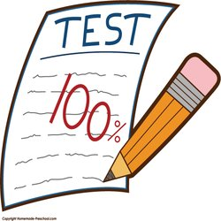
basic_lesson_08_food_drinks_grammar_part_2_test

Exercise 1
Choose the correct answer

- Every morning she …………….. up early and gets ready for work.
- is waking
- wakes
- will wake

- The teacher……………… to talk to you.
- want
- wants
- is wanting

3) We ..................... Greece next month.
a) visit
b) will visit
c) visited

- She ………………… a novel last year.
- wrote b) writes c) is writing

- David and Jane ______at the party last night.
- are b) is c) were

- Yesterday _______ the best day of my life!
a)were b) was c) is

- The weather _______ cold today. I hope it _____warmer soon.
- is, will get b) was, got c) are, get

- They _________ on Thursday.
- doesn`t cook b) not cook c) don`t cook

- When I was a child I always _____ vegetables. Carrots ____my favorite.
- eats, are b) ate, were c) eat, is

- Liz and Tommy ________ to the coast every year.
- traveling b) travel c) travels

11) We ________ a cake tomorrow .
a) baked b) bake c) will bake

Exercise 2
Choose the correct answer

1. He ________ to sing when he was 9 years old. (to begin)
begun
began
beginned
2. My little brother ________ his new glasses when he fell off hus bike. (to break)
broked
broken
broke
3. The pupils ________ at the football championship a week ago. (to be)
was
are
were
4. I ________ my French homework at school yesterday. (to do)
do
did
am doing
5. He ________ all the "Harry Potter" books last year. (to read)
readed
reads
read
6. My father________ at my college last Monday. (to be)
were
is
was
7. That boy________ the ball in the basket. (to throw)
threw
throwed
are throwing
8. The police ________ the thief quickly. (to catch)
caught
catched
catch
9. He ______ a lot of amazing paintings in the gallery. (to see)
sees
saw
seed
10. I ________ T-shirts from the museum shop to remind us of our visit yesterday. (to buy)
buyed
bought
am buying
11. We ________ photos of our favorite stars last week. (to take)
taken
took
taked
12) I _______ an e-mail to my aunt yesterday. ( to write)
a) writed
b) wrote
c) writing

Exercise 3
Put the verbs into the correct form

- Yesterday, my mother (go) shopping.
2. I (watch) TV now.
3. (be) there any cinemas in Paris in 1951?
4. Where (be) you yesterday?
5. What ______ (do) you last weekend?
6. What are you (do)?
7. This morning, I (make) my bed.
8. What do you (do) for a living?
9. Last weekend, I (visit) my friend.
10. The driver ______ (stop) at the bus stop.

Exercise 4
Translate the sentences
- Где ты живешь?
- Мы сейчас слушаем музыку.
- Что ты делаешь каждый день?
- Я завра буду работать.
- Она вчера не готовила.
- Ты мне завтра позвонишь?
- Во сколько ты встаешь каждый день?
- Что Вы делали вчера?
- Погода сегодня теплая и солнечная.
- Я не понимаю это слово.

