Containers 009 basic
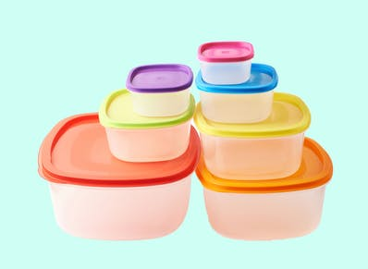
Quizlet
https://quizlet.com/304682227/containers_009_basic-flash-cards/
Exercise 1
Match up the words to the pictures
Bar | 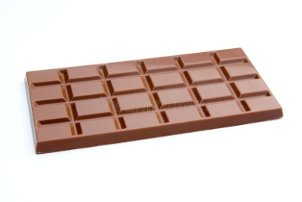
bottle | 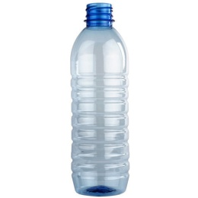
box | 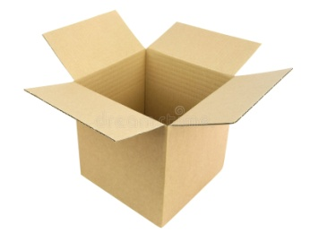
bunch | 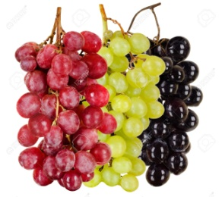
carton | 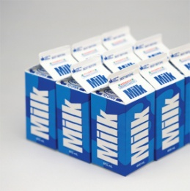
dozen | 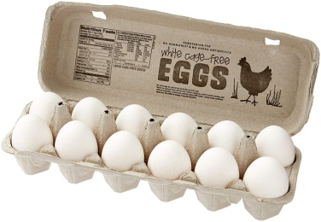
can | 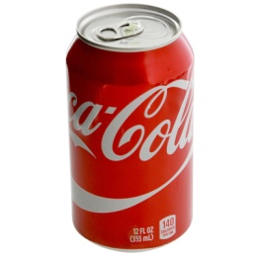
jar | 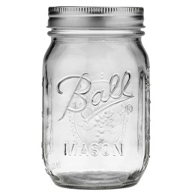
pot | 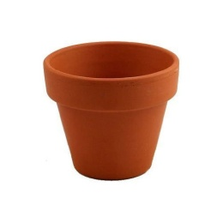
loaf | 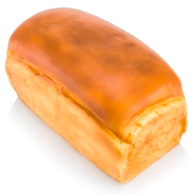
packet | 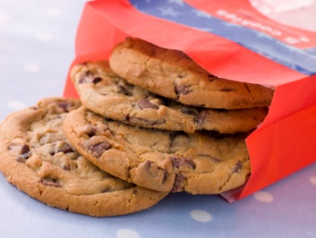
tin | 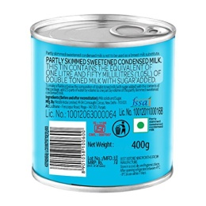
tub | 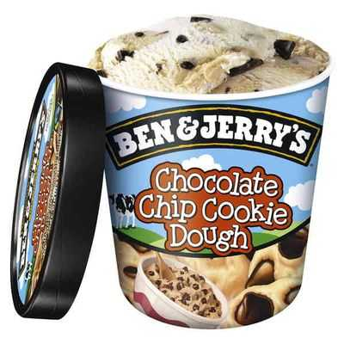

Exercise 2
Match up the containers with the groceries
A bar of | chocolate, soap
A bottle of | milk, wine, shampoo
A box of | matches, chocolates
A bunch of | Flowers, grapes, bananas
A carton of | orange juice
A dozen of | eggs
A can of | Coke, Sprite
A jar of | jam
A loaf of | bread
A packet of | cookies, cigarettes
A tin of | sardines, cat food, soup
A tub of | ice-cream

Exercise 3
Type the correct word into the sentence.

I bought a __of ice-cream.
He smokes 2__of cigarettes every day.
He gave her a huge__of flowers and a teddy bear for her birthday.
Mary has eaten a __of strawberry ice-cream.
Can you please buy a__of bread?
Get yourself some jam from a__.
How many eggs do I buy? –A __ would be more than enough.
She got a__of milk chocolate for her daughter and a __of chocolates for her friend.

