Containers 009 basic
Keys
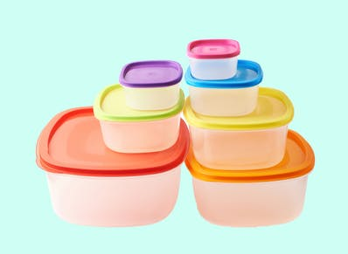
Exercise 1
Match up the words to the pictures
Bar | 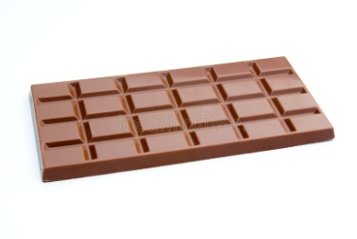
bottle | 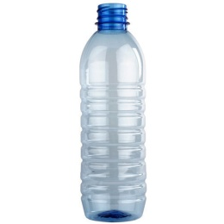
box | 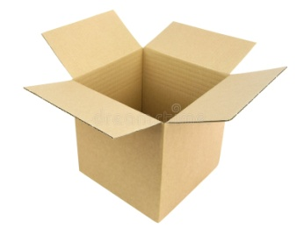
bunch | 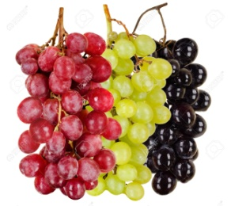
carton | 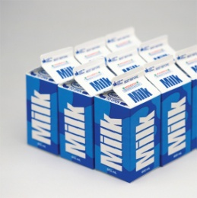
dozen | 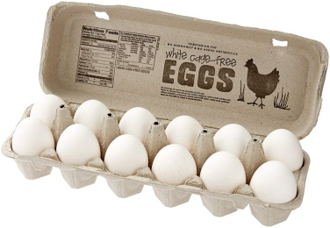
can | 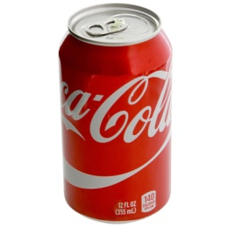
jar | 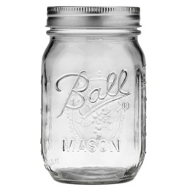
pot | 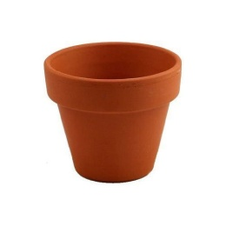
loaf | 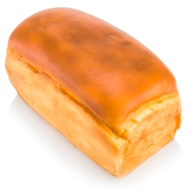
packet | 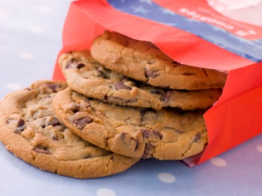
tin | 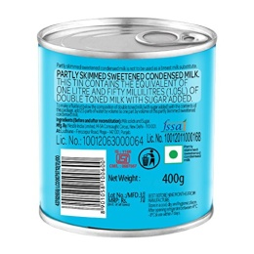
tub | 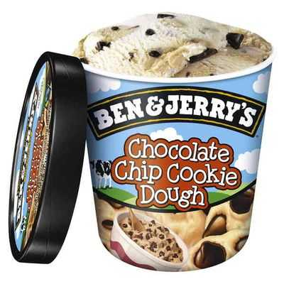

Exercise 2
Match up the containers with the groceries
A bar of | chocolate, soap
A bottle of | milk, wine, shampoo
A box of | matches, chocolates
A bunch of | Flowers, grapes, bananas
A carton of | orange juice
A dozen of | eggs
A can of | Coke, Sprite
A jar of | jam
A loaf of | bread
A packet of | cookies, cigarettes
A tin of | sardines, cat food, soup
A tub of | ice-cream

Exercise 3
Type the correct word into the sentence.
I bought a tub of ice-cream.
He smokes 2 packets of cigarettes every day.
He gave her a huge bunch of flowers and a teddy bear for her birthday.
Mary has eaten a tub of strawberry ice-cream.
Can you please buy a loaf of bread?
Get yourself some jam from a jar.
How many eggs do I buy? –A dozen would be more than enough.
She got a bottle of milk chocolate for her daughter and a box of chocolates for her friend.

