Lesson 9-Containers-Grammar (part2)
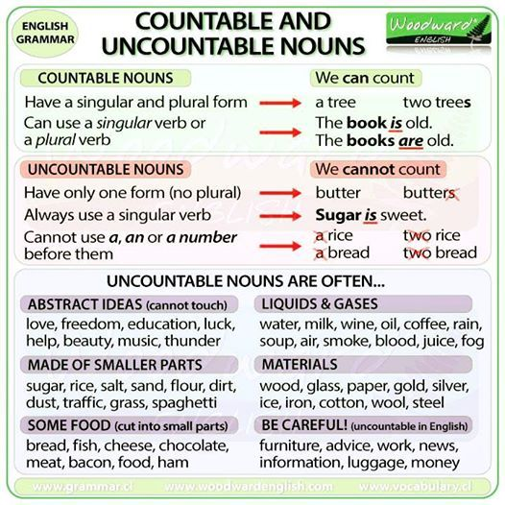
Exercise 1
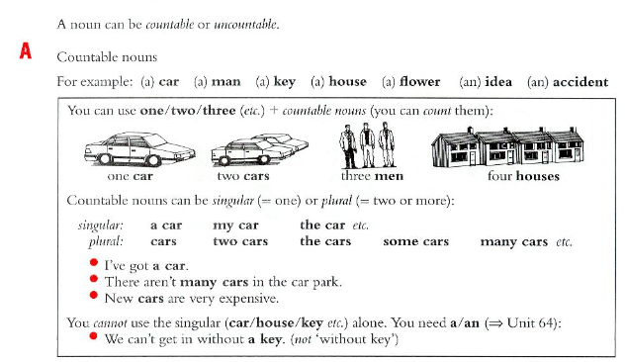
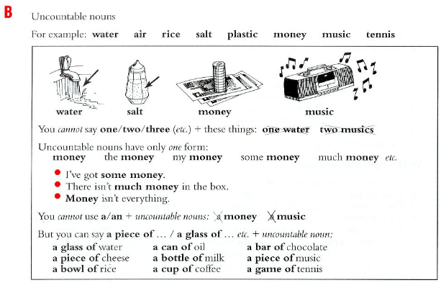

Exercise 2(сделать в hot potatoes-выпадающий список a/an/right)
Some of this sentences are right. Put in a/an where it is necessary.
- I have not got watch a
- Do you like cheese? right
- Ann never wears hat a
- Are you looking for job? a
- Mary doesn’t eat meat right
- Mary eats apple every day an
- I’m going to party tonight a
- Music is wonderful thing a
- Jamaica is island an
- I don’t need key a
- Everybody needs food right
- I’ve got good idea a
- Can you drive car? a
- Do you want cup of coffee? a
- I don’t like coffee without milk right
- Don’t go out without umbrella an

Exercise 3
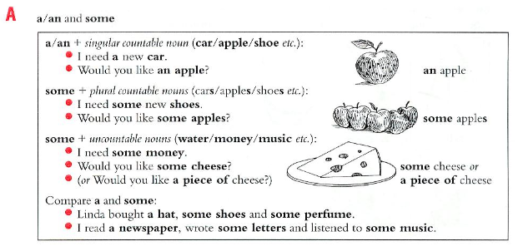
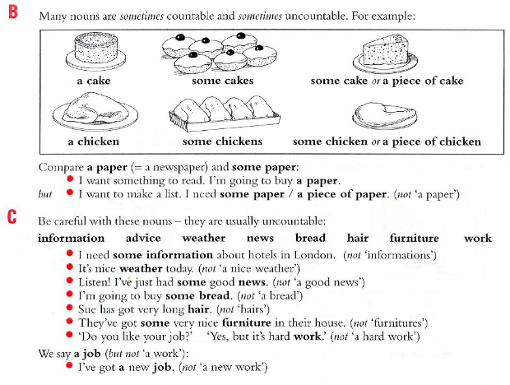
Exercise 4
Put in a/an or some
- I read a book and listened to some music
- I need some money. I want to buy some food.
- We met some interesting people at the party.
- I’m going to open a window to get some fresh air.
- She didn’t eat much for lunch-only an apple and some bread.
- We live in a big house. There’s a nice garden with some beautiful trees.
- I’m going to make a table. First I need some wood.
- Listen to me carefully. I’m going to give you some advice.
- I want to write a letter. I need some paper and a pen.

Exercise 5
Which is right? (то, что идет через слэш, в выпадающий список)
1.Martin has got brown eye/eyes
2. Paula has got short black hair/hairs.
3.The tourist guide gave us some information/informations about the town.
4. We’re going to buy some chair/chairs.
5. We’re going to buy some new furniture/furnitures.
6. It’s difficult to get a work/job at the moment.
7. We had lovely weather/a lovely weather when we were on holiday.

Exercise 6
Complete the sentence with a/an or some
1.Shall we have some fish? This restaurant is famous for it
2. Could you bring me a glass, please?
3. If you need some paper, there is a box on the shelf
4.Would you like some rice with your chicken?
5.My shirt is dry now. Have you got an iron?
6.Jack bought some glass to repair the broken windows.
7. Can you buy me a paper? There’s an article I want to read.

Exercise 7
Choose the correct answer
http://englishtests.ucoz.com/GrammarTests/A_an_and_some-1-.htm
Exercise 7
Decide whether these nouns are countable (C) or uncountable (U)
- The children are playing in the garden.C
- I don't like milk.U
- I prefer tea.U
- Scientists say that the environment is threatened by pollution.C
- My mother uses butter to prepare cakes.U
- There are a lot of windows in our classroom.C
- We need some glue to fix this vase.U
- The waiters in this restaurant are very professional.C
- My father drinks two big glasses of water every morning.C
- The bread my mother prepares is delicious.U
- Drivers must be careful; the road is slippery.C
- Some policemen are organizing road traffic to avoid any accidents.C
- I bought three bottles of mineral water for our picnic.C
- I'd like some juice please! U
- Successful candidates will join the camp later this year.C
- A rise in oil prices is inevitable since there is more and more world demand for energy.U
- The exercises on this website are interesting.C

