Lesson 9-Containers-Grammar (part2)
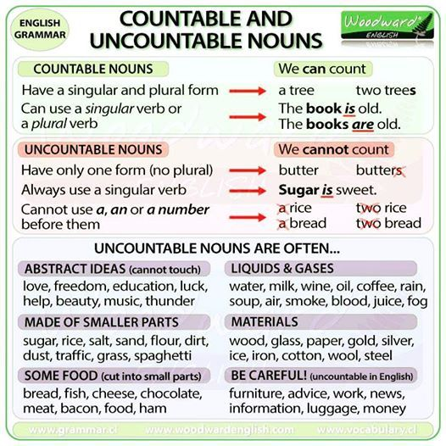
Exercise 1
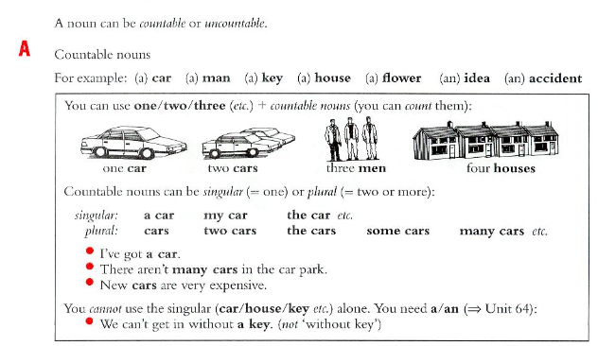
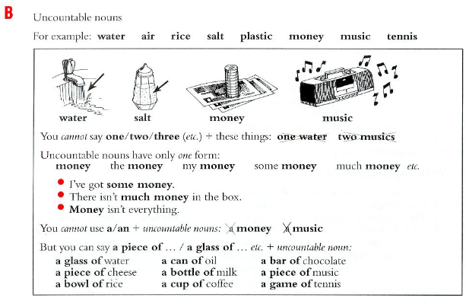

Exercise 2(сделать в hot potatoes-выпадающий список a/an/right)
Some of this sentences are right. Put in a/an where it is necessary.
- I have not got watch.
- Do you like cheese?
- Ann never wears hat
- Are you looking for job?
- Mary doesn’t eat meat
- Mary eats apple every day
- I’m going to party tonight
- Music is wonderful thing
- Jamaica is island
- I don’t need key
- Everybody needs food
- I’ve got good idea
- Can you drive car?
- Do you want cup of coffee?
- I don’t like coffee without milk
- Don’t go out without umbrella

Exercise 3
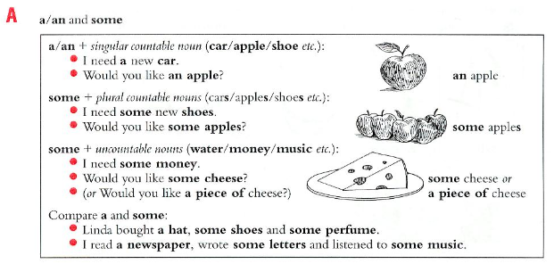
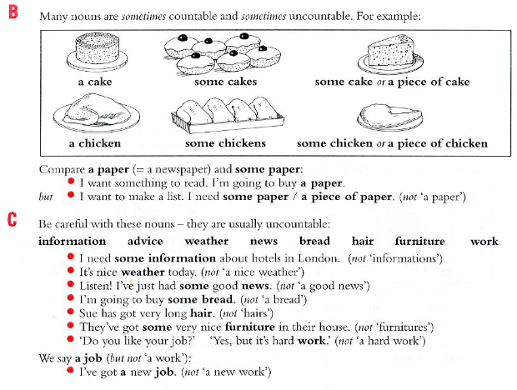
Exercise 4
Put in a/an or some
- I read … book and listened to … music
- I need … money. I want to buy … food.
- We met … interesting people at the party.
- I’m going to open… window to get … fresh air.
- She didn’t eat much for lunch-only … apple and … bread.
- We live in … big house. There’s … nice garden with … beautiful trees.
- I’m going to make a table. First I need … wood.
- Listen to me carefully. I’m going to give you … advice.
- I want to write a letter. I need… paper and … pen.

Exercise 5
Which is right? (то, что идет через слэш, в выпадающий список)
1.Martin has got brown eye/eyes 2. Paula has got short black hair/hairs.
3.The tourist guide gave us some information/informations about the town.
4. We’re going to buy some chair/chairs.
5. We’re going to buy some new furniture/furnitures.
6. It’s difficult to get a work/job at the moment.
7. We had lovely weather/a lovely weather when we were on holiday.

Exercise 6
Complete the sentence with a/an or some
1.Shall we have … fish? This restaurant is famous for it
2. Could you bring me … glass, please?
3. If you need… paper, there is a box on the shelf
4.Would you like … rice with your chicken?
5.My shier is dry now. Have you got … iron?
6.Jack bought … glass to repair the broken windows.
7. Can you buy me ... paper? There’s an article I want to read.

Exercise 7
Choose the correct answer
http://englishtests.ucoz.com/GrammarTests/A_an_and_some-1-.htm
Exercise 8
Decide whether these nouns are countable (C) or uncountable (U)

- The children are playing in the garden.
- I don't like milk.
- I prefer tea.
- Scientists say that the environment is threatened by pollution.
- My mother uses butter to prepare cakes.
- There are a lot of windows in our classroom.
- We need some glue to fix this vase.
- The waiters in this restaurant are very professional.
- My father drinks two big glasses of water every morning.
- The bread my mother prepares is delicious.
- Drivers must be careful; the road is slippery.
- Some policemen are organizing road traffic to avoid any accidents.
- I bought three bottles of mineral water for our picnic.
- I'd like some juice please!
- Successful candidates will join the camp later this year.
- A rise in oil prices is inevitable since there is more and more world demand for energy.
- The exercises on this website are interesting.

