010_basic_vocab
Containers test
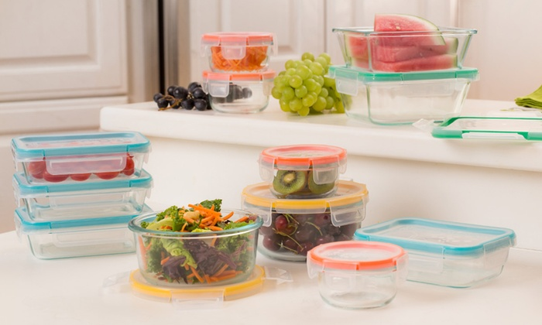

https://quizlet.com/304682227/containers_009_basic-flash-cards/

Exercise 1
http://gamedata.britishcouncil.org/lep25_embed/MjA5NTY=/le
Exercise 2
http://gamedata.britishcouncil.org/lep25_embed/MjA5NTg=/le
Exercise 3
http://gamedata.britishcouncil.org/lep25_embed/MjA2MjA=/le
Exercise 4
http://gamedata.britishcouncil.org/lep25_embed/MjA2MjE=/le
Exercise 5
http://gamedata.britishcouncil.org/lep25_embed/MjA5NTk=/le

