010_basic_vocab
Containers test
Keys
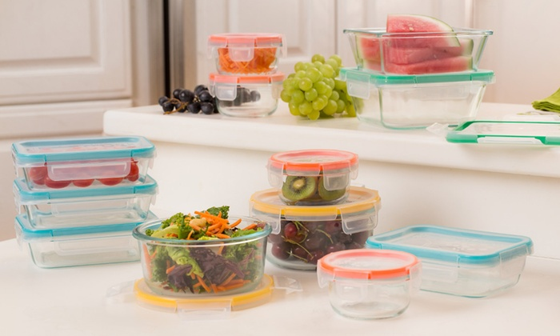
Exercise 1
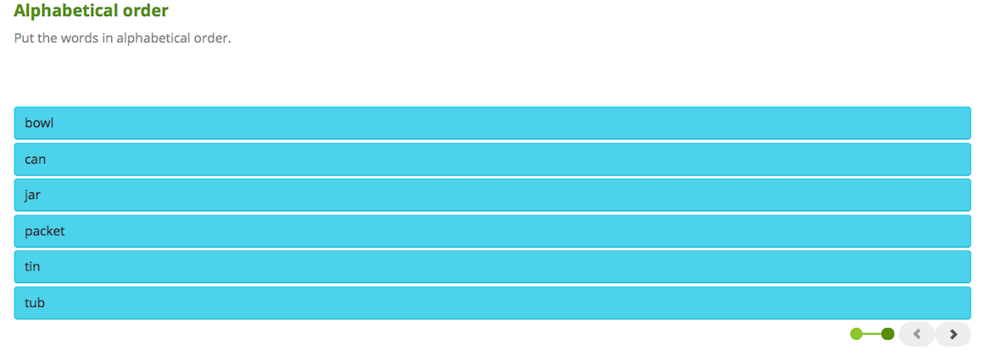
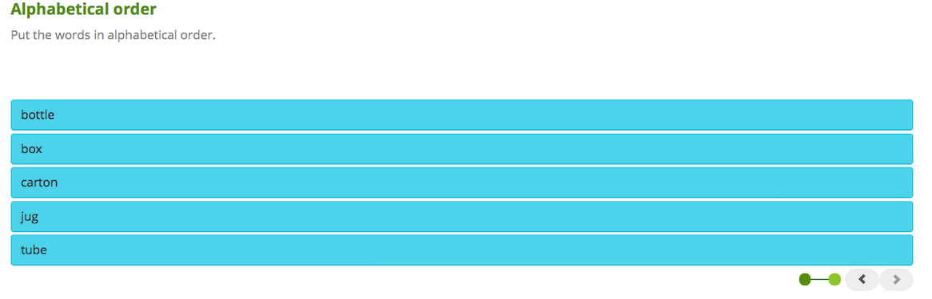
Exercise 2

1. box
2. can
3. jar
4. jug
5. tin
6. tub
7. bowl
8. tube
9. bottle
10. carton
11. packet

Exercise 3
1. Liquids such as water and wine often come in a ___.

bottle
can
packet
2. Jam usually comes in a ___.

box
carton
jar
3. Foods like beans and tuna often come in a ___, which is made of metal.

carton
tin
tube
4. In restaurants, sugar and other sweeteners often come in a small ___.

bottle
carton
packet
5. We can use a ___ to pour drinks for other people.

box
can
jug
6. Milk and juice sometimes come in a ___, which is made of a kind of cardboard.

carton
packet
tin
7. ___ come in different sizes. We need many of them when we move house.

Boxes
Cans
Tins
8. Cold drinks often come in a ___, which is made of metal.

bowl
can
packet
9. Toothpaste usually comes in a ___.

can
jug
tube
10. Butter and ice cream often come in a ___.

tin
tub
tube

Exercise 4
1. Liquids such as water and wine often come in a bottles.
2. Butter and ice cream often come in a tub.
3. Jam usually comes in a jar.
4. Toothpaste usually comes in a tube.
5. Foods like beans and tuna often come in a tin, which is made of metal.
6. Cold drinks often come in a can, which is made of metal.
7. In restaurants, sugar and other sweeteners often come in a small packets.

8. Boxes come in different sizes. We need many of them when we move house.

9. We can use a jug to pour drinks for other people.

10. Milk and juice sometimes come in a carton, which is made of a kind of cardboard.

Exercise 5
