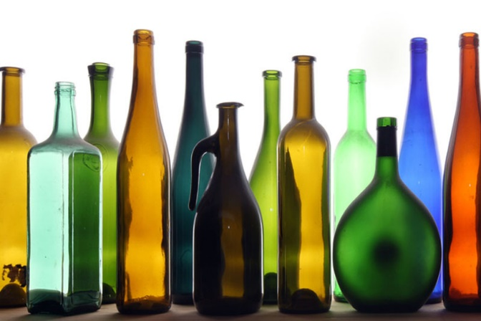
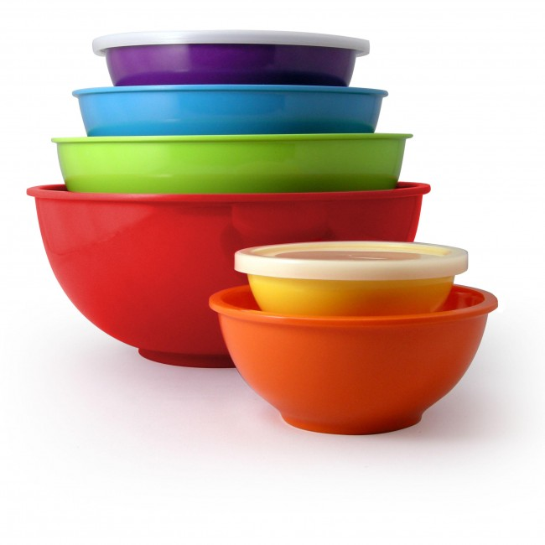
basic_lesson_10_containers_video_part_3

Exercise 1
Watch the video and answer the questions. Pause the video starting from 2.45
https://youtu.be/D6eXc_Zi5DE

Exercise 2
Match the words with the pictures
(in hot potatoes)

Exercise 3
Quizlet
https://quizlet.com/304840492/lesson-10-basic-video-flash-cards/
Watch the video and answer the questions
https://www.youtube.com/watch?v=Zgn58RIKiLw

- Where did the woman put the bag with fruit?
- Into the basket
- Into the cart
- Into the box
- What vegetables did she take?
- Cucumbers
- Peas
- Eggplants
- What do you need to do if you want to know how many kilos the vegetables are?
- You eat them
- You weigh them
- You smell them
- Where did she take a dozen eggs?
- In the dairy department
- In the greengrocery department
- In the bakery department
- What did the woman do at the cash desk?
- She paid for her groceries
- She didn`t pay for her groceries

Exercise 4
Watch the video and answer the questions
https://www.youtube.com/watch?v=u55rQUs_6XQ

- What did the woman take to cook breakfast?
- A slice of bread and a bottle of water
- A loaf of bread and a carton of juice
- A basket of bread and a can of cola
- What fruit did she take?
- A bunch of bananas
- A bunch of grapes
- Two apples
- What kind of meat did she take?
- Chicken
- Turkey
- Pork
- What container was used for meat?
- A tin
- A carton
- A packet
- What did she take for dinner?
- A tin of olives
- A jar of tomato sauce
- A tub of ice cream

Exercise 5
Choose the correct answer
- A tin of_________
- bread
- sweets
- fish
- A jug of _____
- potatoes
- juice
- apples
- A tube of _____
- toothpaste
- cucumbers
- onion
- A bottle of _____
- pears
- water
- jam
- A can of ______
- soda
- watermelon
- sugar
- A box of _____
- chocolates
- butter
- beer
- A tub of _____
- oil
- butter
- bread
- A jar of _____
- jam
- napkins
- toothpaste

