011_basic_vocabulary
Recap
Family, daily routines, food, containers
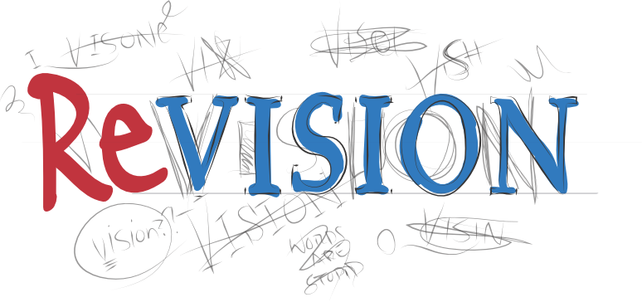

Family quizlet – https://quizlet.com/34932764/flashcards

Exercise 1
Choose the right answer looking at the picture

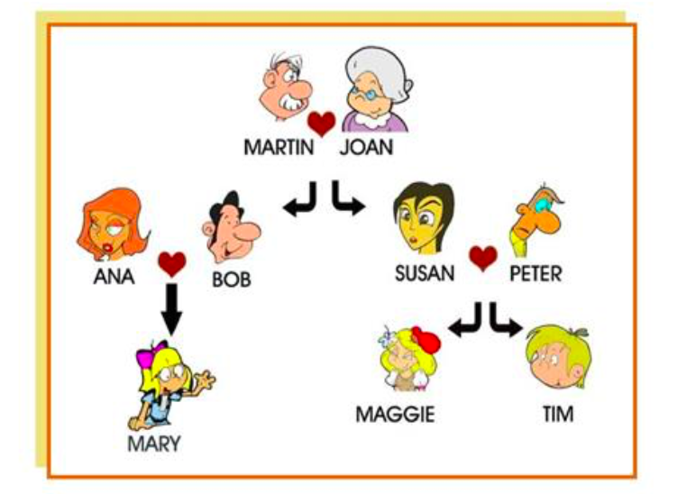
niece, sister, father, mother, uncle, nephew, grandmother, cousin, parents, husband, daughter, wife, grandfather, son

- Susan is Maggie's_____.
- Martin is Tim's_____.
- Peter is Mary's_____.
- Tim is Ana's_____.
- Joan is Maggie's_____.
- Maggie is Tim's_____.
- Bob is Ana's_____.
- Mary is Maggie's_____.
- Mary is Peter's_____.
- Peter is Tim's_____.
- Susan is Martin's_____.
- Tim is Susan's_____.
- Ana is Bob's____.
- Ana and Bob are Mary's_____.

Quizlet(daily routines)- https://quizlet.com/304769440/004_basic_vocabulary_daily_routines-flash-cards/

Exercise 2
http://gamedata.britishcouncil.org/lep25_embed/MTI3ODI=/le

Exercise 3
http://gamedata.britishcouncil.org/lep25_embed/MjA5NjE=/le

Exercise 4
http://gamedata.britishcouncil.org/lep25_embed/MjA5NjI=/le

Exercise 5
http://gamedata.britishcouncil.org/lep25_embed/MjA5NjA=/le

Exercise 6
http://gamedata.britishcouncil.org/lep25_embed/MjA2MjI=/le

