011_basic_vocabulary
Recap
Family, daily routines, food, containers
Keys

Exercise 1
Choose the right answer looking at the picture

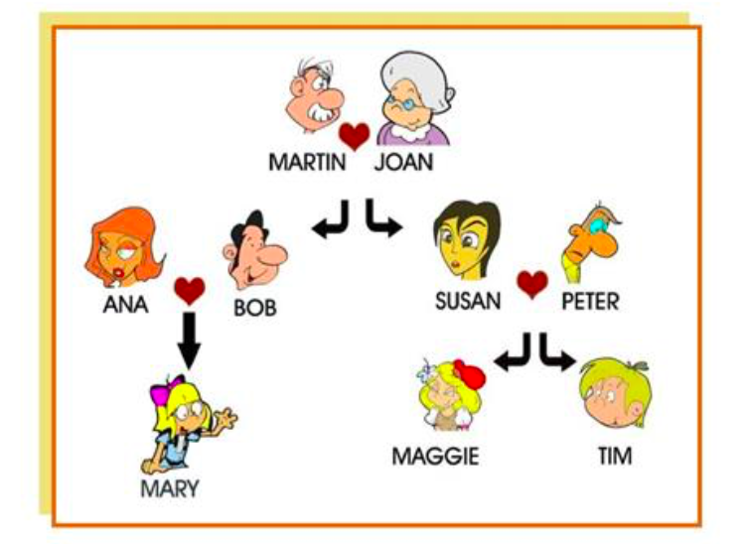
- Susan is Maggie's mother.
- Martin is Tim's grandfather.
- Peter is Mary's uncle.
- Tim is Ana's nephew.
- Joan is Maggie's grandmother.
- Maggie is Tim's sister.
- Bob is Ana's husband.
- Mary is Maggie's cousin.
- Mary is Peter's niece.
- Peter is Tim's father.
- Susan is Martin's daughter.
- Tim is Susan's son.
- Ana is Bob's wife.
- Ana and Bob are Mary's parents.

Exercise 2
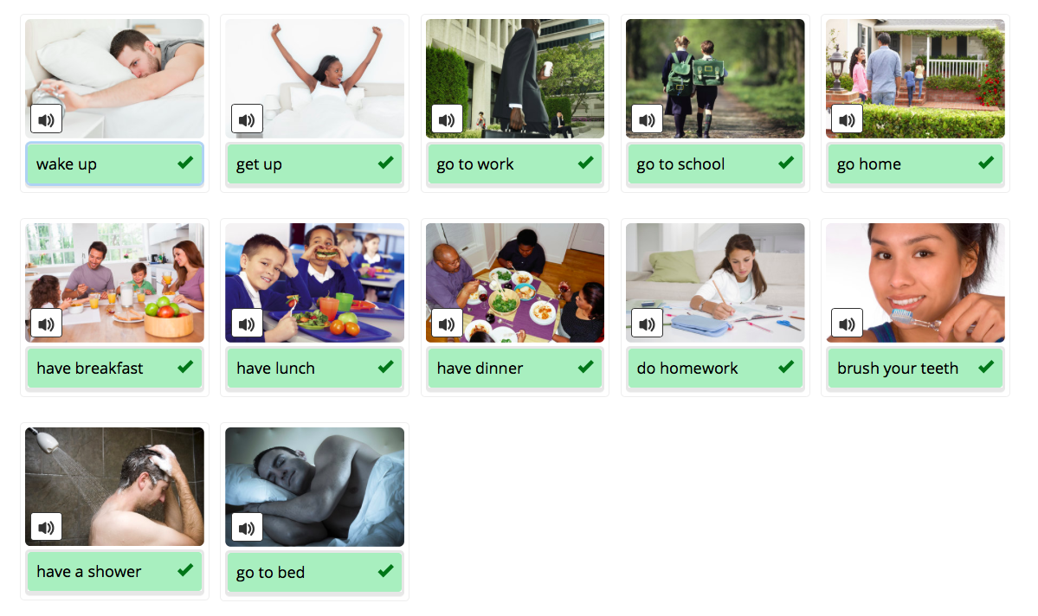
Exercise 3
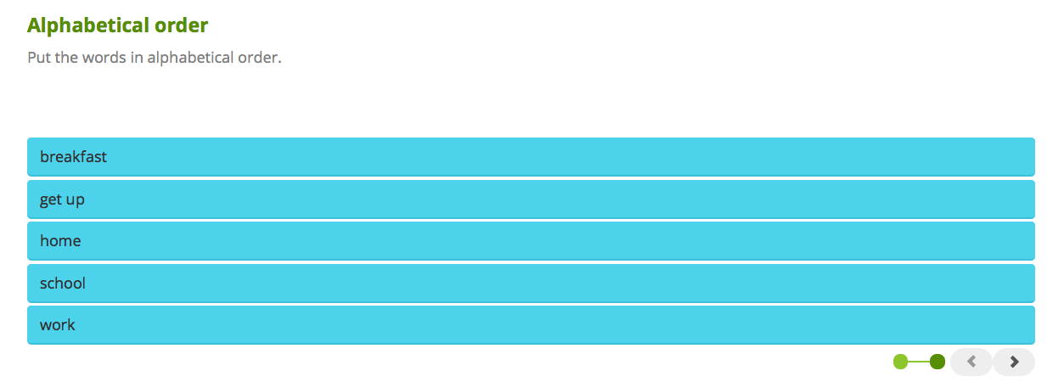
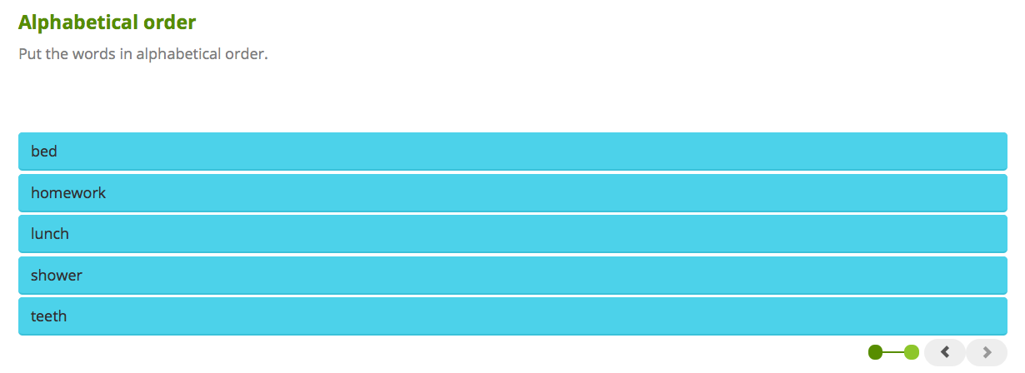
Exercise 4
- brush you teeth
- do homework
- get up
- go home
- go to bed
- go to school
- have a shower
- have breakfast
- have dinner
- have lunch
- wake up
- go to work

Exercise 5
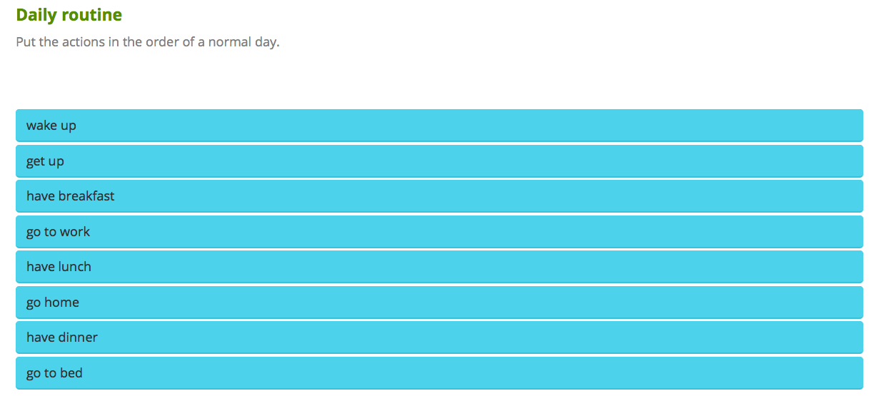
Exercise 6
1. I usually wake up at 6 a.m. when my alarm clock goes off.

2. I usually have lunch at 12.30 p.m.

3. In my family we usually have dinner at about 6 p.m.

4. Since I live in the city, I often go home by bus.

5. On the weekends, I go to bed later than on weekdays.

6. On Sunday I don't get up until I wake up, usually at about 8.30 a.m. It's nice to sleep in!

7. I always brush my teeth before I go to bed.

8. On weekdays, I go to work at 8.30 a.m.

