Lesson 11-Recap-Grammar (part2)
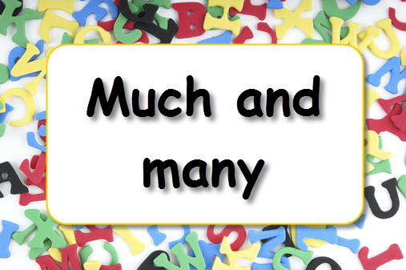
Exercise 1
Exercise 2
Translate into English
Много тетрадей, много молока, много воды, много дней, много газет, много мела, много снега, много лет, много картин, много музыки, много мальчиков, много девочек, много чая, много лимонов, много мяса, много комнат, много учителей, много работы, много воздуха, много птиц, много машин.
Exercise 3
Put much or many (hot potatoes)
1. A don't eat many mangoes.
2. Не eats much fish.
3. She ate so much dessert that she is in bed today with a stomachache.
4. That man drank so much wine, and he smoked so many cigarettes that he has a terrible headache today.
5. Mary must not eat too much salt because she has problems with her blood pressure.
6. My mother says I eat too many French fries and drink too much beer. She wants me to be healthy.
7. There is not too much space in my flat.
8. There are many new pictures in this room.
9. There are many teachers at our school, and many of them are women.
10. many of these plays are quite new.
11. Thanks awfully for the books you sent me yesterday. — Don't mention it, it wasn't much bother.
12. He had many pairs of socks.
13. Please don't put much pepper on the meat.
14. There were many plates on the table.
15. I never eat much bread with soup.
16. Why did you eat so much ice cream?
17. She wrote us many letters from the country.
18. Many of these students don't like to look up words in the dictionary.
19. Much in this work was too difficult for me.
20. Many of their answers were excellent.
21. Much of their conversation was about the university.

Exercise 4 (HOT POTATOES-ВЫПАД СПИСОК)
Put in How much or How many
- … people are coming to the party?
- … milk do you want in your coffee?
- … bread did you buy?
- … players are there in a football team?

Exercise 5
Exercise 6
Put in a little or a few
- Have you got any money? Yes, a little
- Have you got any envelopes? Yes, a few
- Do you want sugar in your coffee? Yes, a little, please
- Did you take any photographs when you were on holiday? Yes, a few
- Dose you friend speak English? Yes, a little
- Are there any factories in this town? Yes, a few

Exercise 7
Put in few, a few, little, a little
- There are few hotels in this town. There is almost nowhere to stay for the tourists.
- Have you got a few minutes? I need to talk to you.
- Could you buy a few bottles of water for me?
- We had a little snow last winter. We made snowmen.
- We have few tomatoes, we can't cook tomato-soup.
- The professor spends little time in company. He likes to be alone.
- They have little furniture in the room. The room is almost empty.
- I want to eat a little I’m hungry.
- We saw a few people at the restaurant because the prices there were very high.
- This is a modern town. There are only a few old buildings.
Exercise 8

Put in some, any, much, many, a little, a few

- There aren’t many car parks in the centre of Oxford
- Eating out is expensive here. There aren’t any cheap restaurants
- Hurry up! We only have a little time before the coach leaves
- We saw some beautiful scenery when we went to Austria
- There are a few shops near the university
- It’s very quiet. There aren’t many people here today
- There are some expensive new flats next to the river

