I. Read the sentences and guess the words.
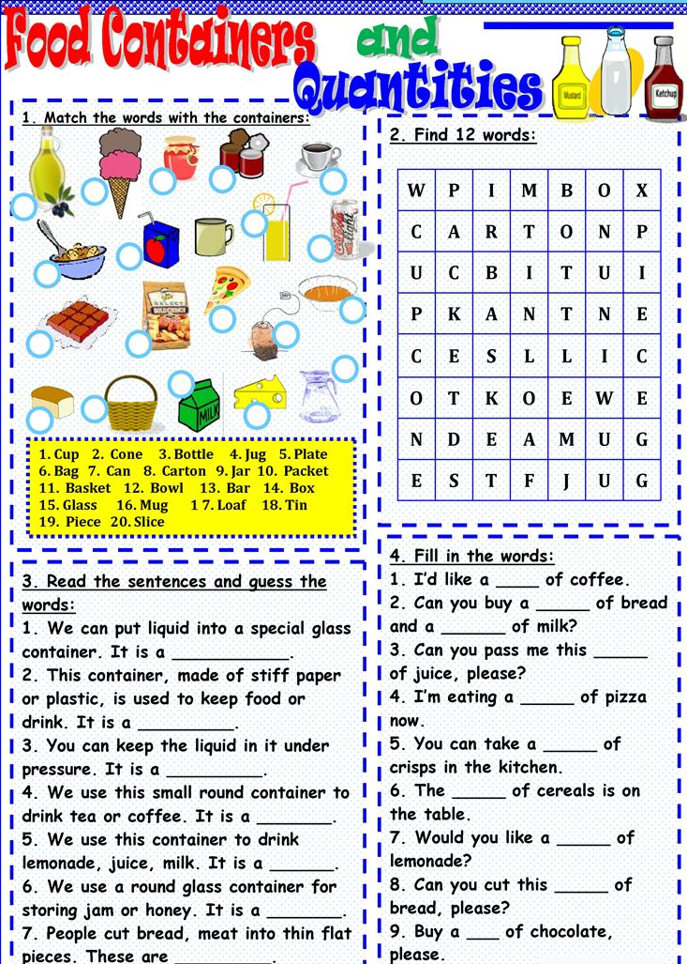

II. Read the text and answer the questions.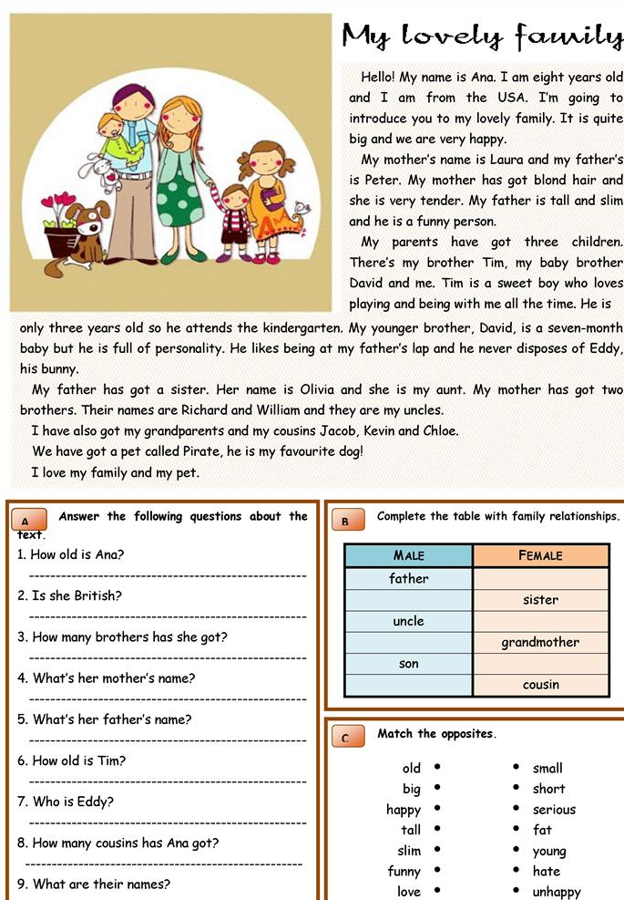

III. Read the text and answer the questions.
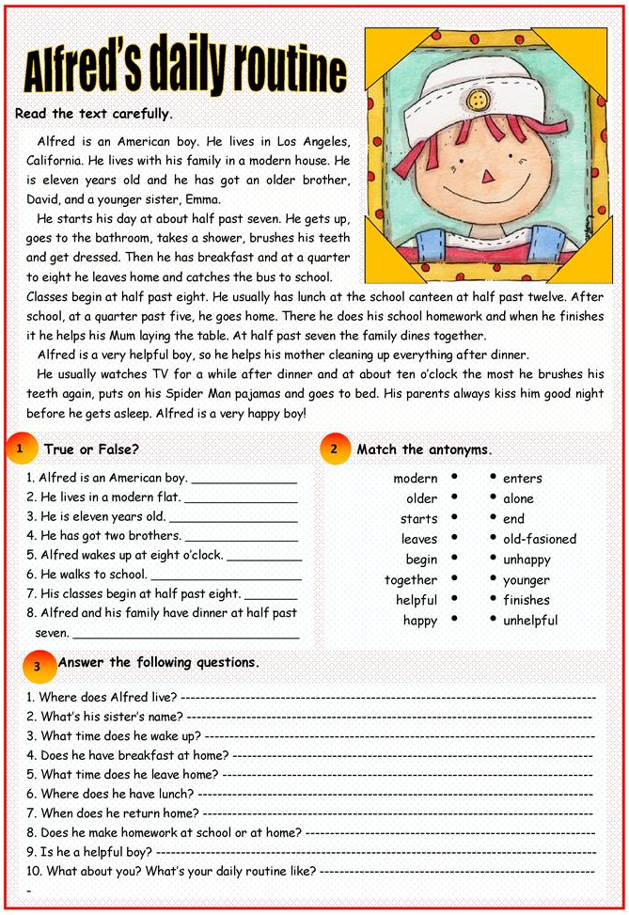
IV. Read and translate the text.
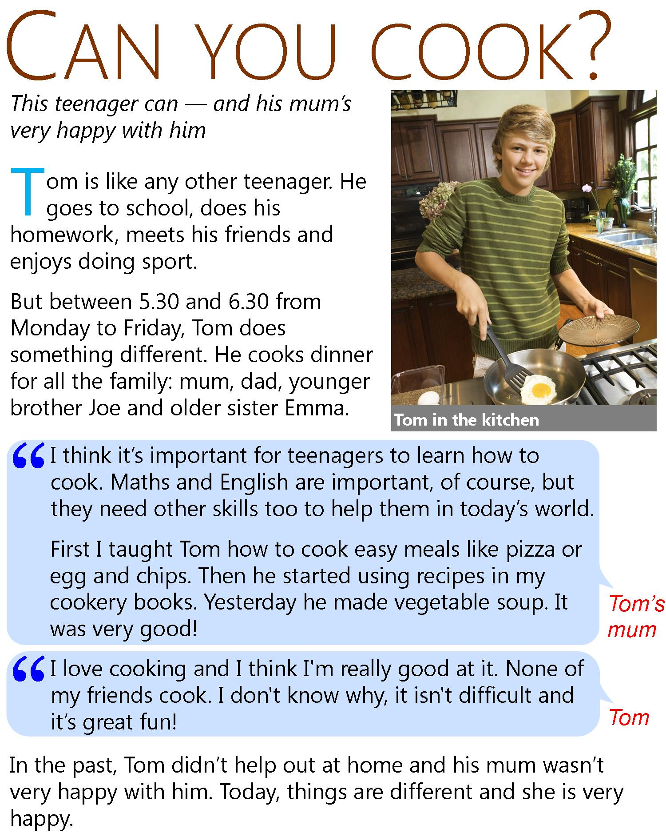

VI. Choose the meaning of the word in CAPITALS in these sentences from the reading text above.
http://gamedata.britishcouncil.org/lep25_embed/MTk5MTI=/teens

VII. Are the sentences true or false?
http://gamedata.britishcouncil.org/lep25_embed/MTk5MTE=/teens

VIII. Fill the gaps with the correct word from the box.
http://gamedata.britishcouncil.org/lep25_embed/MTk5MTA=/teens

