Let’s practice all the words we have already learnt

Family

Ex.1 Name the relative

1. If I have a baby girl, she'll be my __________.
2. My son calls me __________.
3. My mother is my father's __________.
4. My father is my mother's __________.
5. My father has one sister. She's my __________.
6. My mother has one brother. He's my__________.
7. My grandfather is married to my __________.
8. My grandparents call me their __________.
9. My aunt's husband is my __________.
10. My sister is married. Her husband is my __________.
11. My sister has two children, boy and a girl... son is my and her daughter is my __________.
12. My uncle and aunt's children are my __________.
13. When / get married, my partner's mother will be my __________,
14. My father has remarried. His new wife is my __________.
15. When I break. up with my boyfriend (girlfriend), (s)he'll be my __________.

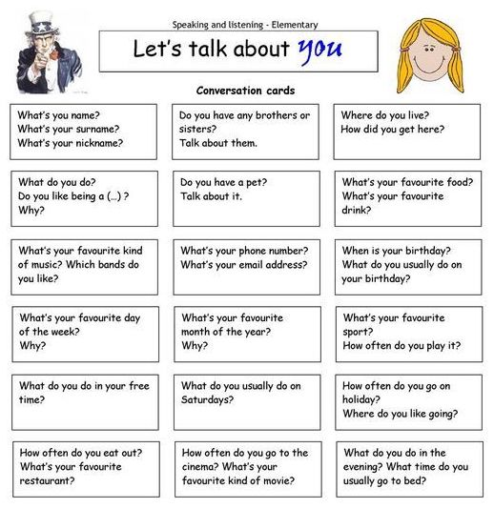
Ex.2 Choose any 5 questions and discuss

Daily activities

Ex.3
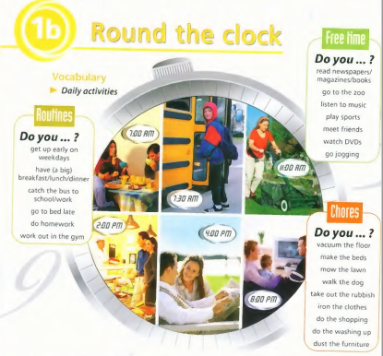

- Which of the activities above do you rarely/often/sometimes/usually/always do?
- Which do you do every day/ morning/afternoon/once/twice a week?
- Which do you do at weekends?
- What is a typical day for you? Use time phrases to write down your daily routine.

Ex.4 What type of person are you? Do the quiz to find out.

Are you a party animal or a home bird?

- A classmate is having a party on Saturday. What are you going to do?
- You are going to stay in. There’s a great film on TV!
- You are going to go, but you are not crazy about the idea.
- You are definitely going to go. You can’t wait!
- You’re going to a wedding and you don’t know many people. How do you feel?
- Horrible. You really don’t want to go.
- A bit nervous, but you are going to try to be sociable.
- Great! You love meeting new people!
- Your parents are going away this weekend. What are you going to do?
- You are going to rent DVDs and relaх at home.
- Your friends are coming over and you are having a barbecue in the garden.
- You’re going dancing with friends.
- Your friend calls to invite you out for coffee but you’re comfortable on the sofa and a little bit tired. What are you going to do?
- You are not moving. You really don’t want to go out!
- You are going to invite your friend over. You can have a coffee at home!
- You are going!

Your score:
Mostly As: Just because you like staying in, it doesn’t mean you can’t have company. Share your sofa with friends some time or go out for cosy meal!

Mostly Bs: You are friendly and popular, but sometimes you just want to stay at home. Good for you! You don’t always have to go out to have a good time.

Mostly Cs: You are the life and soul of the party and everyone’s best friend. Just be careful not to tire yourself out. Why not relax at home once in a while or invite friends over to your house.

Food

Ex.5 Discuss

- What are the most popular foods/dishes in our country? How do you make them?
- Can you cook well? If yes, what food do you cook the most often?
- Did you eat lunch today? What did you eat?
- Do you always eat dinner with your family?
- Do you always eat vegetables?
- Do you eat breakfast every day?
- What food can’t you live without?
- Do you like to eat junk food?
- Do you prefer fish or meat?
- Do you prefer to eat at a restaurant or at home?

