Lesson 12-Test-Grammar (part 2)
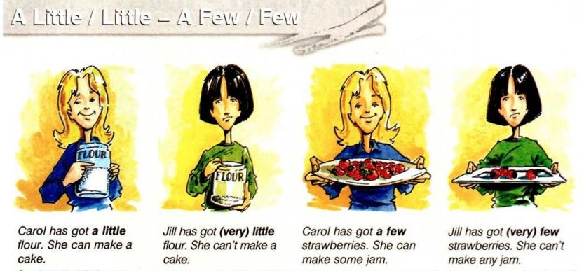

Exercise 1
Translate into English
Мало домов, мало чая, мало чашек, мало яблок, мало окон, мало бумаги, мало кофе, мало статей, мало радости, мало супу, мало деревьев, мало травы, мало детей, мало игрушек, мало света, мало парт, мало колбасы, мало сока, мало книг, мало цветов, мало соли, мало друзей, мало дворцов.
Exercise 2
Translate into English
Немного денег, мало денег, несколько стульев, мало стульев, несколько песен, мало песен, немного веселья, мало веселья, мало мальчиков, немного воды, несколько человек, мало воды, мало воздуха, мало столов, несколько минут, несколько кошек, мало травы, немного удачи, несколько дней, мало работы, немного соли, несколько ложек, мало света, мало окон, несколько машин, немного сахару, мало яиц, мало сыра.
Exercise 3 (hot potatoes-выпадающий список)
Put little, a little, few, a few
1. There is ... salad left in this bowl.
2. Would you like ... salad? — Yes, thank you. My doctor says it's good for my health.
3. I have ... money, so we can go to the cinema.
4. I have ... money, so we cannot go to the cinema.
5. This girl works very ... , that's why she knows nothing.
6. Mother gave us ... apples, and we were glad.
7. He did not like it at the camp: he had very ... friends there.
8. This lemon drink is sour; if you put ... sugar in it, it will be sweeter.
9. This lemon drink is sour; if you put ... lumps of sugar in it, it will be sweeter.
10. The hall was almost empty: there were very ... people in it.

Exercise 4
Choose the correct answer

http://englishtests.ucoz.com/GrammarTests/lexical-test-little-few-.htm

Exercise 5 (HOT POTATOES)
Choose the correct answer (ВЫПАДАЮЩИЙ СПИСОК few/a few/fewer/little/a little)
- I suppose she has … choice
- I saw … interesting films last week.
- … recent films have been screened
- He’s got … time. He can play football.
- I’m sorry, I’m going to be … minutes later
- We’ve got … coffee. It’s not enough for all of us.
- There’s always … snow at this time of the year
- There are … sweets in the box. It’s almost empty.
- I would like … biscuits to drink with tea.

Exercise 6
Correct the mistakes

- There is very few soup in the bowl
- How much carrots are there in the fridge?
- Rita has got many money
- There are a little people in the shop
- Mike hasn’t got much friends
- There is few snow on the mountains
- How much deer can you see in the picture?
- I have got little CDs but a lot of cassettes
- There are much animals in the zoo
- How many sugar is there in the bowl?

Exercise 7
Put in a little or a few+ one of these words
air, chairs, days, friends, letters, milk, Russian, times

- Last night I wrote … to my family and friends
- Can I have … in my coffee, please?
- When did Julia go away? … ago
- Do you speak any foreign languages? I can speak…
- Are you going out alone? No, I am going with …
- Have you ever been to Rome? Yes,…
- There was not much furniture in the room-just a table and …
- I’m going out for a walk. I need … fresh…

Exercise 8 (HOT POTATOES-ВЫПАДАЮЩИЙ СПИСОК little/a little/few/a few)
Put in little/a little/few/a few

- There was … food in the fridge. It was nearly empty.
- When did Sarah go out? … minutes ago
- I can’t decide now. I need … time to think about it
- There was … traffic, so we arrived earlier than we expected
- The bus service isn’t very good at night-there are … buses after 9 o’clock
- Would you like some soup? Yes, …, please
- I’d like to practice my English more but I have … opportunity.

