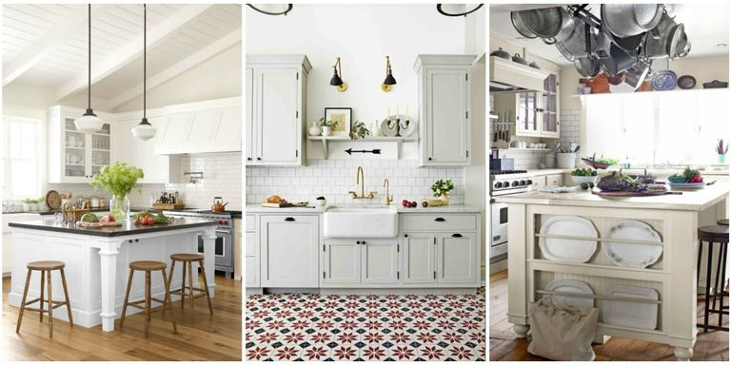

Ex 1 Look at the words and translate them into Russian https://quizlet.com/305809832/english-basic-lesson-13-in-the-kitchen-flash-cards/?new

Ex 2 Choose whether the sentence true or false
1 I use a frying pan to drink out of. False
2 Washing-up liquids make the dishes clean. True
3 The fridge is cold inside. True
4 The freezer is not as cold as the fridge. False
5 I turn on the tap to get water. True
6 A tea towel is for making plates wet. False

Ex 3 Complete the sentences using vocabulary from the Ex 1

fridge microwave cupboard wastebin sink
shelf freezer washing mashing frying pan
- Put the milk in the ... fridge
- Put those dirty clothes in the … washing mashing
- Put the dirty plates in the … sink
- Put the cups and … cupboard
- Put the books on the … shelf
- Put the empty packets in the … wastebin
- Cook the eggs in the … frying pan
- Put the ice cream in the … freezer
- Heat the soup in the … microwave

Ex 4 Look at the words and translate them into Russian
https://quizlet.com/305812450/english-basic-lesson-13-in-the-kitchen-part-12-flash-cards/?new

Ex 5 What is the woman doing on the picture?
making a sandwich
doing the washing up
doing the shopping
doing the ironing
cooking lunch for family
putting the shopping away
taking the washing out of the washing machine
emptying the wastebin
cleaning the cooker
putting the dirty clothes in the washing mashing

She is …

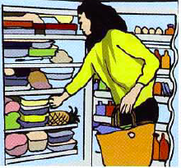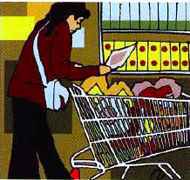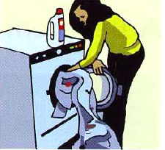
putting the shopping away doing the shopping putting the dirty clothes in the washing mashing
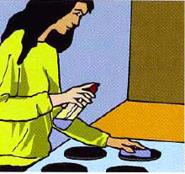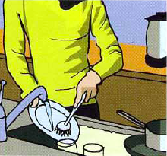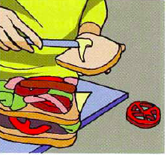
cleaning the cooker doing the washing up making a sandwich

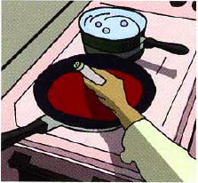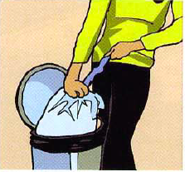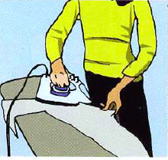
cooking lunch for family emptying the wastebin doing the ironing

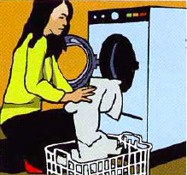
taking the washing out of the washing machine

Ex 6 Complete the text.
Saturday is my day for doing the housework. First, I go to town and do the shopping. Then I come back, put everything away in the cupboards, and empty the bin. If the kitchen's dirty, I clean it, and then I make a cup of tea. My sister usually helps me. She puts all the dirty clothes in the washing machine and takes the washing out when it's finished. I cook lunch, but afterwards, we do the washing-up together. When the clothes are dry, I do the ironing.

Ex 7 Answer the questions.
In your home …
1 Who does the shopping?
2 Who cooks the dinner?
3 Who does the washing-up?
4 Who cleans the kitchen?
5 Who empties the bin?
6 Who does the ironing?

PDF

Ex 1 Look at the words and translate them into Russian https://quizlet.com/305809832/english-basic-lesson-13-in-the-kitchen-flash-cards/?new

Ex 2 Choose whether the sentence true or false
1 I use a frying pan to drink out of.
2 Washing-up liquids make the dishes clean.
3 The fridge is cold inside.
4 The freezer is not as cold as the fridge.
5 I turn on the tap to get water.
6 A tea towel is for making plates wet.

Ex 3 Complete the sentences using vocabulary from the Ex 1

fridge microwave cupboard wastebin sink
shelf freezer washing mashing frying pan
- Put the milk in the ...
- Put those dirty clothes in the …
- Put the dirty plates in the …
- Put the cups and …
- Put the books on the …
- Put the empty packets in the …
- Cook the eggs in the
- Put the ice cream in the
- Heat the soup in the

Ex 4 Look at the words and translate them into Russian
https://quizlet.com/305812450/english-basic-lesson-13-in-the-kitchen-part-12-flash-cards/?new

Ex 5 What is the woman doing on the picture?
making a sandwich
doing the washing up
doing the shopping
doing the ironing
cooking lunch for family
putting the shopping away
taking the washing out of the washing machine
emptying the wastebin
cleaning the cooker
putting the dirty clothes in the washing maching

She is …

Ex 6 Complete the text.
Saturday is my day for doing the …. First, I go to town and do the … Then I come back, … everything … in the cupboards, and … the bin. If the kitchen's dirty, I … it, and then I … a cup of tea. My sister usually helps me. She … all the dirty clothes in the washing machine and … the washing out when it's finished. I … lunch, but afterwards, we do the …-… together. When the clothes are dry, I do the …

Ex 7 Answer the questions.
In your home …
1 Who does the shopping?
2 Who cooks the dinner?
3 Who does the washing-up?
4 Who cleans the kitchen?
5 Who empties the bin?
6 Who does the ironing?

