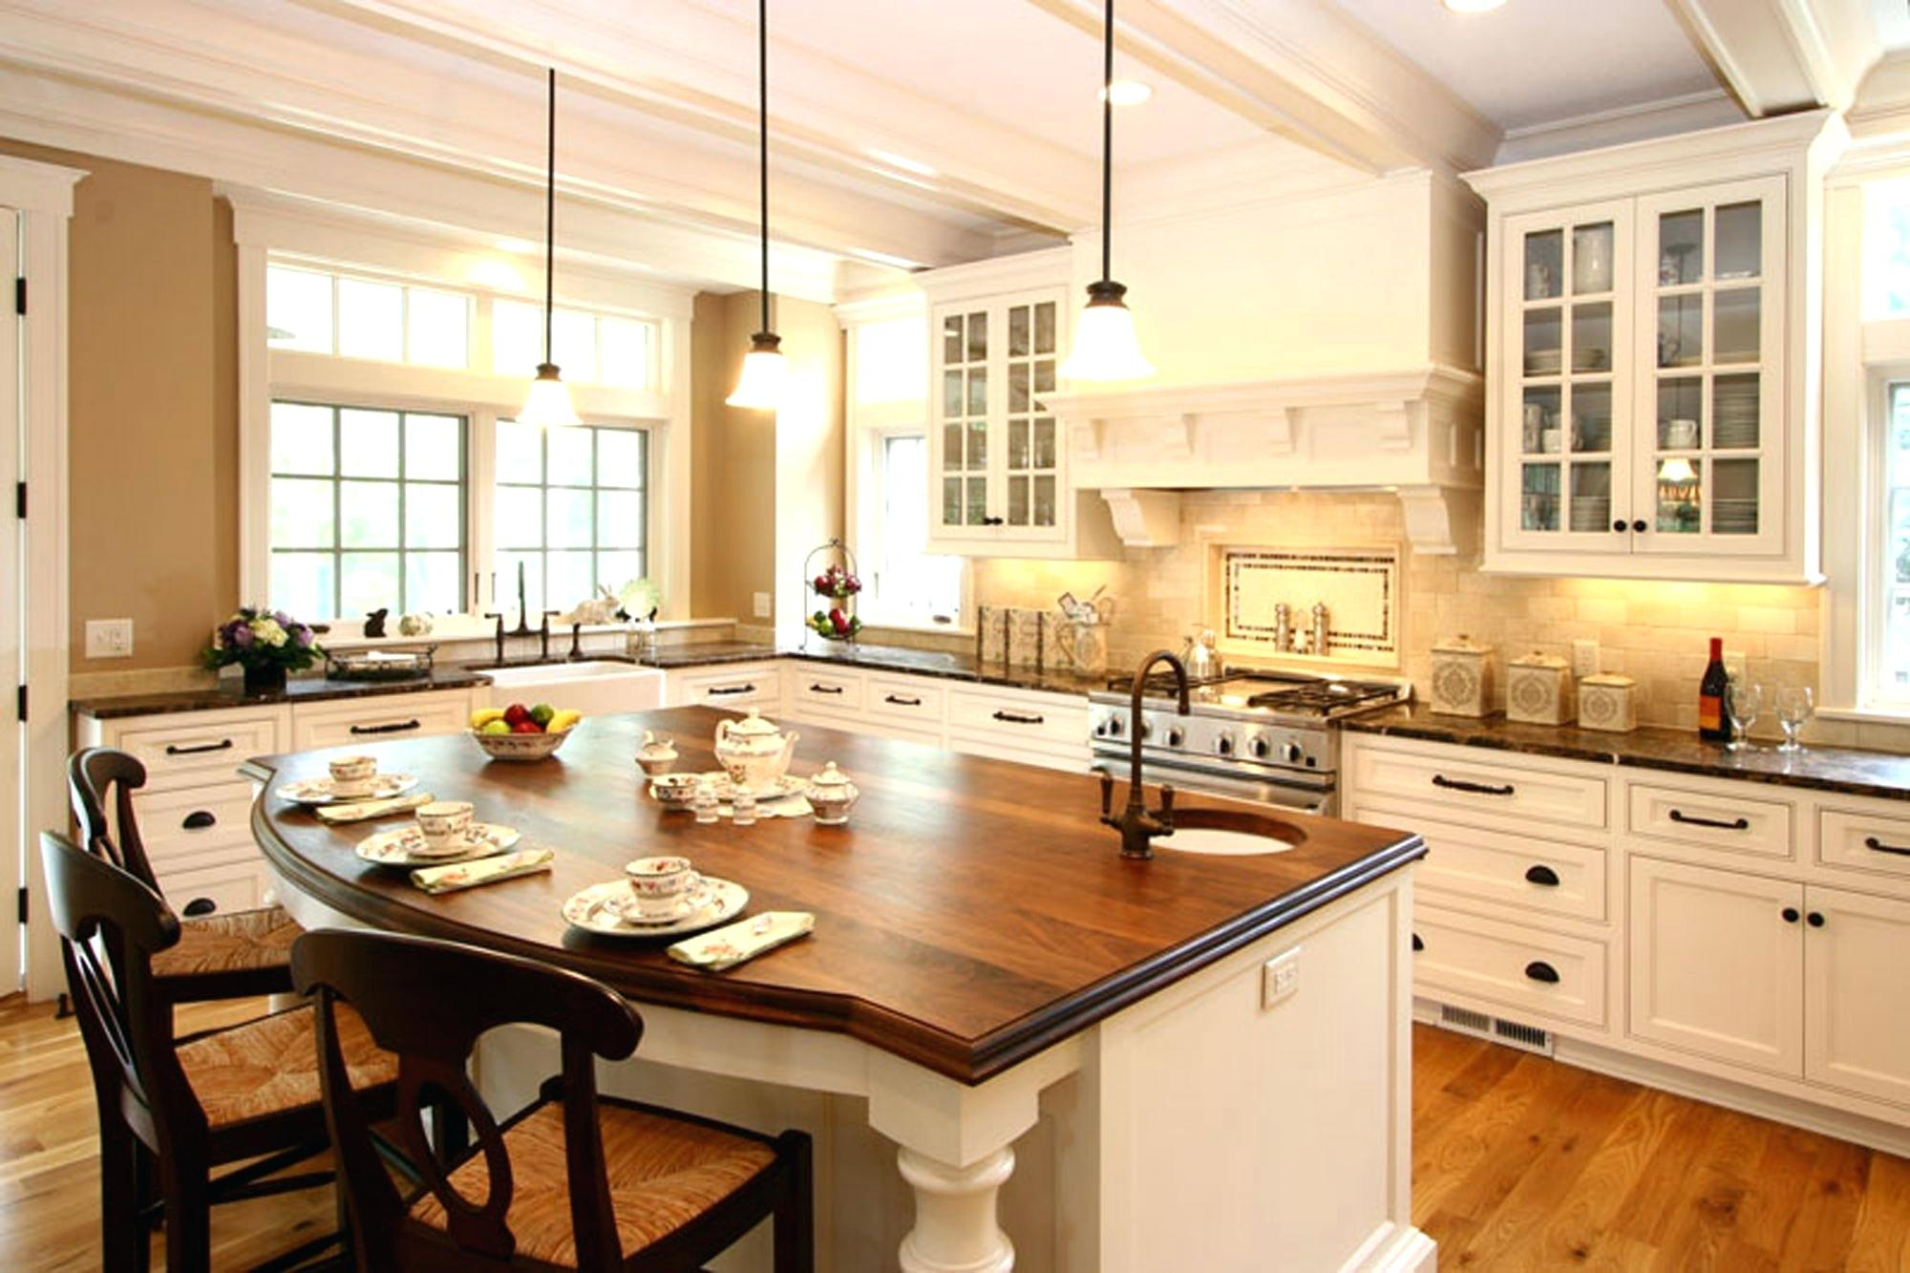

Look at these tables
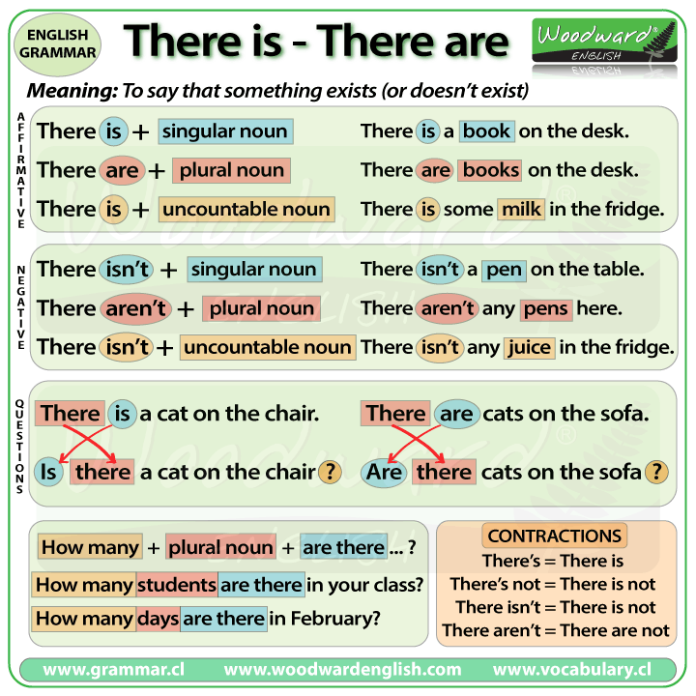
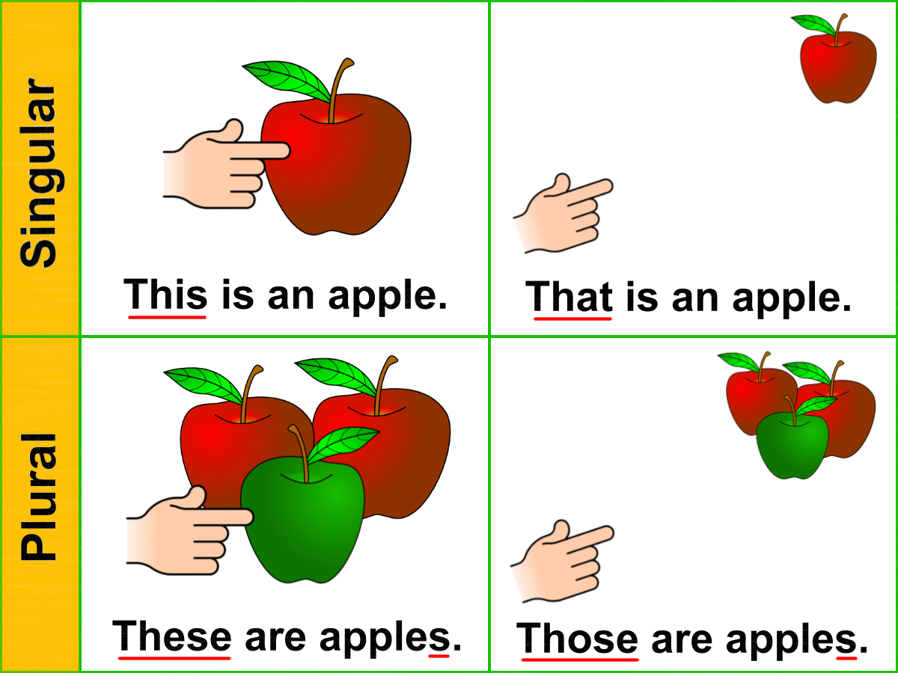

Task 1
Choose the correct variant
- ______ too much cheese on the sandwich.
  - There is
  - There are
- ______ four eggs in the refrigerator.
  - There is
  - There are
- ______ a lot of salt in this sauce.
  - There is
  - There are
- ______ four cans of soup on the shelf.
  - There are
  - There is
- ______ a lot of tea in the cup.
  - There are
  - There is
- ______ some peanuts in the jar.
  - There is
  - There are
- ______ two cups of sugar in the cookie recipe.
  - There is
  - There are
- ______ five potatoes in the bag.
  - There is
  - There are
- ______ a pound of spaghetti in the cabinet.
  - There are
  - There is
- ______ a red pepper in the salad.
  - There is
  - There are

Task 2
Complete the sentences using "Is there" or "Are there","there isn't" or "there aren't" .
1. … an opera in our city?
2. … many girls in your class?
3. … a police-station near the hospital?
4. … any bananas in the basket?
5. … trees in the park?
6. … many people in the streets.
7. … any butter in te fridge.
8. … any plates on the table.
9. … any milk in the bottle.
10. … any coffee in the cup.

Task 3
Choose the correct word.
- this /these shoes
- this / these trousers
- this / these socks
- this / these shorts
- this / these trainers
- this / these hat
- this / these dress
- this / these blouse
- this / these skirt
- this / these scarf
- this / these boots
- this / these tights

Task 4
Choose the correct variant.
- This __________ is easy.
a) questions b) homework
- These ___________ are my neighbors.
a) women b) man
- What are you doing ________ afternoon?
a) that b) this
- Who's ________ speaking?
a) this b) it
- These are my glasses and ________ are hers.
a) those b) that
- We are going to the seaside __________ summer.
b) this a) that
- __________ man over there is a famous politician.
b) These a) That

Task 5
Complete the sentences with this, that, these, those.
- Could you pass me … dictionary beside you?
- … jeans over there are quite cheap.
- … apples are much sweeter that those ones.
- Look here! Do you like … ring?
- Do you know … woman in black over there?
- … shoes are very tight. I must take them off.
- How much are … teddy-bears in the shop-window?
- … tower looks so small because it’s far away.
- … dolphins we saw in the sea were so funny.
- … ice-cream I am eating is my favourite.

Task 6
Choose the correct pronoun
1. __ book is very expensive.
a) This
b) These
2. __ dog is small.
a) That
b) Those
3. __ pencils are blue.
a) This
b) These
4. __ film is funny.
a) That
b) Those
5. __ cars are very big.
a) That
b) Those
6. __ morning is perfect for jogging.
a) This
b) These
7. __ bicycle is not expensive.
a) That
b) Those
8. __ chocolate is delicious.
a) This
b) These
9.__ kids are cold.
a) That
b) Those
10. __ food is not healthy.
a) This
b) These

ANSWERS
Task 1
Choose the correct variant
- ______ too much cheese on the sandwich.
  - There is
  - There are
- ______ four eggs in the refrigerator.
  - There is
  - There are
- ______ a lot of salt in this sauce.
  - There is
  - There are
- ______ four cans of soup on the shelf.
  - There are
  - There is
- ______ a lot of tea in the cup.
  - There are
  - There is
- ______ some peanuts in the jar.
  - There is
  - There are
- ______ two cups of sugar in the cookie recipe.
  - There is
  - There are
- ______ five potatoes in the bag.
  - There is
  - There are
- ______ a pound of spaghetti in the cabinet.
  - There are
  - There is
- ______ a red pepper in the salad.
  - There is
  - There are

Task 2
Complete the sentences using "Is there" or "Are there","there isn't" or "there aren't" .
1. Is there an opera in our city?
2. Are there many girls in your class?
3. Is there a police-station near the hospital?
4. Are there any bananas in the basket?
5. Are there trees in the park?
6. There aren't many people in the streets.
7. There isn't any butter in te fridge.
8. There aren't any plates on the table.
9. There isn't any milk in the bottle.
10. There isn't any coffee in the cup.

Task 3
Choose the correct word.
- this /these shoes
- this / these trousers
- this / these socks
- this / these shorts
- this / these trainers
- this / these hat
- this / these dress
- this / these blouse
- this / these skirt
- this / these scarf
- this / these boots
- this / these tights

Task 4
Choose the correct variant.
- This __________ is easy.
a) questions b) homework
- These ___________ are my neighbors.
a) women b) man
- What are you doing ________ afternoon?
a) that b) this
- Who's ________ speaking?
a) this b) it
- These are my glasses and ________ are hers.
a) those b) that
- We are going to the seaside __________ summer.
a) this b) that
- __________ man over there is a famous politician.
a) These b) That

Task 5
Complete the sentences with this, that, these, those.
- Could you pass me that dictionary beside you?
- Those jeans over there are quite cheap.
- These apples are much sweeter that those ones.
- Look here! Do you like this ring?
- Do you know that woman in black over there?
- These shoes are very tight. I must take them off.
- How much are those teddy-bears in the shop-window?
- That tower looks so small because it’s far away.
- Those dolphins we saw in the sea were so funny.
- This ice-cream I am eating is my favourite.

Task 6
Choose the correct variant
1. __ book is very expensive.
a) This
b) These
2. __ dog is small.
a) That
b) Those
3. __ pencils are blue.
a) This
b) These
4. __ film is funny.
a) That
b) Those
5. __ cars are very big.
a) That
b) Those
6. __ morning is perfect for jogging.
a) This
b) These
7. __ bicycle is not expensive.
a) That
b) Those
8. __ chocolate is delicious.
a) This
b) These
9.__ kids are cold.
a) That
b) Those
10. __ food is not healthy.
a) This
b) These

