Pre – listening exercise 1. Match the picture with the correct word.
https://www.youtube.com/watch?v=bw6E7108sG0

- bedroom
- kitchen
- closet
- bathroom
- basement
- workshop
- storage
- furniture
- backyard

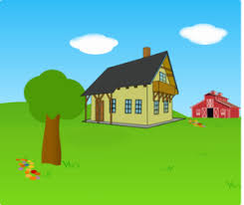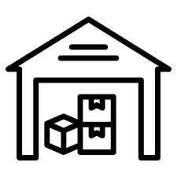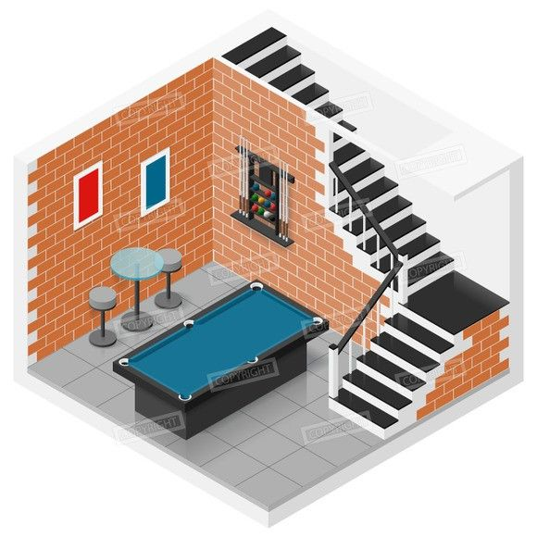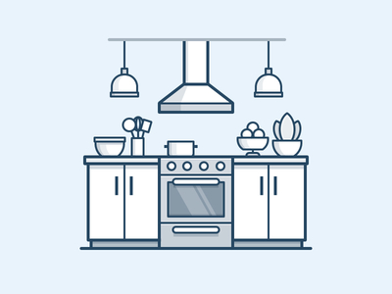

Listen to the first part of the video and answer the questions

1.How many bedrooms does the house have?
- One
- Two
- None
2. Who cooks dinner every night?
- Mom and dad
- The boy
- The dog
3. What does Dad have in the basement
- A workshop
- A study
- A storage
What does Dad make?
- Mistakes
- Wood toys
- Wood furniture
What is in the backyard
- A maple tree,
- A vegetable garden
- A swimming pool
- All of the above

Pre – listening exercise 2. Match the word with the it’s definition.

- (of a building) having two floors or levels;
- a structure through which smoke or steam is carried up away from fire;
- a tough material for building houses;
- a piece of cloth that is hung to cover a window;
- one or two beds that are fixed together, one above the other;
- a place for relaxation and rest;
- a place for storage under the house.

- Brick
- Recreation room
- Chimney
- Basement
- Bunk bed
- Two-storey house
- Curtains

Listen to the first part of the video and answer the questions
https://www.youtube.com/watch?v=ZYF_NtMWHZw

- What is the upper part of the house made of?
- Red brick
- White brick
- Straw
- Which room is next to the living room?
- The dining room
- The bathroom
- The guest room
- How many bedrooms are there?
- Four
- Two
- Three
- What color is her brothers room?
- Black
- Blue
- Brown
- What is there in the basement?
- The recreation room
- The video room
- Girl’s room

Quizlet link https://quizlet.com/_51q72t

Translate sentences into English
- В моем доме 2 комнаты.
- В моем доме есть кухня
- В моем доме есть большая ванная комната
- В моем доме много шкафов
- В моем доме есть подвал
- Я живу в двухэтажном доме
- Дымоход также сделан из красного кирпича.
- Моя комната покрашена в розовый и на окнах шторы.
- У него в комнате двухъярусная кровать.
- В подвале у нас комната отдыха.

Answer keys

Pre-listening ex. 1 (картинки выставлены в правильном порядке)

- bedroom
- kitchen
- closet
- bathroom
- basement
- workshop
- storage
- furniture
- backyard

Listening ex

1.b
2. a
3. a
4. c
5 d

Pre – listening exercise 2

- f
- c
- a
- g
- e
- b
- d

Listening ex

- a
- a
- c
- b
- a

