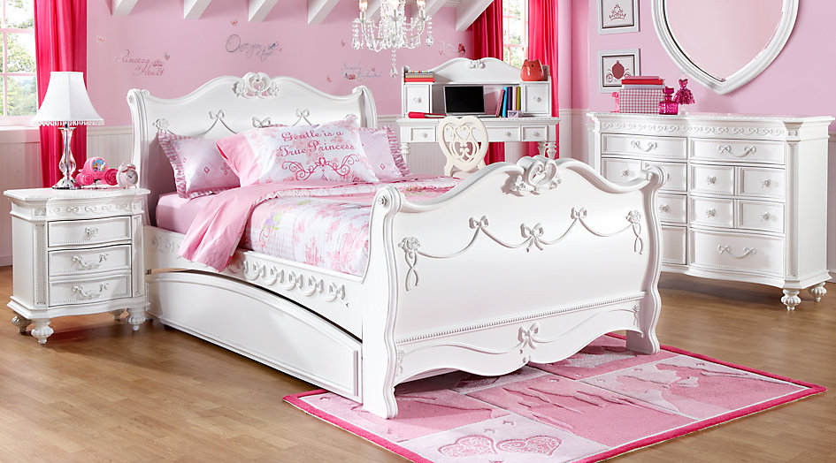

Ex 1 Look at the new words and translate them into Russian
https://quizlet.com/305882854/english-basic-lesson-13-in-the-bedroom-bathroom-flash-cards/?new

Ex 2 Read the text and fill in the gaps

Furnished single bed bedside table chest of drawers wardrobe bath
Washbasin mirror blankets sheets towels
International student house

Our rooms are all newly furnished, and include: a single bed, bedside table, desk and chair, chest of drawers and wardrobe. There are three bathrooms on each floor: each has a bath, shower, washbasin, mirror, toilet, and bidet.
We provide blankets, but students must bring their own sheets and towels.

Ex 3 Circle the correct word.
1 I do/put on my hair with a razor/a brush.
2 Do you have/do a bath every day?
3 She puts on/has make-up when she goes out.
4 Do you often have a shave/wash with an electric razor?
5 He washes/cleans his hair with expensive perfume/shampoo .
6 When you take off make-up you use tissues/a comb.

Ex 4 Write a, an or nothing (-).
1 I don't use (-) make-up.
2 I need A new comb
2 Do you want A tissue?
3 I never use (-) perfume.
4 I must buy A brush.
5 I buy (-)shampoo every week.
6 Have you got AN electric razor?
7 I just use (-)soap
8 I need A new toothbrush and (-)toothpaste.

Ex 5. Name the things, which you can see in the picture.

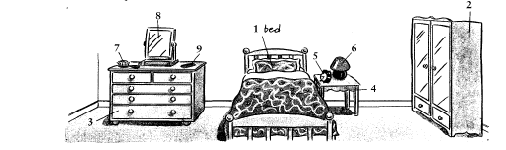

PDF

Ex 1 Look at the new words and translate them into Russian
https://quizlet.com/305882854/english-basic-lesson-13-in-the-bedroom-bathroom-flash-cards/?new

Ex 2 Read the text and fill in the gaps

Furnished single bed bedside table chest of drawers wardrobe bath
Washbasin mirror blankets sheets towels
International student house

Our rooms are all newly … , and include: a …, …, desk and chair, … and …. There are three bathrooms on each floor: each has a …, shower, …, …, toilet, and bidet.
We provide …, but students must bring their own … and ….

Ex 3 Circle the correct word.
1 I do/put on my hair with a razor/a brush.
2 Do you have/do a bath every day?
3 She puts on/has make-up when she goes out.
4 Do you often have a shave/wash with an electric razor?
5 He washes/cleans his hair with expensive perfume/shampoo
6 When you take off make-up you use tissues/a comb.

Ex 4 Write a, an or nothing (-).
1 I don't use … make-up.
2 I need .. new comb
2 Do you want … tissue?
3 I never use … perfume.
4 I must buy … brush.
5 I buy … shampoo every week.
6 Have you got … electric razor?
7 I just use … soap
8 I need … new toothbrush and … toothpaste.

Ex 5. Name the things which you can see in the picture.

