Task 1
Watch the video about Past Simple
https://www.youtube.com/watch?time_continue=106&v=dKigBKdOBBY

Task 2
Look at the table
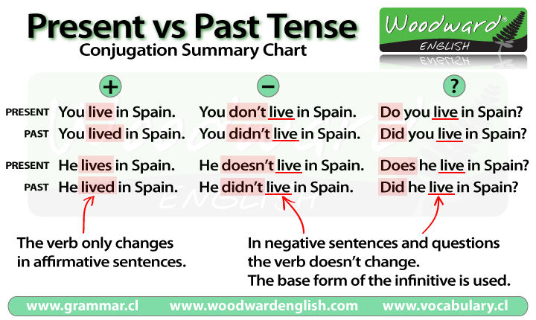

Task 3
Write the past simple of the verb in (brackets) to complete the sentences.
a. Yesterday I _____ to the park. (go)
b. My grandparents _____ us last week. (visit)
c. Last weekend I ______ an email to my friend. (write)
d. My brother ______ any computer games last night. (not play)
e. We ______ cereal and ______ juice for breakfast. (eat, drink)
f. I ______ my favourite TV programme yesterday. (not watch)
g. My friend ______ me a new pencil case for my birthday. (give)
h. Yesterday I ______ to school, I ______ by car. (walk, not go)
Task 4
Choose the correct words to complete the sentences.
- We ____ about the storm on the news.
hear
heard
- They ____ that it was my birthday.
find out
found out
- The waiter ____ us the menu to look at.
bring
brought
- I didn’t ____ very well last night.
sleep
slept
- Did you ____ your coat in the cafe?
leave
left
6. It was so cold that the pipes ____.
freeze
froze
7.She didn’t ____ us what to do for homework.
tell
told
8.He ____ bad about failing the test.
feel
felt

Task 5
Put the irregular verb in the past simple tense to fill the gaps.
1. I ____ (buy) some food for lunch.
2. Who ____ (meet) you at the airport?
3. We all ____ (have) the same idea.
4. ____ (do) you speak to Sophie?
5. I ____ (see) the weather forecast earlier.
6. He ____ (give) us a lift into town.
7. She ____ (read) three books in one week!
8. They ____ (take) a taxi to the hotel

Task 6
Choose the correct answer.
- I _______ yesterday
  - work
  - didn't work
  - did work
- He ______ to work by car yesterday.
  - goes
  - didn't go
  - was go
- What ______ last week?
  - did you do
  - you did
  - do you do
- Three days ago I ____ an accident
  - has
  - didn't had
  - have
  - had
- We _____ our homework
  - didn't do
  - didn't
  - didn't did
  - don't do
- Why _____ to İstanbul?
  - she went
  - did she went
  - did she go
  - she did go
- My mother ____ a cake this morning
  - make
  - made
  - maked
  - making
- _____ a new car last year?
  - did you buy
  - do you buy
  - did you bought
- She _____ three emails to me yesterday
  - writes
  - writed
  - did write
  - wrote
- Where ______ last night?
  - you stayed
  - did you stay
  - does he stay
  - do you stay

ANSWERS
Task 3
Write the past simple of the verb in (brackets) to complete the sentences.
a. Yesterday I went to the park. (go)
b. My grandparents visited us last week. (visit)
c. Last weekend I wrote an email to my friend. (write)
d. My brother did not play any computer games last night. (not play)
e. We ate cereal and drank juice for breakfast. (eat, drink)
f. I did not watch my favourite TV programme yesterday. (not watch)
g. My friend gave me a new pencil case for my birthday. (give)
h. Yesterday I walked to school, I did not go by car. (walk, not go)
Task 4
Choose the correct words to complete the sentences.
- We ____ about the storm on the news.
hear
heard
- They ____ that it was my birthday.
find out
found out
- The waiter ____ us the menu to look at.
bring
brought
- I didn’t ____ very well last night.
sleep
slept
- Did you ____ your coat in the cafe?
leave
left
6. It was so cold that the pipes ____.
freeze
froze
7.She didn’t ____ us what to do for homework.
tell
told
8.He ____ bad about failing the test.
feel
felt

Task 5
Put the irregular verb in the past simple tense to fill the gaps.
1. I bought (buy) some food for lunch.
2. Who met (meet) you at the airport?
3. We all had (have) the same idea.
4. Did (do) you speak to Sophie?
5. I saw (see) the weather forecast earlier.
6. He gave (give) us a lift into town.
7. She read (read) three books in one week!
8. They took (take) a taxi to the hotel

Task 6
Choose the correct answer.
- I _______ yesterday
  - work
  - didn't work
  - did work
- He ______ to work by car yesterday.
  - goes
  - didn't go
  - was go
- What ______ last week?
  - did you do
  - you did
  - do you do
- Three days ago I ____ an accident
  - has
  - didn't had
  - have
  - had
- We _____ our homework
  - didn't do
  - didn't
  - didn't did
  - don't do
- Why _____ to İstanbul?
  - she went
  - did she went
  - did she go
  - she did go
- My mother ____ a cake this morning
  - make
  - made
  - maked
  - making
- _____ a new car last year?
  - did you buy
  - do you buy
  - did you bought
- She _____ three emails to me yesterday
  - writes
  - writed
  - did write
  - wrote
- Where ______ last night?
  - you stayed
  - did you stay
  - does he stay
  - do you stay

