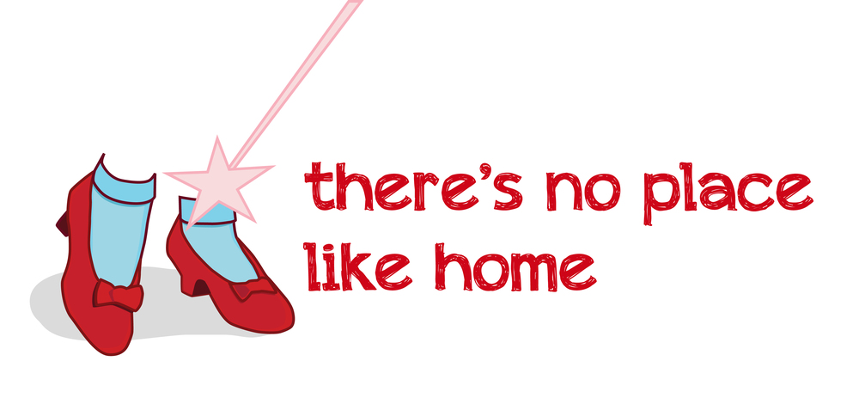

In this lesson you may choose video you want to watch. The first video is the easiest and the two other are more difficult.
Video 1

https://www.youtube.com/watch?v=O07X1XLK4tM

Ex.1 Find the best answer

- When did Anne's family planted the trees?
- last spring
- last noon
- last season
- Which room do the come first into?
- parent’s room
- living room
- bedroom
- Where does she have the rest of the books?
- living room
- parent's room
- study room
- Why did they go to the kitchen
- to have some cupcakes
- to sleep
- to play
- Where is the bathroom?
- next to Anne's room
- in the garden
- there is no such room

Ex.2 Answer the questions

- Do you like Anne's house? Why? Why not?
- Do you have a similar house?
- How many rooms are there in Anne's house? Name them all.
- Which room did you like the most?
- Do your friends come to visit you at home? What do you do together? Where do you spend time in the house with them?

Video 2

https://www.youtube.com/watch?v=VgSsGDfJWMQ

Watch till 1:50

Ex.1 Correct the mistakes in the sentences after watching the video
1. A home is a place where a family lives unhappily together.
2. A small thatched Hut is made out of sand and dried leaves.
3. A wooden cabin, which is completely made out of logs of plastic.
3. A cottage is a two- or three- floor house.
4. A mansion is a place where animals live
5. An apartment complex has many buildings.

Optional task:
Video 3

https://www.youtube.com/watch?v=_bh3qp6WXKg

Ex.1 Match the pictures with the words

A bungalow
A cottage
A terraced house
A semi-detached house
A detached house
An old house
A new house
A large house
A small house
An apartment
A mansion
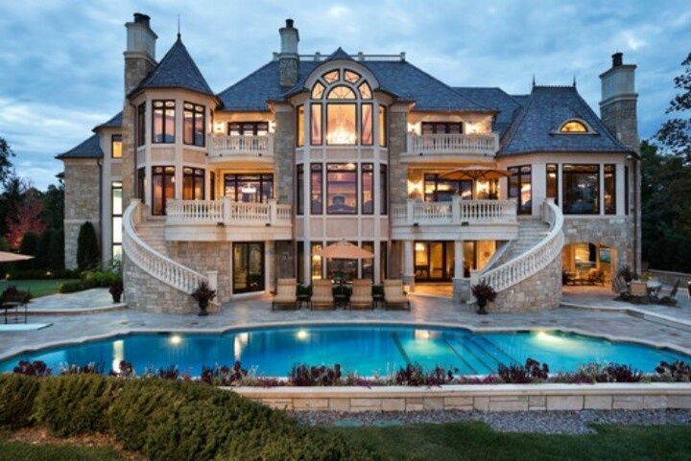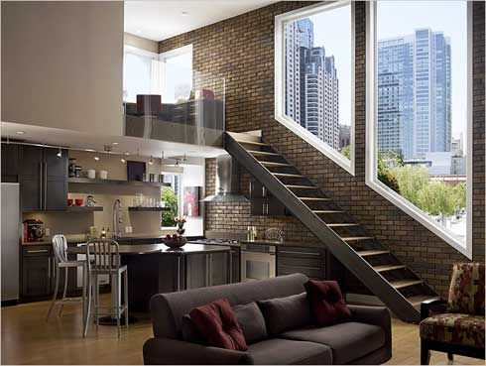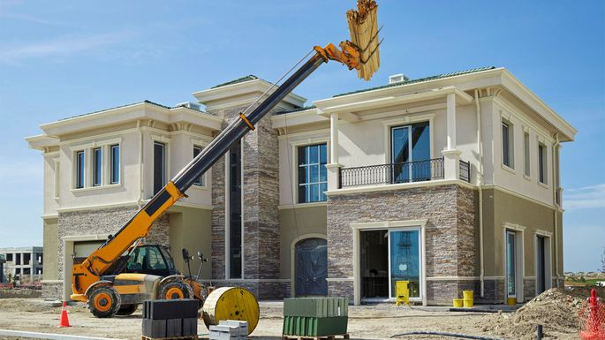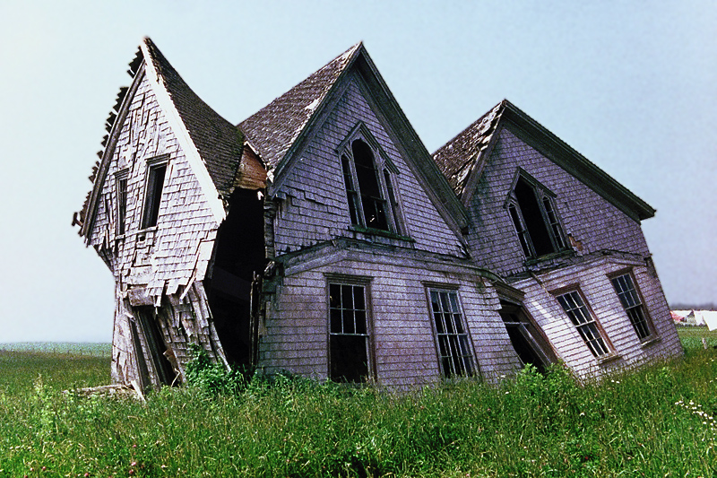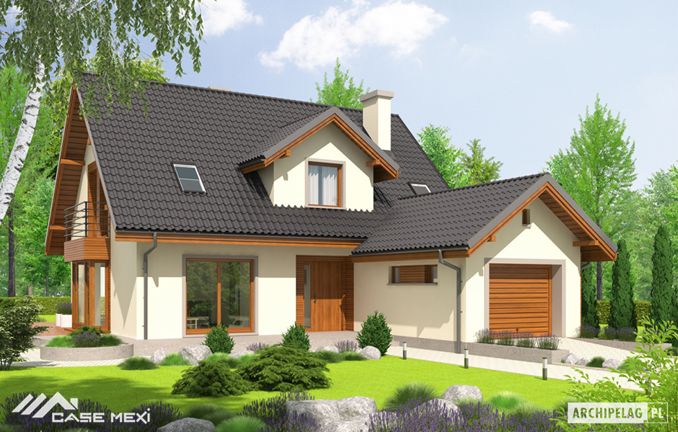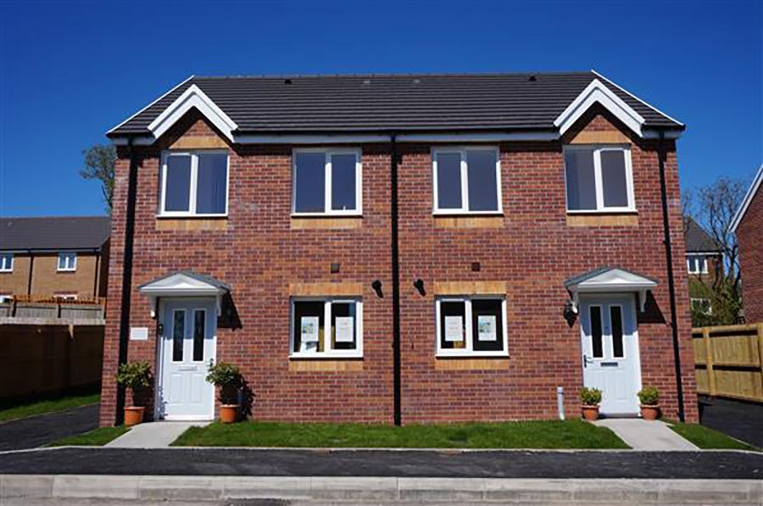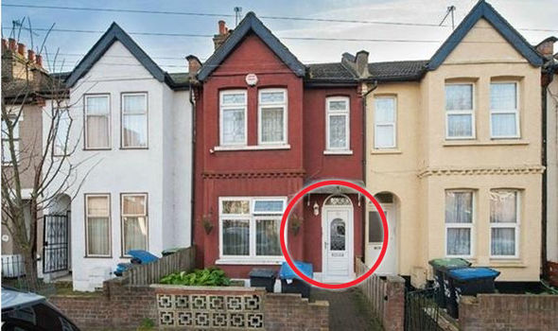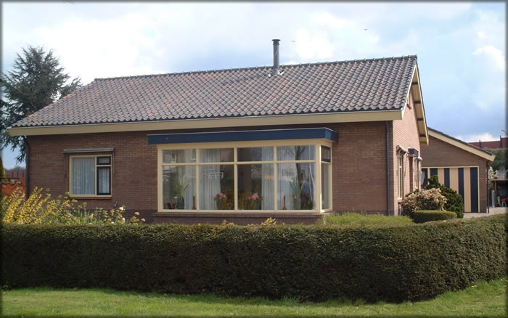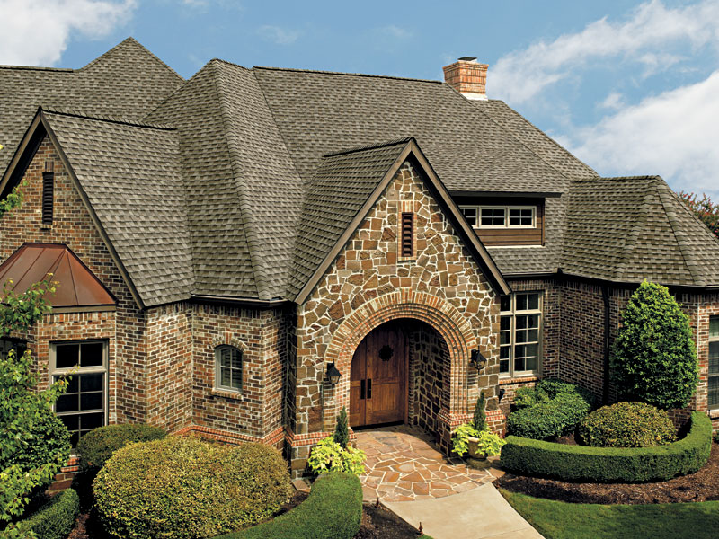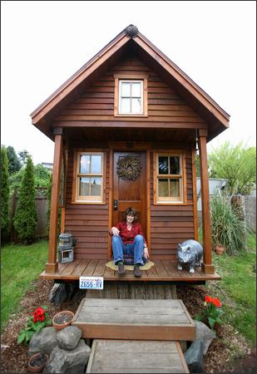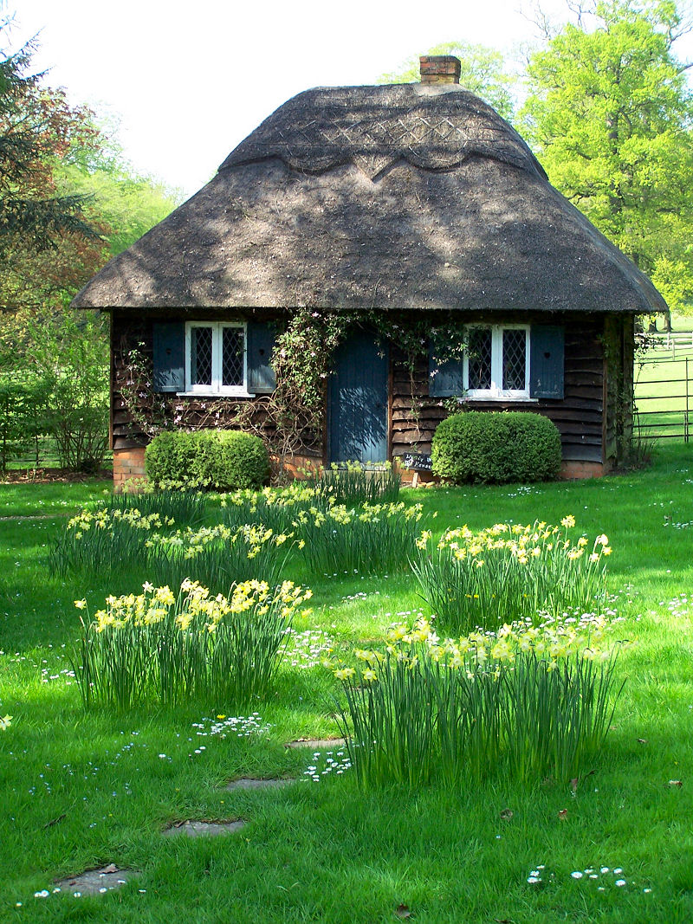

Discuss the video
- How do the most British people live ?
- What are the types of houses in Britain can you live in?
- How does the house look inside?
- What do Robinsons do in the living room?
- What are there in the kitchen?
- Where else can people eat in the house?
- How many floors are there?
- What is July doing?
- What do people have in a bathroom?
- What is a study?

Answer key

Video 1
Ex.1 Find the best answer

- When did Anne's family plant the trees?
- last spring
- last noon
- last season
- Which room do they come first into?
- parent’s room
- living room
- bedroom
- Where does she have the rest of the books?
- living room
- parent's room
- study room
- Why did they go to the kitchen
- to have some cupcakes
- to sleep
- to play
- Where is the bathroom?
- next to Anne's room
- in the garden
- there is no such room

Video 2
Ex.1 Correct the mistakes in the sentences after watching the video
1. A home is a place where a family lives happily together.
2. A small thatched Hut is made out of mud and dried leaves.
3. A wooden cabin, which is completely made out of logs of wood.
3. A cottage is a two- or three- room house.
4. A mansion is a place where people live
5. An apartment complex has many flats/apartments.

Video 3
Ex.1 (картинки стоят в правильном порядке)
A bungalow
A cottage
A terraced house
A semi-detached house
A detached house
An old house
A new house
A large house
A small house
An apartment
A mansion

