Lesson 15-Home-Reading
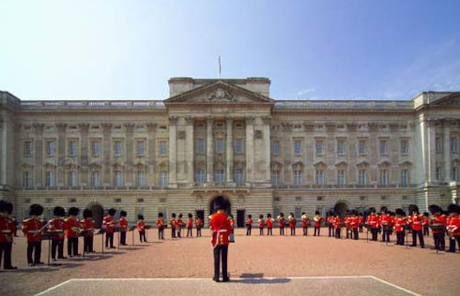
Where Is Buckingham Palace?

Buckingham Palace is in London, England. Buckingham Palace was built around 1705. It is famous because Queen Elizabeth of England lives there. She became queen in 1952.
Buckingham Palace is a big and beautiful building. A ﬂag ﬂies at the palace. It flies on top of the palace when the queen is there. Queen Elizabeth and her family live on the second floor of the palace. The queen also has her ofﬁce at the palace. Presidents, kings, and politicians meet with her. Queen Elizabeth often asks important people to eat dinner at the palace. She also has three garden parties in the summer. She invites 9,000 people to each party! A lot of people meet the queen.
Buckingham Palace is like a small town. It has a police station, a hospital, two post ofﬁces, a movie theater, a swimming pool, two sports clubs, a garden, and a lake. The palace has about 600 rooms. About 400 people work there. Two people have very unusual jobs. They take care of the clocks. There are 300 Clocks in Buckingham Palace! Queen Elizabeth’s day starts at 7:00 in the morning. Seven people take care of her. One person prepares her bath, and another person prepares her Clothes. Another person takes care of her dogs. The queen loves dogs. Right now, she has eight dogs. Every day, a man brings food for the dogs to Queen Elizabeth’s room. The queen puts the food in the bowls with a silver spoon
At 8:30 every morning, the queen has breakfast with her husband, Prince Philip. They drink a special coffee with hot milk. During breakfast, a musician plays Scottish music outside. Then Queen Elizabeth works in her office the rest of the morning. After lunch, she visits hospitals, schools, or new buildings. It is very interesting to eat dinner at Buckingham Palace. You have to follow rules. Queen Elizabeth starts to eat ﬁrst, and then everybody eats. When the queen finishes eating, everybody finishes eatingi You can’t leave the table during dinner. The queen never accepts a telephone call during dinner, even in an emergency. People Visit the rooms in Buckingham Palace in August and September. There are wonderful things to see, like paintings and statues. Don't forget that Queen Elizabeth is one of the richest people in the world.

Exercise 1
Write the correct words in the blanks
Politicians, ﬂag, bowls, prepares, garden, emergency, ﬂoor
1. Buckingham Palace has a place with ﬂowers and plants. It has a garden
2. The queen doesn’t get her clothes ready. A person prepares the queen's Clothes for her.
3. The prime minister and the president are important politicians. They are the leaders of their governments.
4. England has a red, white, and blue flag . It ﬂies on top of the palace.
5. The queen lives on the second level of the palace. She lives on the second floor
6. The queen sometimes gets a very important telephone call. Sometimes the call is an emergency
7. The queen puts the dogs’ food in round dishes. She puts it in bowls

Exercise 2
Choose the right answer
1. Buckingham Palace is
a. near a small town
b. a new building
C. the home of the queen

2. Buckingham Palace is
a. like a town
b. famous for its ﬂag
C. a small palace

3. You can visit Buckingham Palace
a. all year
b. in August and September
c. when the queen is there

Exercise 3
Match the column A and Column B to make sentences
A
- The queen visits - b
- The queen has breakfast - d
- The queen never answers-a
- The queen works-c
- Visitors can go-f
- The queen meets-e

B
a. the telephone during dinner
b. hospitals, schools or new buildings
c. in her office in the morning
d. at 8.30 in the morning
f. to the palace in August and September

Exercise 4

Do you think the queen has a wonderful life? Give reasons
Do countries need kings and queens?
What other countries have kings and queens? What are they like?

