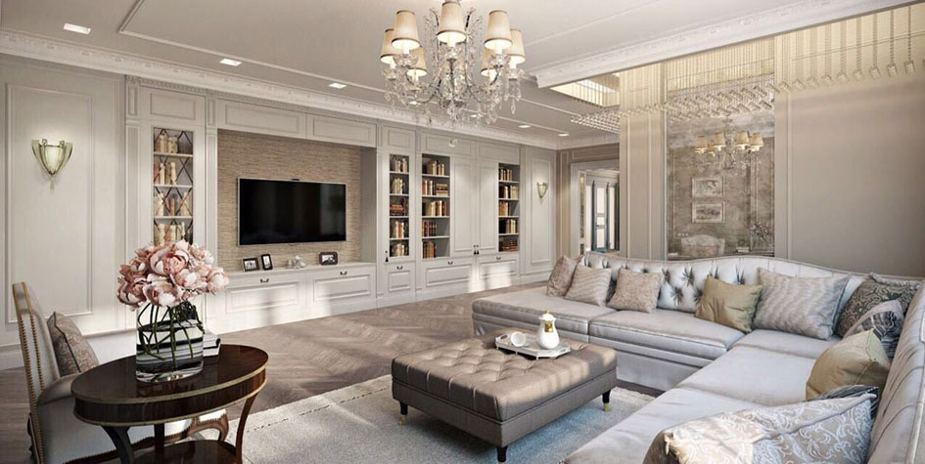

Ex 1 Underline the correct word in each sentence.
1 Don't forget to turn off/ close the light when you leave.
2 Can you shut / stop the door? It's cold in here.
3 Jim and Tina usually have/get lunch in the kitchen.
4 Our house is dirty because nobody likes making / doing housework.
5 Someone is hitting /knocking at the door.
6 Why don't you put / take a picture on this wall?
7 Can you open/turn on the light? I can't see.
8 Tom is living /staying with his sister for a few days.

Ex 2 Complete each sentence. Use the giving words

armchair bathroom ceiling desk floor furniture upstairs window

1 Our house has two floors, and my bedroom is upstairs.
2 If I stand on a chair, I can touch the ceiling.
3 Peter does his homework at his desk in his bedroom.
4 I can't move in your room! There is too much furniture
5 From my window can see the park at the end of the street.
6 Kate dropped a glass on the floor and it broke.
7 Jack is in the bathroom He's taking a shower
8 When I read, I like sitting in a comfortable armchair

Ex 3 Choose the things you usually find in each room.
1 kitchen
A cooker B sofa C bath D fridge
2 bedroom
A blanket B dustbin C wardrobe D pillow
3 living-room
A bed B armchair С carpet D table
4 bathroom
A mirror B television C bookshelf D shower
5 study
A bed B desk C bookshelf D cooker
6 dining room
A table B bath C chair D wardrobe

Ex 4 Choose the most suitable word for each space.
1 To stop the light coming in the window we need some …
A curtains B radiators C shelves
2 It's very cold. Why don't you turn on the....?
A central heating B cooker C stove
3 In the evening I like to relax in...
A a chair B a seat C an armchair
4 Laura sat at her … and turned on her computer.
A study B desk C office
5 My school books are in the … in the living room.
A library B bookcase C bookshelf
6 There was a lovely fire burning in the.....
A chimney B central heating C fireplace
7 You can wash your hands in the … in the bathroom.
A basin B shower C tap
8 The biscuits are in the in the kitchen
A table B shelf C cupboard

Ex 5 Here are some definitions. What are the words?
1 The room where you talk and watch TV – living room
2 The room where you wash and have a shower - bathroom
3 The room where you cook food - kitchen
3 The room where you sleep - bedroom
4 The room where you do work/homework – study
5 The place where you put the car - garage

PDF

Ex 1 Underline the correct word in each sentence.
1 Don't forget to turn off/ close the light when you leave.
2 Can you shut / stop the door? It's cold in here.
3 Jim and Tina usually have/get lunch in the kitchen.
4 Our house is dirty because nobody likes making / doing housework.
5 Someone is hitting /knocking at the door.
6 Why don't you put / take a picture on this wall?
7 Can you open/turn on the light? I can't see.
8 Tom is living /staying with his sister for a few days.

Ex 2 Complete each sentence. Use the giving words

armchair bathroom ceiling desk floor furniture upstairs window

1 Our house has two floors, and my bedroom is...
2 If I stand on a chair, I can touch the…
3 Peter does his homework at his … in his bedroom.
4 I can't move in your room! There is too much ...
5 From my… can see the park at the end of the street.
6 Kate dropped a glass on the… and it broke.
7 Jack is in the... He's taking a shower
8 When I read, I like sitting in a comfortable....

Ex 3 Choose the things you usually find in each room.
1 kitchen
A cooker B sofa C bath D fridge
2 bedroom
A blanket B dustbin C wardrobe D pillow
3 living-room
A bed B armchair С carpet D table
4 bathroom
A mirror B television C bookshelf D shower
5 study
A bed B desk C bookshelf D cooker
6 dining room
A table B bath C chair D wardrobe

Ex 4 Choose the most suitable word for each space.
1 To stop the light coming in the window we need some …
A curtains B radiators C shelves
2 It's very cold. Why don't you turn on the....?
A central heating B cooker C stove
3 In the evening I like to relax in...
A a chair B a seat C an armchair
4 Laura sat at her … and turned on her computer.
A study B desk C office
5 My school books are in the … in the living room.
A library B bookcase C bookshelf
6 There was a lovely fire burning in the.....
A chimney B central heating C fireplace
7 You can wash your hands in the … in the bathroom.
A basin B shower C tap
8 The biscuits are in the in the kitchen
A table B shelf C cupboard

Ex 5 Here are some definitions. What are the words?
1 The room where you talk and watch TV - …
2 The room where you wash and have a shower - …
3 The room where you cook food - …
3 The room where you sleep - …
4 The room where you do work/homework - …
5 The place where you put the car -…

