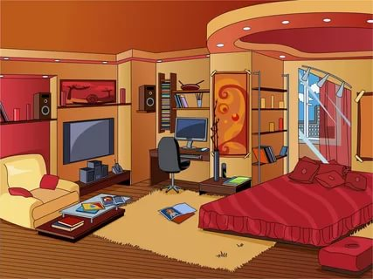

Task 1
Watch the video about prepositions
https://www.youtube.com/watch?v=lhUzq16KM48

Task 2
Choose the right preposition of place:
- the picture, I can see a family a kitchen.
- There is a dish full of fruits the worktop.
- The mother is standing her son and daughter.
- She is holding a vase her hand.
- The son and the daughter are sitting the worktop smiling each other.
- There are beautiful cupboards the wall.
- There is a window the mother.
- The woman is looking her daughter.

Task 3
Fill in the blanks with appropriate prepositions of place.
1. Can you see a woman … the picture? (in / on / at)
2. London is … the river Thames. (on / at / in)
3. The man is sitting … a table. (in front of / in / to)
4. The mother sat … her children. (beside / besides / across)
5. There are a laptop and a few books … the table. (on / at / with)
6. He put the money … the box. (in / on / under)
7. The cat was hiding … the door. (behind / on / under)
8. Why do you wear that ring … your first finger? (in / on / at)
9. Can you see the helicopter … the palace? (above / under / on)
10. The plane was flying … Scotland. (along / across / above)

Task 4
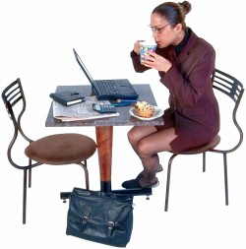
Complete the exercise according to the picture.
- the picture, I can see a woman.
- The woman is sitting a table.
- She is sitting a chair.
- There is another chair the woman.
- Her feet are the table.
- The woman is holding a cup her hands.
- the table are a laptop, a paper, a calculator, an appointment calendar, two pens and a muffin.
- The woman is looking her laptop.
- The woman's bag is the table.

Task 5
Fill the gaps with the correct prepositions.
- We live London.
- Would you like to go the cinema tonight?
- No, thanks. I was the cinema yesterday.
- We are going holiday next week.
- There is a bridge the river.
- The flight from Leipzig to London was Frankfurt.
- my wall, there are many picture postcards.
- Who is the person this picture?
- Come the sitting room, we want to watch TV.
- Munich lies 530 meters sea level.

Task 6
Complete with the necessary preposition
- There's a strange woman standing ____ a tree. (под)
- There's a motorbike ____ the car (перед) and a bicycle ____ it (позади), so the car is _____ the yellow motorbike and the bicycle.
- There's a bus waiting ___ a bus stop.
- There's a briefcase____ the desk. (под)
- Can you see a camera ____ the drawer?
- There's a large picture _____ the wall.
- There are two bedrooms ____ the flat.
- Santa Monica is ____Southern California.
- I've got a poster of Kevin Costner_____my wall.
- Heidelberg is____the River Neckar.

ANSWERS
Task 2
Choose the right preposition of place:
1. In the picture, I can see a family in a kitchen.
2. There is a dish full of fruits on the worktop.
3. The mother is standing in front of her son and daughter.
4. She is holding a vase in her hand.
5. The son and the daughter are sitting at the worktop smiling at each other.
6. There are beautiful cupboards on the wall.
7. There is a window behind the mother.
8. The woman is looking at her daughter.

Task 3
Fill in the blanks with appropriate prepositions of place.
1. Can you see a woman … the picture? (in / on / at)
2. London is … the river Thames. (on / at / in)
3. The man is sitting … a table. (in front of / in / to)
4. The mother sat … her children. (beside / besides / across)
5. There are a laptop and a few books … the table. (on / at / with)
6. He put the money … the box. (in / on / under)
7. The cat was hiding … the door. (behind / on / under)
8. Why do you wear that ring … your first finger? (in / on / at)
9. Can you see the helicopter … the palace? (above / under / on)
10. The plane was flying … Scotland. (along / across / above)

Task 4
Complete the exercise according to the picture.
1. In the picture, I can see a woman.
2. The woman is sitting at a table.
3. She is sitting on a chair.
4. There is another chair opposite the woman.
5. Her feet are under the table.
6. The woman is holding a cup in her hands.
7. On the table are a laptop, a paper, a calculator, an appointment calendar, two pens and a muffin.
8. The woman is looking at her laptop.
9. The woman's bag is under the table.

Task 5
Fill the gaps with the correct prepositions.
1. We live in London.
2. Would you like to go to the cinema tonight?
3. No, thanks. I was at the cinema yesterday.
4. We are going on holiday next week.
5. There is a bridge across the river.
6. The flight from Leipzig to London was via Frankfurt.
7. On my wall, there are many picture postcards.
8. Who is the person in this picture?
9. Come into the sitting room, we want to watch TV.
10. Munich lies 530 meters above sea level.

Task 6
Complete with the necessary preposition
1. There's a strange woman standing under a tree. (под)
2. There's a motorbike in front of the car (перед) and a bicycle behind it (позади), so the car is between the yellow motorbike and the bicycle.
3. There's a bus waiting at a bus stop.
4. There's a briefcase under the desk. (под)
5. Can you see a camera in the drawer?
6. There's a large picture on the wall.
7. There are two bedrooms in the flat.
8. Santa Monica is in Southern California.
9. I've got a poster of Kevin Costner on my wall.
10. Heidelberg is on the River Neckar.

