basic_lesson_17_city_listening_part_3

Exercise 1
Match the pictures with places
mall - kindergarten – bus station - market – hospital - train station – gas station - library

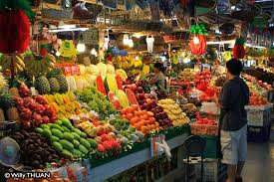

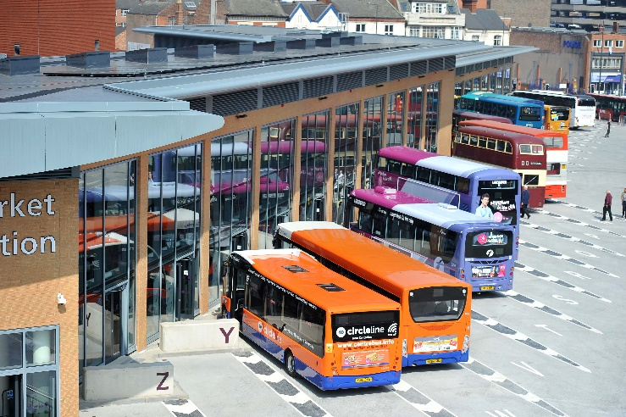
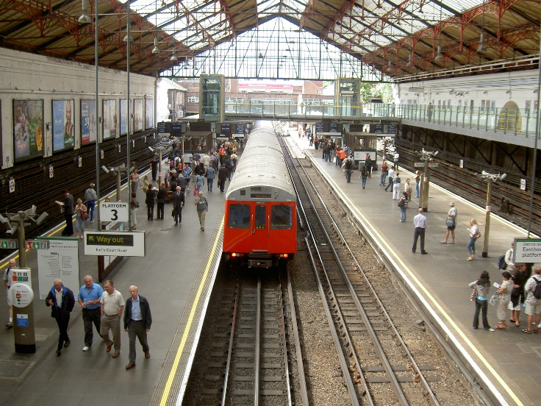

Exercise 2
Listen to the dialogue, read the script and answer the questions afterwards.
https://soundcloud.com/elllo-todd/beginner-esl-lesson-5-her-hometown

John: So Sarah, what can you tell me about your hometown?
Sarah: My hometown. Well, my hometown is called Eau Claire, Wisconsin. And it's a really great city.
There are about 80,000 people. There are lots of things to do. There are three movie theatres. I love to watch movies.
John: Me too.
Sarah: There's lots of shopping. You can find anything you want there. There are a lot of malls and stores.
John: Are there many restaurants?
Sarah: Yes. The thing I like is you can eat any type of food. There are Chinese restaurants and Korean restaurants, Italian restaurants. There is a big variety of restaurants, and they're all good.
John: That sounds great. What about parks? Are there many places to see nature in your town?
Sarah: Yes. We have a lot of rivers, and lakes and hills. My hometown has four seasons. So in summer, it's great because there are lots of lakes to swim in, lots of forests to play in. In winter, there is a lot of snow. So you can go ice skating or ice fishing or even skiing.
John: Wow. That sounds really fun.
Sarah: Yeah. It's a really nice city. It's also really safe. There are lots of nice people there.
John: Good. Is there much to do at night?
Sarah: Well, maybe, maybe not. There's not many things to do at night. There aren't any nightclubs. There aren't many bars. So actually, maybe there isn't much night life.
John: That's okay. It sounds like a nice place to have a family.
Sarah: Yeah. It is. It's a great place to have a family. There's lots of good schools and libraries.

Answer these questions. More than one option is possible.
1) She says there is ______ to do in her town.
a) not much
b) lots
c) nothing

2) There are _______ restaurants?
a) not many good
b) too many
c) some international

3) She says there are _______ .
a) lakes
b) mountains
c) forests

4) What sports does she mention?
a) fishing
b) golfing
c) ice-skating

5) There are lots of good ______ .
a) golf courses
b) schools
c) libraries

Exercise 3
Listen to the second dialogue and answer the questions
https://soundcloud.com/elllo-todd/beginner-esl-lesson-6-hometown-in-wisconsin
Sarah: So John, where are you from?
John: My hometown is very small. It's a little town in the countryside, in Wisconsin. There are only 5,000 people there.
Sarah: Wow. There aren't very many people.
John: No, it's very small. There aren't very many businesses. There isn't a shopping mall. There are a lot of grocery stores. And there are a lot of gas stations. But there isn't much to do there.
Sarah: Oh really? Are there any movie theaters?
John: Well, there is one movie theater. So that's a nice thing to do. In fact, there are many screens in the theater. There are eight different movies showing.
Sarah: How about at night? What's fun to do – how about at night? Is there very much night life?
John: Yeah, there is not so much. But there is a bowling alley. It's fun to go bowling with friends. There's a bowling alley and the movie theater. There is one restaurant where you can go for tacos and burritos. And there's one more restaurant for pizza and spaghetti.
But during the daytime, you can go to the park. There's a river that goes through the town. So in the middle of town, there's a river. And there's a park that goes along both sides of the river. And at the park, there is a tennis court and a disc golf course.
Sarah: Disc golf?
John: Yeah. I like to play disc golf with my friends. It's really fun. And after we finish playing disc golf, we usually go to the pizza restaurant.
Sarah: Oh, I see. How about schools? Are there very many schools?
John: Let's see. No, there aren't very many. There is only one elementary school, one junior high school and one high school. That's it.
Sarah: Interesting.
John: Yeah. There aren't very many schools but the town doesn't need more schools because there aren't very many people there.
Sarah: I see. Are there any mountains?
John: No. The whole area is very flat. There are no mountains but there are a lot of trees. In fact, there are trees on my town's sign because my town is famous for all the trees on every street.
Sarah: Oh wow. It sounds like a great city.

Answer these questions.
1) In his town, there are lots _____.
a) businesses
b) gas stations
c) parks

2) The town does not have a ______ .
a) mall
b) park
c) theater

3) What food does he eat in his town?
a) Japanese food
b) Mexican food
c) Thai food

4) Who does he go bowling with?
a) His bowling team
b) His friends
c) Just himself

Exercise 4
Listen to the story and match the places which appear in it
https://www.englisch-lernen-online.de/wp-content/uploads/sites/20/2015/04/story-unit3.mp3
- the new house
- fire brigade
- cinema
- park
- hospital
- market
- train station
- shops
- post office
- school
- church
- airport

Answer the questions
- What color is their new house?
- blue
- grey
- yellow

- This new city is ….
a)small
b) big

- How are they getting home from the airport?
- By bus
- Bu train
- By car

