**Lesson18 prepositions of place and direction test part 2**

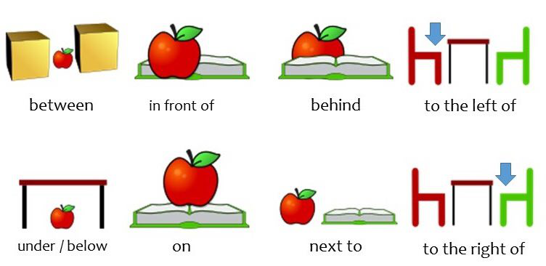

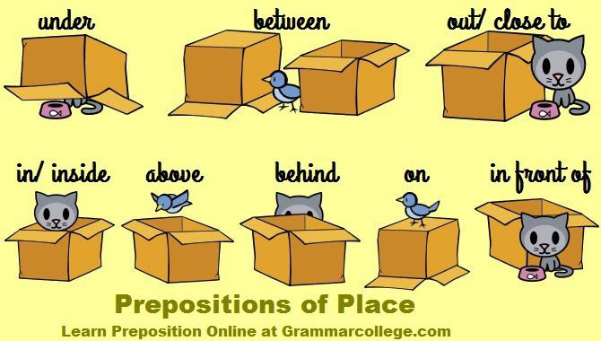

**Exercise 1.**

**Read and choose the suitable preposition**

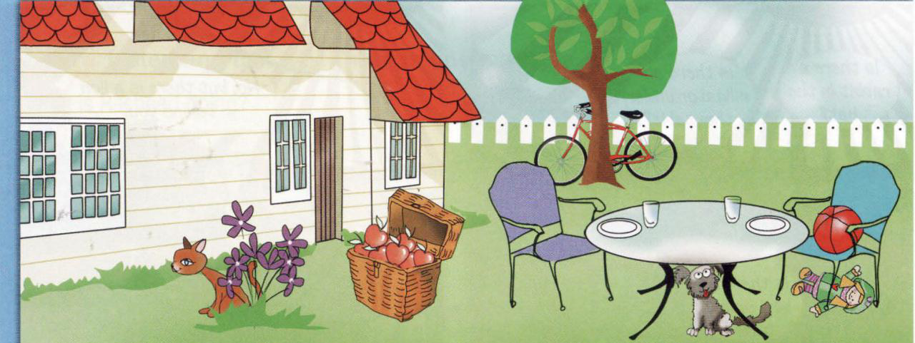

1. There is a table_____ the garden.

a) in

b) on

1. There is a dog_____ the table.

a) under   
b) on

1. There are glasses _____ the table.

a) on   
b) under

1. There is a bike _____ the tree.   
   a) behind  
    b) on
2. There is a ball _____ the blue chair.   
   a) under  
    b) on
3. There are apples _____ the basket.

a) in  
 b) under

1. There is a doll _____ the blue chair.

a) under  
 b) in

1. There is a cat _____ the flowers.   
   a) behind   
   b) on

**Exercise 2.**

**Look at the pictures.**

**Fill in the gaps**

**in in on behind under under**

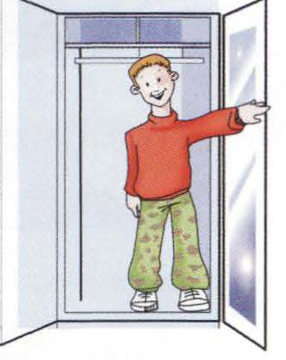

1. He is ____ the wardrobe

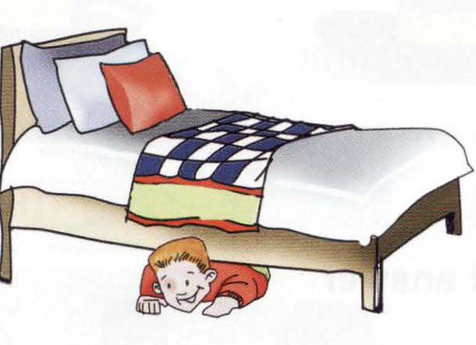

1. He is _____ the bed.

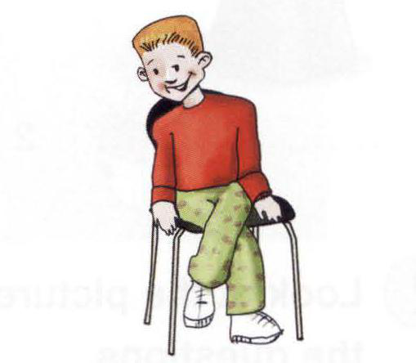

1. He is ­­­­____ the chair.

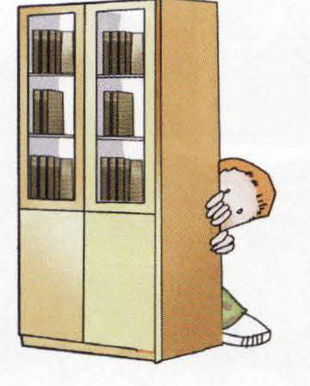

1. He is ____ the bookcase.

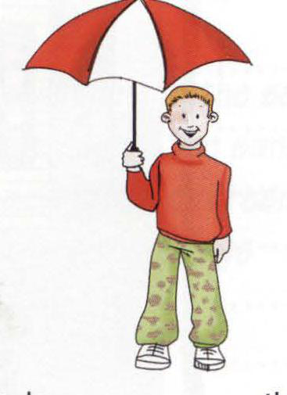

1. He is ____ the umbrella.



1. He is ­­_____ the box.

Exercise 3.

**Look**

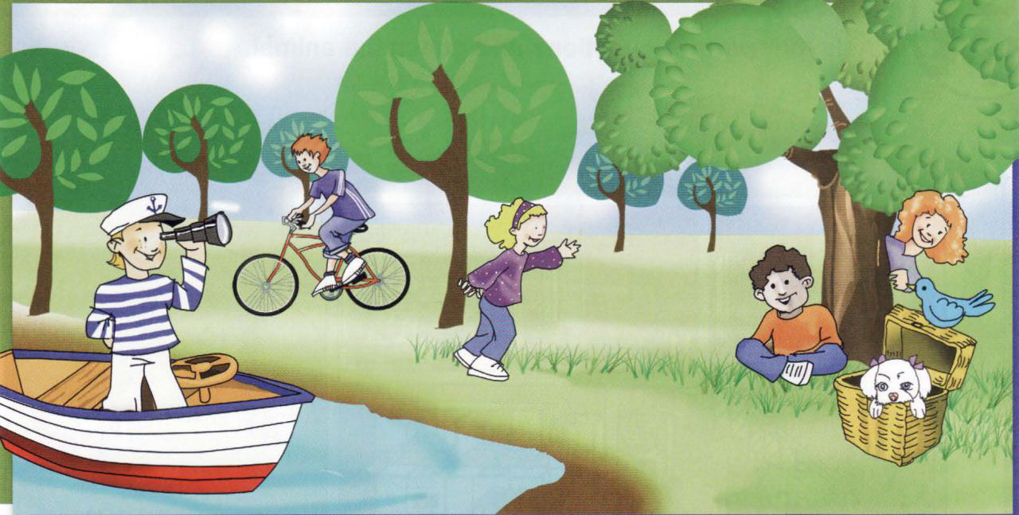

**Fill in:**   
**under**  **behind** **in in on on**

The children are having fun in the park. Ted is 1) ........... the boat. Peter is 2) .............. his

bike. John is sitting 3) .............. the tree. Look! Ann is standing 4) ............. the tree! There is a bird 5) .............. the basket. Can you see the dog 6) .............. the basket?

**Exercise 4**

<https://learningapps.org/506484>

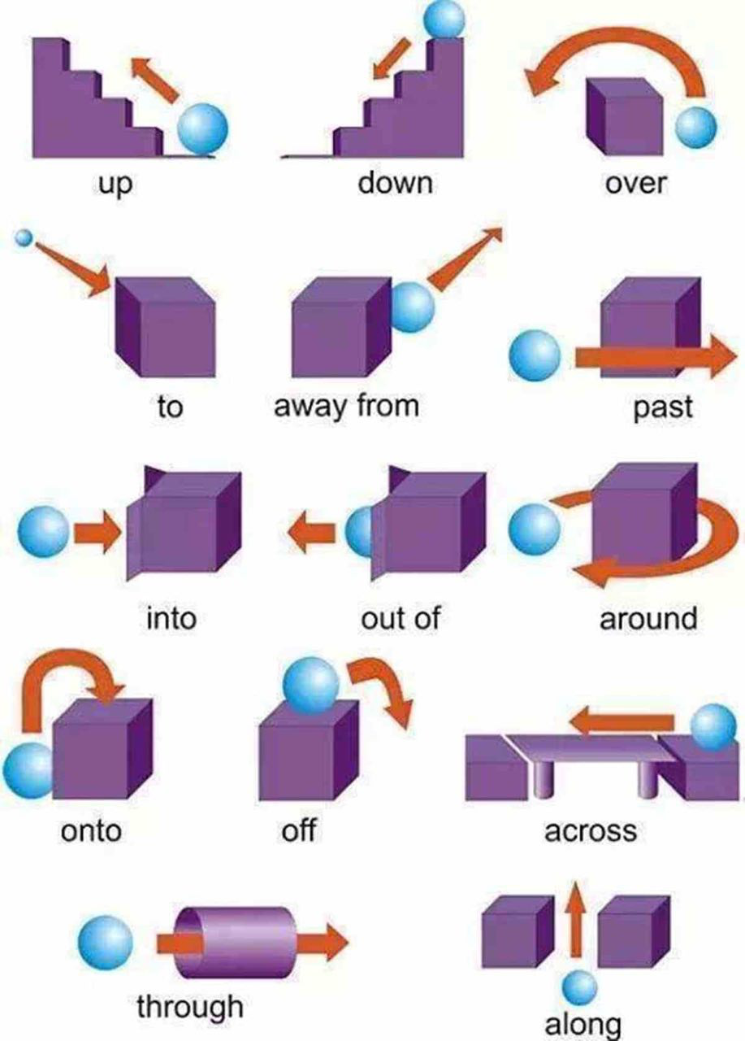

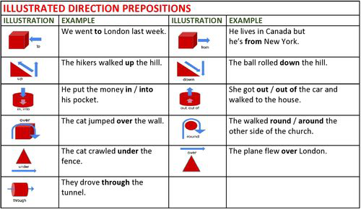

**Exercise 5**

**Choose the correct answer**

1. He goes ____ disco techs every night.
2. to
3. across
4. down
5. towards
6. You must walk ____ the bridge.
7. into
8. across
9. down
10. along
11. Walk ____ the street and turn left.
12. around
13. onto
14. down
15. across
16. That woman going ____ the supermarket is my mother.
17. into
18. onto
19. across
20. off
21. Sally is talking ____ Michael.
22. to
23. off
24. through
25. up
26. We walked ____ to the top of the mountain.   
    a) up   
    b) down   
    c) onto  
    d) across
27. We both jumped ____ the swimming pool at the same time.  
    a) in  
     b) on  
    c) at   
    d) though
28. In some countries it's considered unlucky to walk ____ a ladder.  
    a) across   
    b) under   
    c)down   
    d)along
29. The athletes ran ____ a the track for 1 hour.  
     a)off  
    b) up  
    c) around  
    d) down
30. You must always wear a helmet when you cycle if you fall ____ the bike.  
     a) under   
    b) off  
    c) into  
    d) through
31. The first person to swim ____ the English Channel was Mathew Webb, in 1875.   
    a) around   
    b) over   
    c) down   
    d) across
32. Ferdinand Magellan was a Portuguese sailor who sailed ____ the world in the 16th century.   
    a) around   
    b)over   
    c) off   
    d) into
33. Get ____ ­of the car now! I have to take you to school.  
     a) around   
    b) onto  
    c) out   
    d) across
34. The boat sailed the ____ the river up to the sea.   
    a) along  
     b) across   
    c)out of  
    d) into
35. The teacher walked ____ the class, so we stopped talking and sat down.  
    a) out of  
    b) onto  
    c) through   
    d) into

**Key**

**Exercise 1**

1. There is a table_____ the garden.

**a) in**

b) on

1. There is a dog_____ the table.

**a) under**   
b) on

1. There are glasses _____ the table.

**a) on**   
b) under

1. There is a bike _____ the tree.   
   **a) behind**  
    b) on
2. There is a ball _____ the blue chair.   
   a) under  
    **b) on**
3. There are apples _____ the basket.

**a) in**  
 b) under

1. There is a doll _____ the blue chair.

**a) under**  
 b) in

1. There is a cat _____ the flowers.   
   **a) behind**   
   b) on

**Exercise 2**

1. He is ____ **in** the wardrobe
2. He is _____ **under** the bed.
3. He is ­­­­____ **on** the chair.
4. He is ____ **behind** the bookcase.
5. He is ____ **under** the umbrella.
6. He is ­­_____ **in** the box.

**Exercise 3**

The children are having fun in the park. Ted is 1) ........... **in** the boat. Peter is 2) .............. **on** his

bike. John is sitting 3) ..............**under** the tree. Look! Ann is standing 4) ............. **behind** the tree! There is a bird 5) .............. **on** the basket. Can you see the dog 6) .............. **in** the basket?

Exercise 5

1. He goes ____ disco techs every night.

**a) to**

b) across

c) down

d) towards

1. You must walk ____ the bridge.
2. into
3. **across**
4. down
5. along
6. Walk ____ the street and turn left.
7. around
8. onto
9. **down**
10. across
11. That woman going ____ the supermarket is my mother.
12. **into**
13. onto
14. across
15. off
16. Sally is talking ____ Michael.
17. **to**
18. off
19. through
20. up
21. We walked ____ to the top of the mountain.   
    **a) up**   
    b) down   
    c) onto  
    d) across
22. We both jumped ____ the swimming pool at the same time.  
    **a) in**  
     b) on  
    c) at   
    d) though
23. In some countries it's considered unlucky to walk ____ a ladder.  
    a) across   
    **b) under**   
    c)down   
    d)along
24. The athletes ran ____ a the track for 1 hour.  
     a)off  
    b) up  
    **c) around**  
    d) down
25. You must always wear a helmet when you cycle if you fall ____ the bike.  
     a) under   
    **b) off**  
    c) into  
    d) through
26. The first person to swim ____ the English Channel was Mathew Webb, in 1875.   
    a) around   
    b) over   
    c) down   
    **d) across**
27. Ferdinand Magellan was a Portuguese sailor who sailed ____ the world in the 16th century.   
    **a) around**   
    b)over   
    c) off   
    d) into
28. Get ____ ­of the car now! I have to take you to school.  
     a) around   
    b) onto  
    **c) out**   
    d) across
29. The boat sailed the ____ the river up to the sea.   
    **a) along**  
     b) across   
    c)out of  
    d) into
30. The teacher walked ____ the class, so we stopped talking and sat down.  
    a) out of  
    b) onto  
    c) through   
    **d) into**