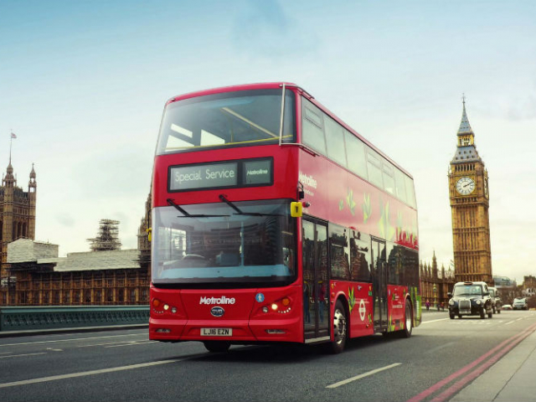
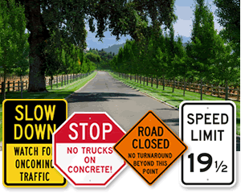
basic_lesson_19_transport_reading_part_3

Quizlet
https://quizlet.com/306674673/reading-basic-transport-flash-cards/?new
Exercise 1
Match the pictures with the words
helicopter - steam train – submarine - tram – airplane - trolleybus - cart
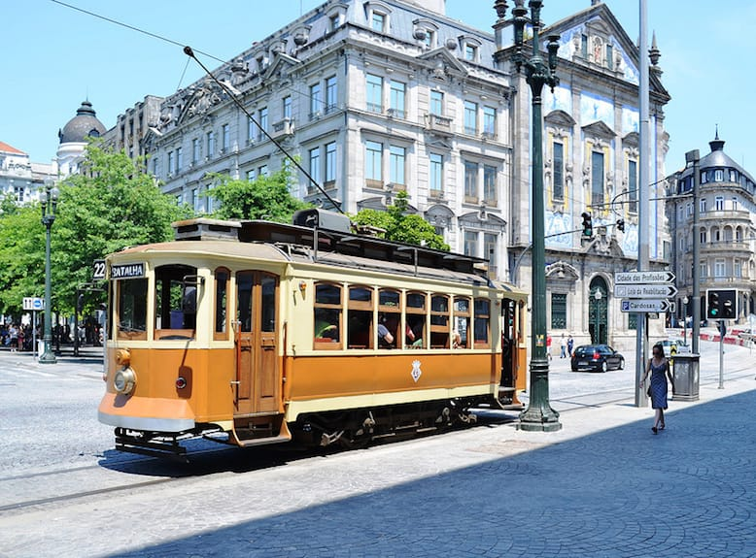
tram
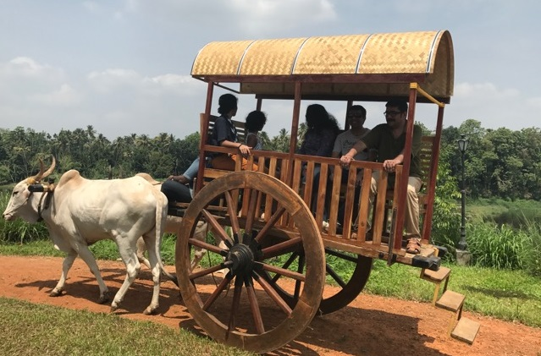
cart

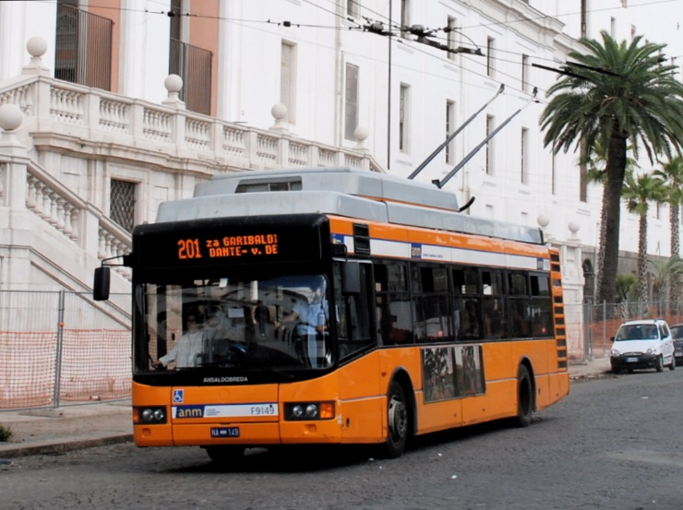
trolleybus
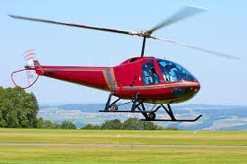
helicopter

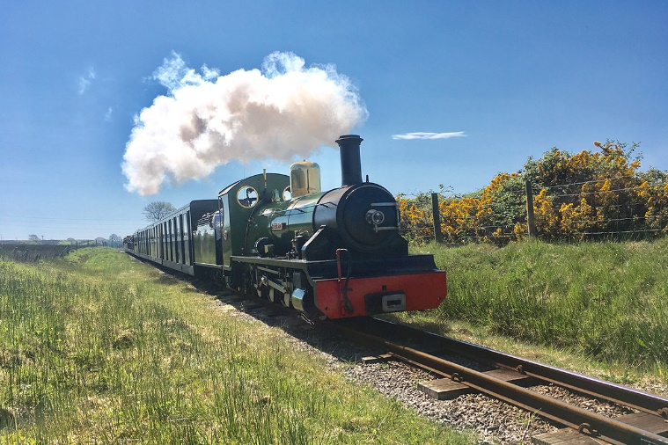
steam train

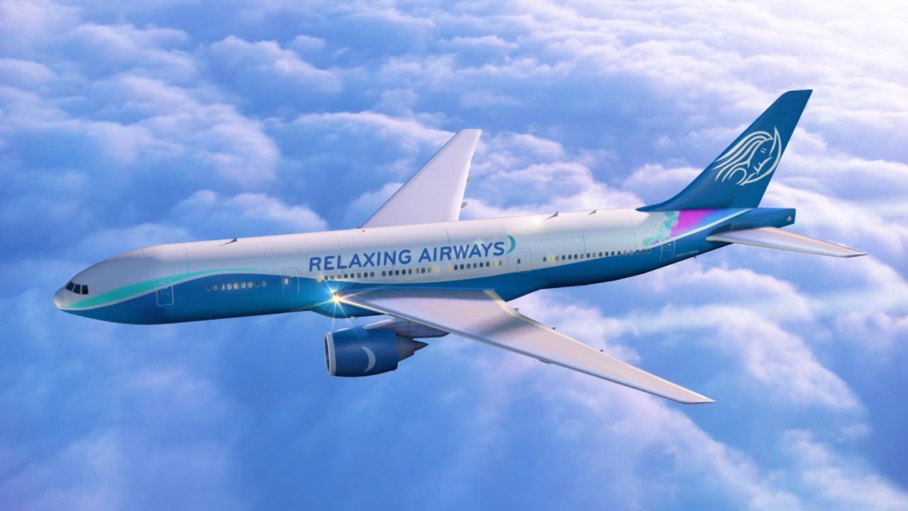

airplane

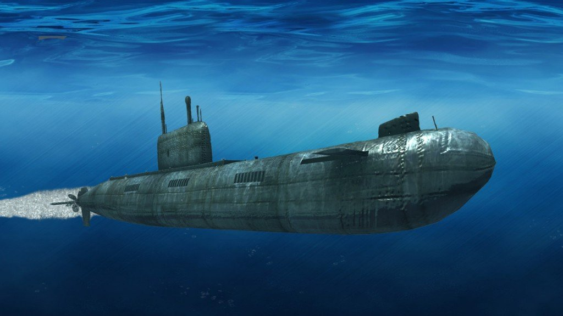
submarine

Exercise 2
Read the text and answer the questions

Transport is the way in which things are carried from one place to the other. How did people and things travel many years ago?
Earliest humans had no fancy transport to travel. So what did they do when they felt the need to travel and explore? They used their legs. Humans and animals walked to travel from one place to other.
However, this was a slow process. But this went on for many years until something round was discovered. Can you guess what it was? A wheel! Travel became faster than before.
Coaches or carts were pulled by donkeys or horses. They were used to transport goods and people. In 1886, a German inventor Karl Benz came up with the idea of motor run wagons. This event is often known as the ‘birth of the modern automobile’.

Answer the questions:
- How did people travel in primitive times?
- By car
- On foot
- Which invention was revolutionary and helped people travel faster?
- hammer
- wheel
- broom
- Which transport was pulled by animals?
- car
- balloon
- coach
- The inventor of the first car in the world was:
- Thomas Edison
- Karl Benz
- Werner von Siemens

Exercise 3
Read the passage and answer the questions
Rail
Why railways? Wasn’t road travel good enough? No. Not for the transport of heavy goods in big quantities. That’s when the concept of rail took birth. Slowly, people also began to travel as it made travel cheaper and quicker. Earliest rails were known as ‘Wagonways’. The invention of steam engine gave a historic leap to the rail travel. In 1781, James Watt created a steam engine.
- What influenced the rail travel?
- gas engine
- oil engine
- steam engine
- When was a steam engine invented
- In the 20th century
- In the 18th century
- In the 19th century
Exercise 4
Read the passages and answer the questions
Water travel
In primitive times, boats were developed to be used in rivers for fishing. Then sail were invented and they used the wind to move the ship. Sailing ships were used to carry cargo for trade. Ships were also used in war. Later, steam engines made ships travel even faster.
Air travel
Can you guess what were the first man-made flying objects? Kites! The famous painter Leonardo da Vinci had the idea of flying machines, but never constructed them. Montgolfier brothers invented the first hot air balloon. The first aeroplane ever was built by two American brothers, Wilbur and Orville Wright in 1903. The plane called The Wright Flyer was the beginning of air travel.
Space
Rocket technology is one of the most important inventions of the last hundred years. It has given humans a way of travelling into space and discovering a whole new world. The first human spaceflight was achieved with the Soviet space program in 1961. Yuri Gagarin was the first astronaut.
Answer the questions
- How were boats used in ancient primitive times?
- for fishing
- to transport goods
- What helped to move ship faster?
- A rope
- A wheel
- A sail
- The first man-made flying object was:
- A kite
- A balloon
- A spaceship
- The first aeroplane was invented by:
- the Germans
- the English
- the Americans
- The first man in space was:
- Neil Armstrong
- Yuri Gagarin

