Key
Exercise 3
Choose the right answer to match the picture
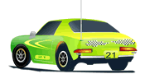 | 1. a) boat  b) lorry  c) plane  d) car
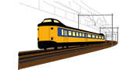 | 2. a) lorry  b) bus  c) train  d) taxi
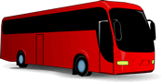 | 3. a) plane  b) bus  c) lorry  d) train
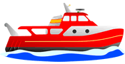 | 4. a) boat  b) lorry  c) plane  d) car
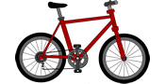 | 5. a) motorcycle  b) boat  c) bike  d) helicopter
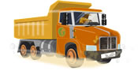 | 6. a) boat  b) lorry  c) plane  d) car
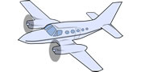 | 7. a) plane  b) helicopter  c) lorry  d) boat
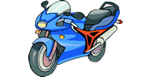 | 8. a) motorcycle  b) boat  c) bike  d) car
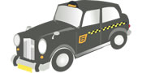 | 9. a) boat  b) lorry  c) plane  d) taxi
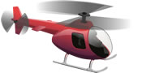 | - a) plane  b) helicopter  c) lorry  d) boat
Exercise 4
Complete the sentences
- Which platform ______ is it?
- Can I book in ______ advance?
- Is the train ______ direct?
- When do we get to ______ London?
- Where is the ticket ______ office?
- Can I reserve a ______ seat?
Exercise 5
Complete the text using the map
There are two bus ______ routes: the 24 and the 16. For the 24, the first ______ stop is museum, and the ______ next/second stop is the cinema; the ______ last stop is the bus station, where everybody has to ______ get off the bus. The 16 starts at the museum too, but it ______ goes to the railway station. The ______ timetable tells you how often the buses ______ run . The 24 bus ______ runs ______ every ten minutes. It ______ takes two minutes to get from school to the park.
Exercise 6
Choose the right answer
- A ....... is where you stand and wait for a bus or streetcar.
a) crossroads
b) stop
c) traffic light
d) parking lot
- If you want to ring someone, you need to find a ....... .
a) bridge
b) pedestrian zone
c) cathedral
d) telephone box
- You leave your car in a ....... when you go shopping.
a) crossroads
b) stop
c) traffic light
d) parking lot
- A ....... is a place where you can cross the road safely.
a) pavement
b) road sign
c) zebra crossing
d) car park
- Where two roads meet is called a ....... .
a) pavement
b) road sign
c) zebra crossing
d) crossroads

