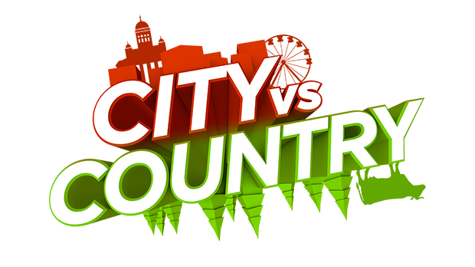
basic_lesson_20_transport_speaking_part_3

Exercise 1
Choose the correct answer for each word. Match the words which are related to a city and to the countryside.
City Countryside
- Field
- University
- Traffic lights
- Cows
- Crowd
- Mall
- Farmer
- Cottage
- Tourist attractions
- Restaurants

Exercise 2
Answer the questions
- What is your favorite city? Why?
- Which world city do you think would be the best to live in?
- Do you prefer city or country life? Why?
- What do you like and dislike about the capital city of your country?
- How are the cities in your country different?
- Would you prefer to live in a really old historical city, or a really new modern city?
- What are some tourist attractions in your city?
- What mean of transport do you use getting round your city?
- What kind of transportation do you prefer when you travel? Why?
Exercise 3
Guess what kind of transport it is.
plane – submarine – car – bycicle - ship
- It is huge underwater ship.
- You don`t need any special documents to ride it. Children and adults like to ride this kind of transportation.
- If you go on cruise it means that you sail on it.
- It has four wheels and you need a driving license to drive it.
- It is very fast but expensive.

Exercise 4
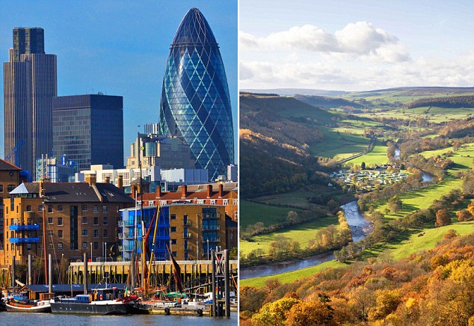
Describe the following pictures
- What do you see in the left picture?
- What do you see in the right picture?
- How can you compare these two pictures?
- What adjectives can you name for each picture?

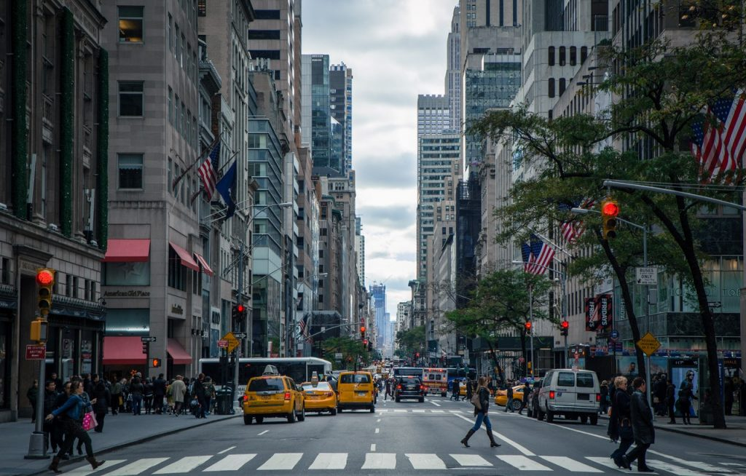

What do you see in this picture?

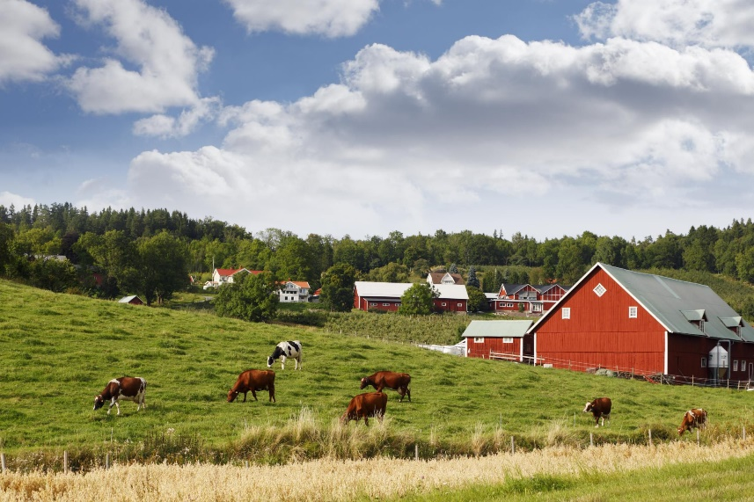

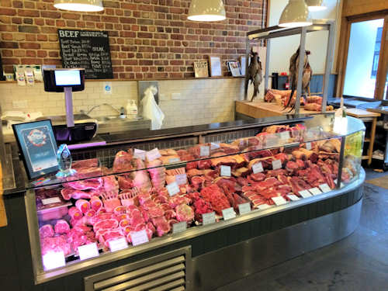
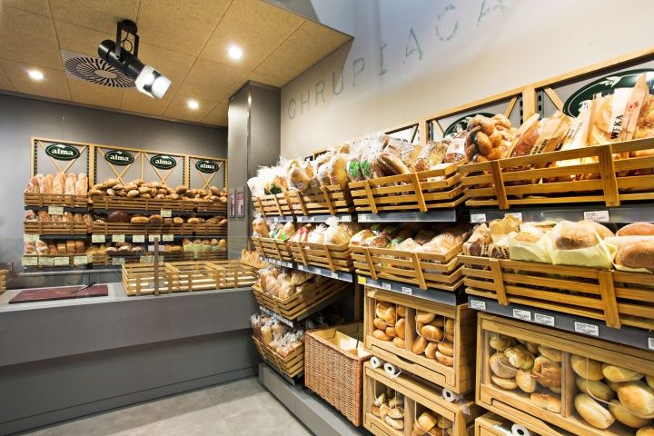
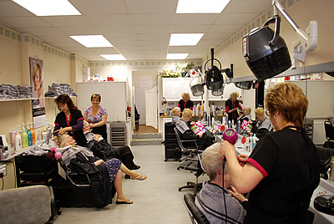
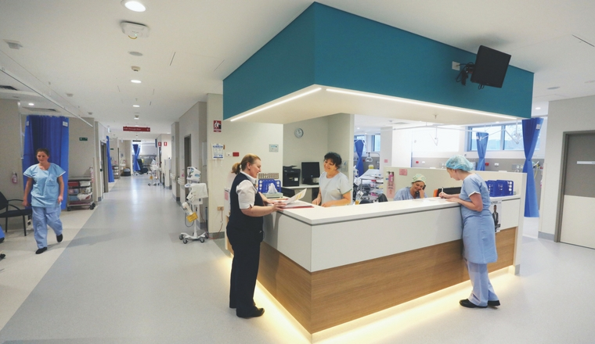
Name these places. How often do you go there? Describe what you see.

