Lesson 21-Halloween-Grammar (part 2)
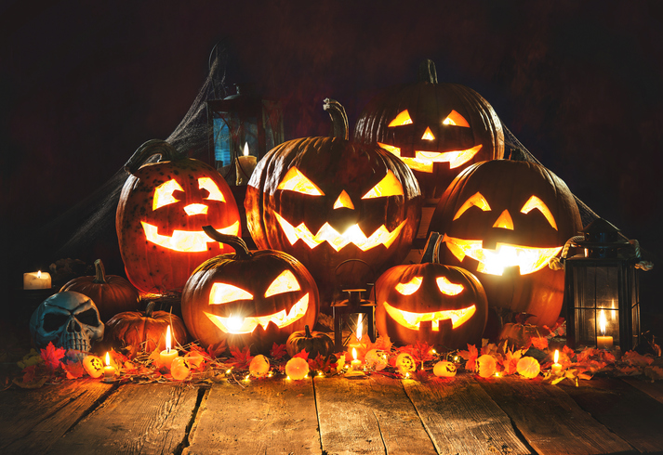
Exercise 1
https://learnenglishkids.britishcouncil.org/en/word-games/halloween-1
Exercise 2
https://learnenglishkids.britishcouncil.org/en/word-games/halloween-1
Exercise 3
Tick the correct answer
- When do we celebrate Halloween?
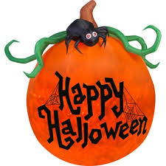
A beginning of October
B end of October
C middle of October
D November

- What does the witch cook
A a soup
B a magic potion
C a pie
D a steak
- Where do witches live
A in a flat
B in the cemetery
C in a car
D in a haunted house
- What fruit is typical for Halloween
A cherry
B watermelon
C pumpkin
D pear
- What do the children like to do?
A sing
B put on costumes
C draw
D cook
- Who likes to drink blood?
A ghosts
B mommies
C vampires
D skeletons
- What animal makes a net?
A ant
B cat
C spider
D owl
- What is typical for witches?
A boots
B a bag
C a black hat
D a car
- Witches travel by…
A broom
B car
C flying carpet
D spaceship
- Where does Halloween come from?
A Ireland
B France
C South Africa
D England
- What do the children want when they go trick or treating?
A hamburgers
B fruits
C candies
D parsley

Exercise 4
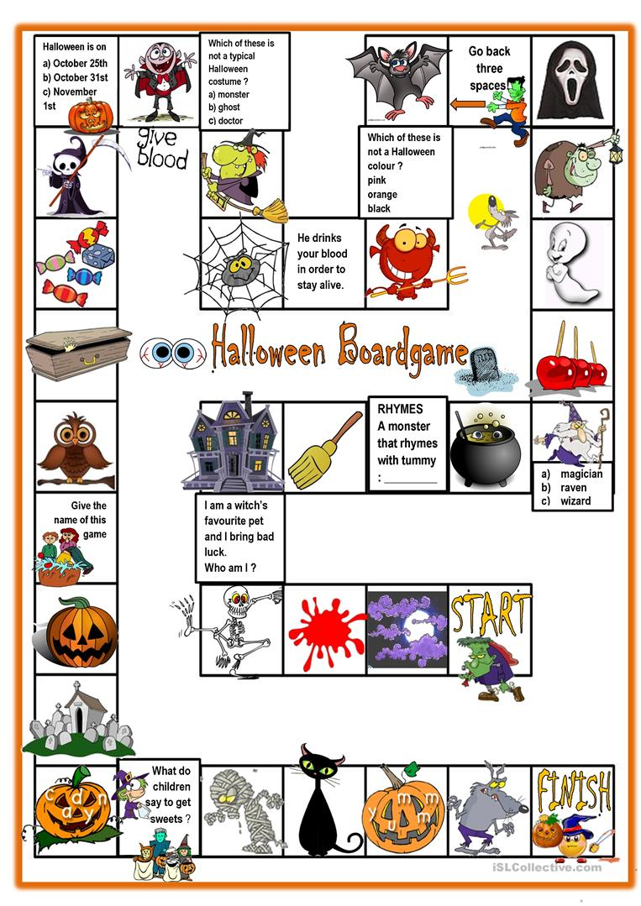

Exercise 5
