Lesson 21-Halloween- Vocabulary (part1)
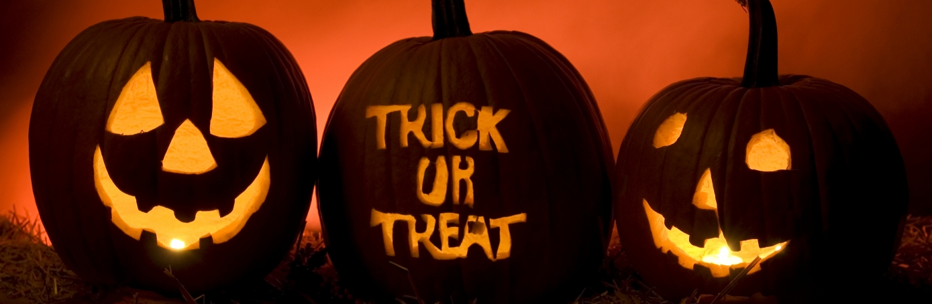
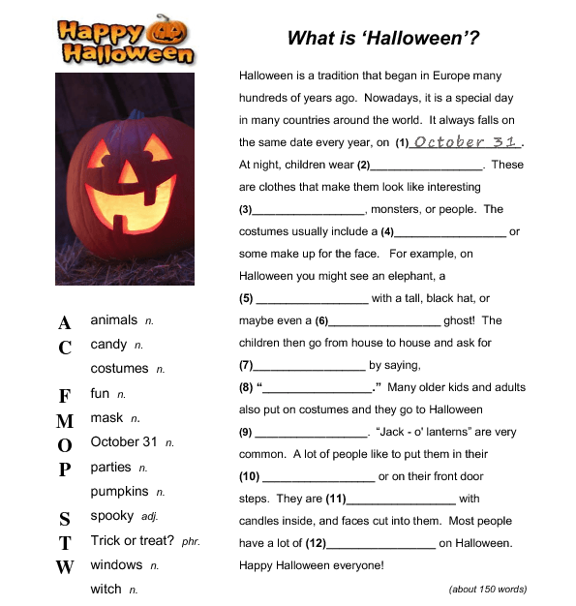
1. October 31 2. costumes 3. animals 4. mask 5. witch 6. spooky 7. candy 8. Trick or treat? 9. parties 10. windows 11. pumpkins 12. fun
Exercise 2
Match the words on the left with the meanings on the right
1. candle B. a long stick of wax that can be burned to give light
2. costume G. clothes people wear to look like another person or thing
3. make up E. colors used on the face to change the way you look
4. mask H. something used to cover your face
5. monster F. a strange and scary animal (probably not real)
6. pumpkin A. a large, round, orange vegetable
7. spooky D. strange and scary
8. witch C. a person (usually a woman) that has magic powers

1. B 2. G 3. E 4. H 5. F 6. A 7. D 8. C
Exercise 3
Choose True or False next to each statement.

1. The paragraph describes the best costumes to wear at Halloween. F
2. Halloween is popular in many places in the world. T
3. People usually celebrate Halloween in the morning or in the afternoon. F
4. Elephants like to wear tall, black hats. F
5. Pumpkins are very common during Halloween. T
6. Most people are afraid of witches during Halloween, so they stay at home. F

Exercise 4
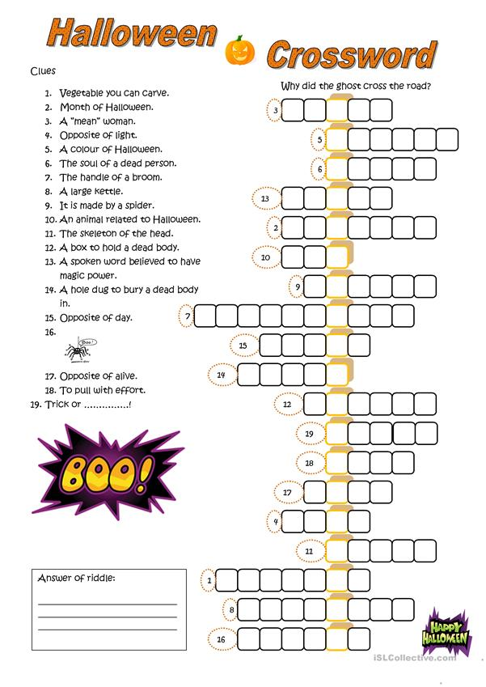
- Vegetable you can carve - pumpkin
- Month of Halloween-October
- A «mean» women-witch
- Opposite of light-dark
- A color of Halloween-orange
- The soul of the dead person-ghost
- The handle of a broom-broomstick
- A large kettle-cauldron
- It is made by a spider-web
- An animal related to Halloween-bat
- The skeleton of a head-skull
- A box to a hold dead body-coffin
- A spoken word believed to have magic power-spell
- A hole dug to bury a dead body-grave
- Opposite of day-night
- 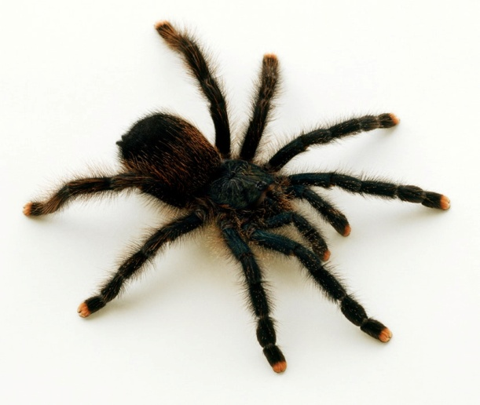 spider
- Opposite of alive-dead
- To pull with effort-push
- Trick or …! treat

