Ex.1 Label the boy with the words below.
arm
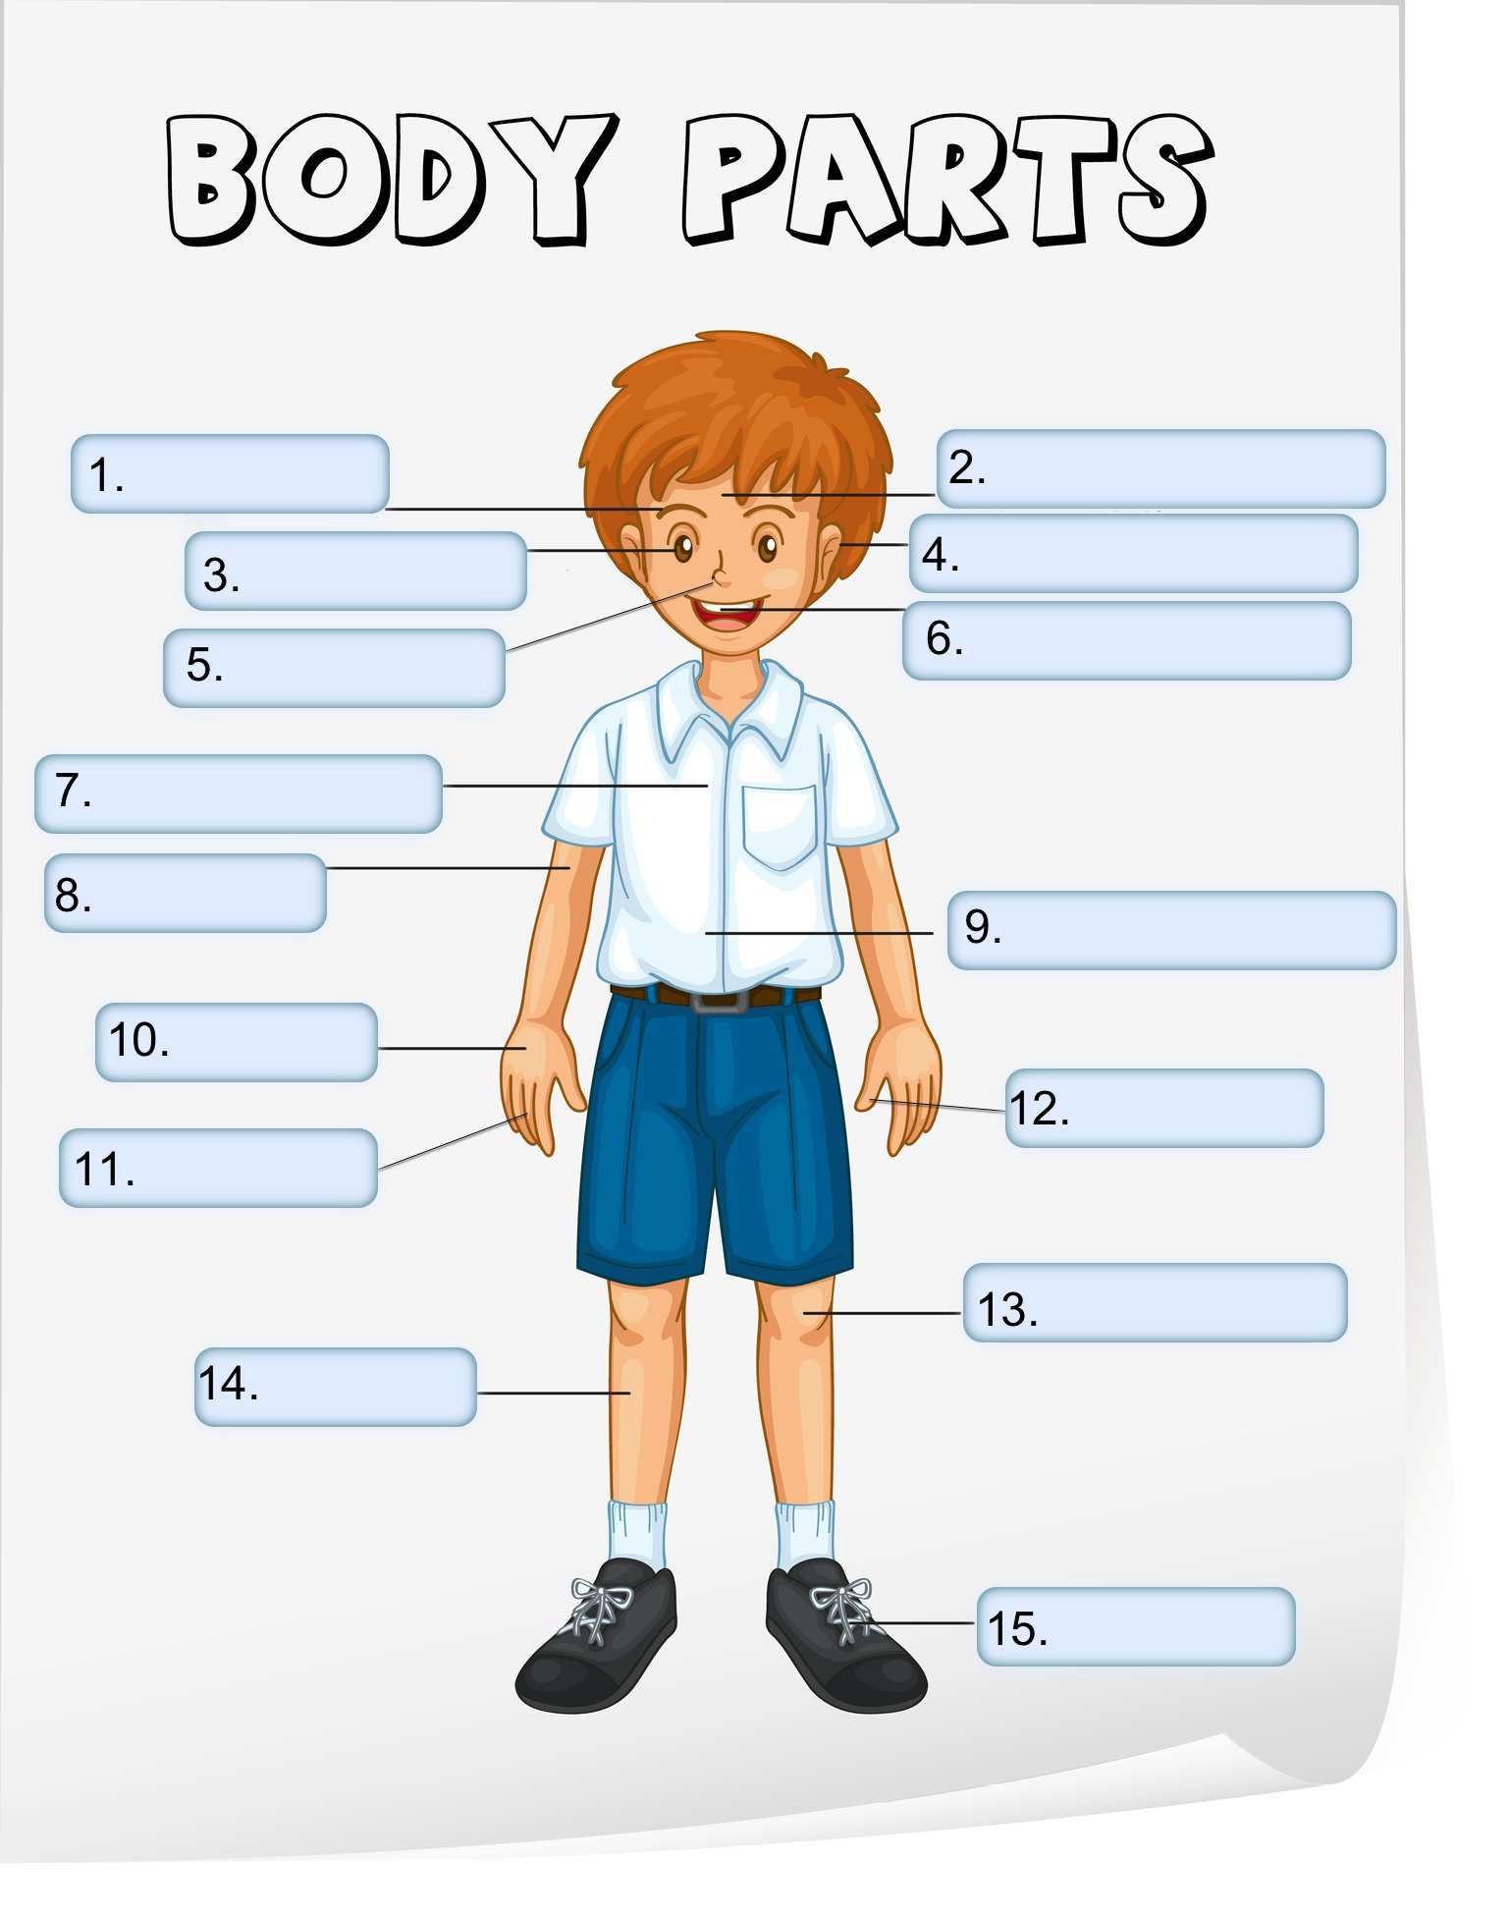
chest
ear
eye
eyebrow
finger
foot
forehead
hand
knee
leg
mouth
nose
stomach
thumb

Ex. 2 Match the verbs on the left with the words on the right.
1. smile a. arms and hands
2. smell b. ears
3. kick c. eyes
4. run d. finger or hand
5. cry e. foot
6. listen f. legs
7. wave g. mouth
8. touch h. nose
9. taste i. the whole body
10. dance j. tongue or mouth

Ex.3 Watch the video. Work with a partner. Ask and answer the question `What's he doing?', `What's she
doing?' or `What are they doing?'.
Scan the code or go to: https://www.linguahouse.com/r/62
1. She’s smelling a flower.
2. He . . . . . . . . . . . . . . . . . . . . . . . . . . . . . . . . . . . . . . . . . . . . . . . . . . . . . . . . . . . . . . . . . . . . . . . . . . . . . . . . . . . .
3. They . . . . . . . . . . . . . . . . . . . . . . . . . . . . . . . . . . . . . . . . . . . . . . . . . . . . . . . . . . . . . . . . . . . . . . . . . . . . . . . . . .
4. He's . . . . . . . . . . . . . . . . . . . . . . . . . . . . . . . . . . . . . . . . . . . . . . . . . . . . . . . . . . . . . . . . . . . . . . . . . . . . . . . . . .
5. They . . . . . . . . . . . . . . . . . . . . . . . . . . . . . . . . . . . . . . . . . . . . . . . . . . . . . . . . . . . . . . . . . . . . . . . . . . . . . . . . . .
6. She's . . . . . . . . . . . . . . . . . . . . . . . . . . . . . . . . . . . . . . . . . . . . . . . . . . . . . . . . . . . . . . . . . . . . . . . . . . . . . . . . . .
7. She's . . . . . . . . . . . . . . . . . . . . . . . . . . . . . . . . . . . . . . . . . . . . . . . . . . . . . . . . . . . . . . . . . . . . . . . . . . . . . . . . . .
8. She's . . . . . . . . . . . . . . . . . . . . . . . . . . . . . . . . . . . . . . . . . . . . . . . . . . . . . . . . . . . . . . . . . . . . . . . . . . . . . . . . . .

Ex.4 Match the words below.
Verb Noun
1. see a. feel
2. smell b. sight
3. hear c. smell
4. touch d. sound
5. taste e. taste

Ex.5. Now complete the sentences below with your own ideas.
1. I love the taste of . . . . . . . . . . . . . . . . . . . . . . . . . . . . . . . . . . . . . . . . . . . . . . . . . . . . . . . . . . . . . . . . . . . . . . . .
2. I hate the sound of . . . . . . . . . . . . . . . . . . . . . . . . . . . . . . . . . . . . . . . . . . . . . . . . . . . . . . . . . . . . . . . . . . . . . .
3. I like the feel of . . . . . . . . . . . . . . . . . . . . . . . . . . . . . . . . . . . . . . . . . . . . . . . . . . . . . . . . . . . . . . . . . . . . . . . . .
4. I don't like the smell of . . . . . . . . . . . . . . . . . . . . . . . . . . . . . . . . . . . . . . . . . . . . . . . . . . . . . . . . . . . . . . . . . .
5. I like the sight of . . . . . . . . . . . . . . . . . . . . . . . . . . . . . . . . . . . . . . . . . . . . . . . . . . . . . . . . . . . . . . . . . . . . . . . .

Now discuss these questions.
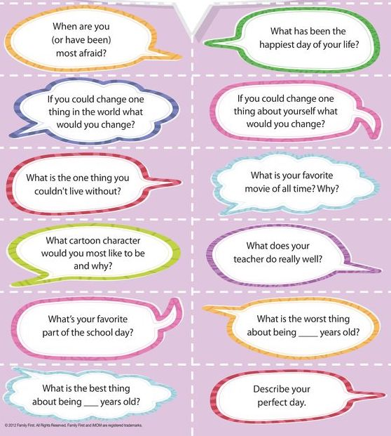

Answer key

Ex.1
1. eyebrow
2. forehead
3. eye
4. ear
5. nose
6. mouth
7. chest
8. arm
9. stomach
10. hand
11. finger
12. thumb
13. knee
14. leg
15. foot

Ex 2

1. g
2. h
3. e
4. f
5. c
6. b
7. a
8. d
9. j
10. I

Ex.3
2. He's kicking a ball.
3. They are waving.
4. He's listening to somebody.
5. They are running.
6. She's crying.
7. She's touching a statue.
8. She's dancing.

Ex.4
1. b 2. c 3. d 4. a 5. e

