Lesson 22-Parts of the body-Vocabulary (part1)
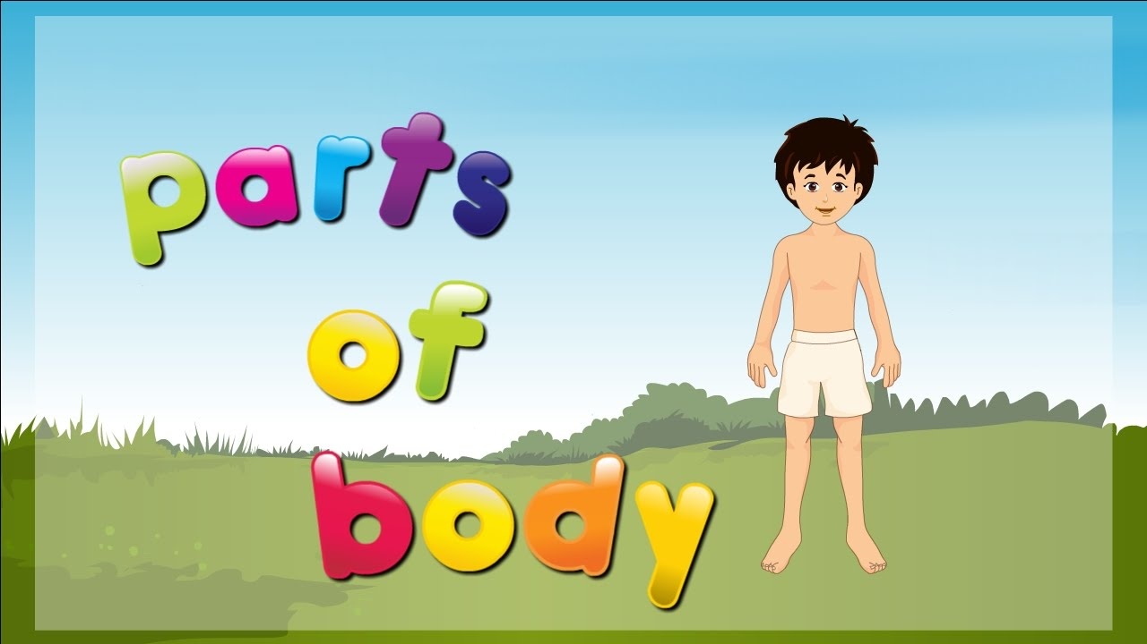
Exercise 1

Exercise 2
Which one is different?
1. foot wrist toe ankle
2. arm hand wrist stomach
3. neck ears nose lips
4. cheeks finger chin hair
5. mouth teeth lips shoulder
6. eyes legs knees ankle
7. shoulder chest neck bottom

Exercise 3
http://learnenglishteens.britishcouncil.org/vocabulary/beginner-vocabulary/body-parts
1 (Match the words and pictures) and 2 (Check your vocabulary: matching)
Exercise 4
Complete the sentences
Ears, toes, blood, heart, knees, fingers, teeth, nose

- A hand has five…
- A foot has five…
- An adult has 32…
- You smell with your…
- The … is a symbol of love
- You hear with your…
- The child sat on her dad’s …
- Your … type can A, B, AB or O

Exercise 5
https://quizlet.com/182495734/parts-of-the-body-flash-cards/
Exercise 6

- I can carry things with my right …
- I listen to you with my…
- I hope I will pass my exam, I cross my my
- Children love kicking a ball with one …
- She has red lips and long
- In winter I wear a scarf round my
- When you have a cold you often blow your
- Tom is 6 and he lost one .. lat night
- When you agree with someone you generally nod your …

