Lesson 22-Parts of the body-Vocabulary (part1)
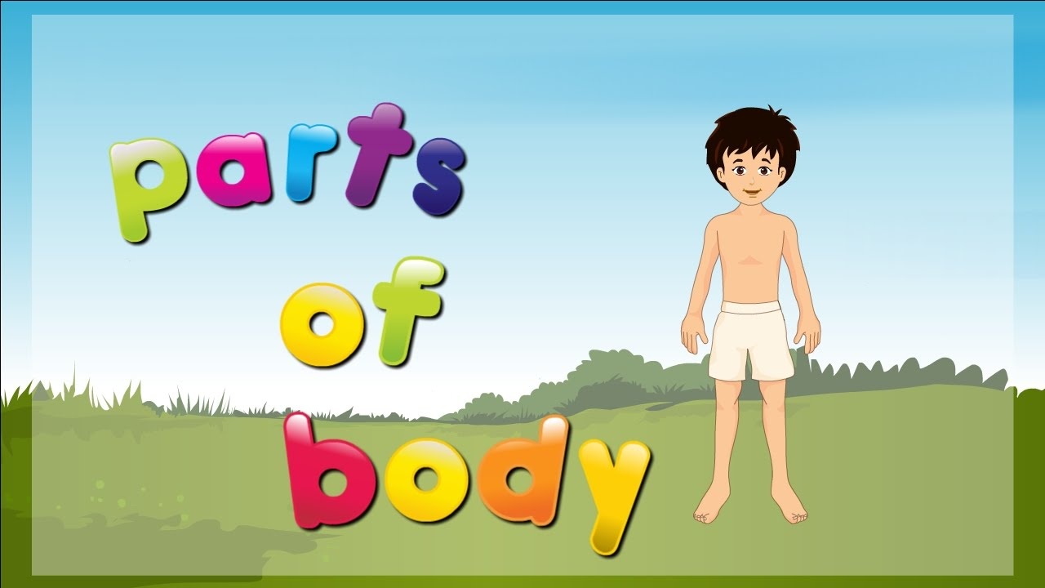
Exercise 1

Exercise 2
Which one is different?
1. foot wrist toe ankle
2. arm hand wrist stomach
3. neck ears nose lips
4. cheeks finger chin hair
5. mouth teeth lips shoulder
6. eyes legs knees ankle
7. shoulder chest neck bottom

Exercise 3
http://learnenglishteens.britishcouncil.org/vocabulary/beginner-vocabulary/body-parts
1 (Match the words and pictures) and 2 (Check your vocabulary: matching)
Exercise 4
Complete the sentences

- A hand has five fingers
- A foot has five toes
- An adult has 32 teeth
- You smell with your nose
- The heart is a symbol of love
- You hear with your ears
- The child sat on her dad’s knees
- Your … type can A, B, AB or O blood

Exercise 5
https://quizlet.com/182495734/parts-of-the-body-flash-cards/
Exercise 6

- I can carry things with my right hand
- I listen to you with my ear
- I hope I will pass my exam, I cross my fingers
- Children love kicking a ball with one leg
- She has red lips and long hair
- In winter I wear a scarf round my neck
- When you have a cold you often blow your nose
- Tom is 6 and he lost one tooth last night
- When you agree with someone you generally nod your head

