Lesson 24-Vocabulary-Appearance
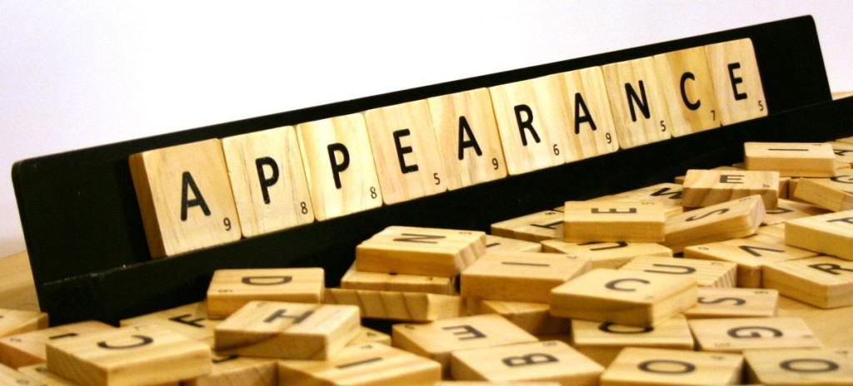
Exercise 1
Exercise 2
True or False?
- Average height means not tall and short short T
- Attractive and good-looking mean the same T
- You can say a man is good-looking or beautiful F
- If someone is fat, they are overweight T
- The answer to «How much does he weight?» is «200 cms» F
- «How tall are you?» is correct T
- It is polite to call someone fat and ugly F
- Thin and slim mean the same, but thin is more positive T

Exercise 3
Complete the dialogue
- She’s not tall or short, really.- No, she’s average height
- Are the 2 brothers attractive?- Yes, they’re both handsome
- Is she quite thin?-Yes, she’s very slim
- He’s about average weight.-Yes, he’s a bit overweight
- Is she very attractive?-Yes, she’s beautiful

Exercise 4

Exercise 5

Replace the underlined word in each sentence with a word which is more suitable
- He told me he met a handsome girl in the disco last night beautiful
- She’s beautiful but her younger sister is really quite ugly plain
- I think Peter is getting a bit fat, don’t you? overweight
- Most people want to stay slim, but not as skinny as that girl over there thin
- I think she’s hoping she’ll meet a few beautiful men at the tennis club handsome

Exercise 7
Presentation basic

Exercise 8
Describe the appearance

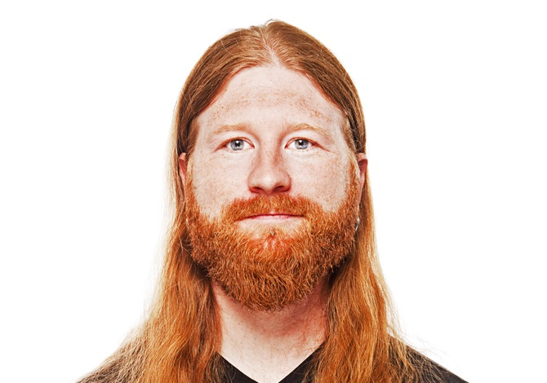

Exercise 9
Play the game
http://learnenglishkids.britishcouncil.org/en/archived-word-games/make-the-sentences/people-and-appearance

