Lesson 24-Vocabulary-Appearance
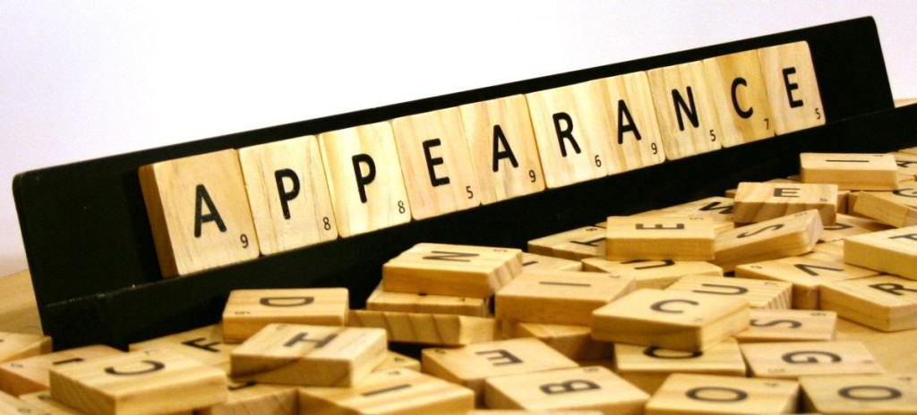
Exercise 1
Exercise 2
True or False?
- Average height means not tall and short short
- Attractive and good-looking mean the same
- You can say a man is good-looking or beautiful
- If someone is fat, they are overweight
- The answer to «How much does he weight?» is «200 cms»
- «How tall are you?» is correct
- It is polite to call someone fat and ugly
- Thin and slim mean the same, but thin is more positive

Exercise 3
Complete the dialogue
- She’s not tall or short, really.- No, she’s average …
- Are the 2 brothers attractive?- Yes, they’re both …
- Is she quite thin?-Yes, she’s very
- He’s about average weight.-Yes, he’s a bit
- Is she very attractive?-Yes, she’s

Exercise 4
Exercise 5
Choose the adjective you don’t need
- I’ve got medium-length, short, curly hair
- Her hair is short, blonde, light brown, wavy
- My sister’s hair is short, long, curly
- My brother’s got short, grey, black hair and moustache
- My father’s got a beard and long, wavy, straight hair

Exercise 6

Replace the underlined word in each sentence with a word which is more suitable
- He told me he met a handsome girl in the disco last night
- She’s beautiful but her younger sister is really quite ugly
- I think Peter is getting a bit fat, don’t you?
- Most people want to stay slim, but not as skinny as that girl over there
- I think she’s hoping she’ll meet a few beautiful men at the tennis club

Exercise 7
Presentation basic

Exercise 8
Describe the appearance

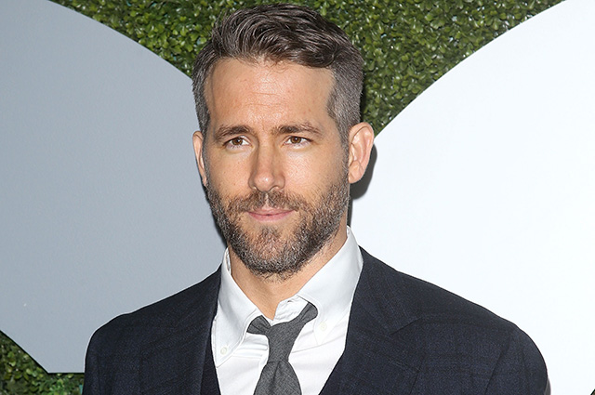
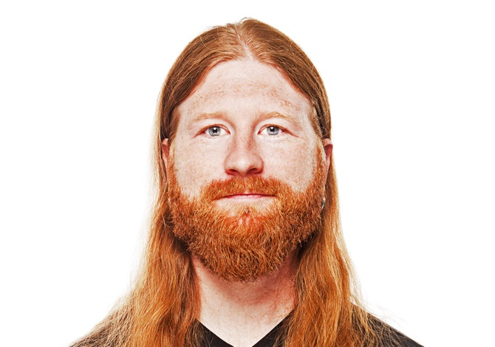

Exercise 9
Play the game
http://learnenglishkids.britishcouncil.org/en/archived-word-games/make-the-sentences/people-and-appearance

