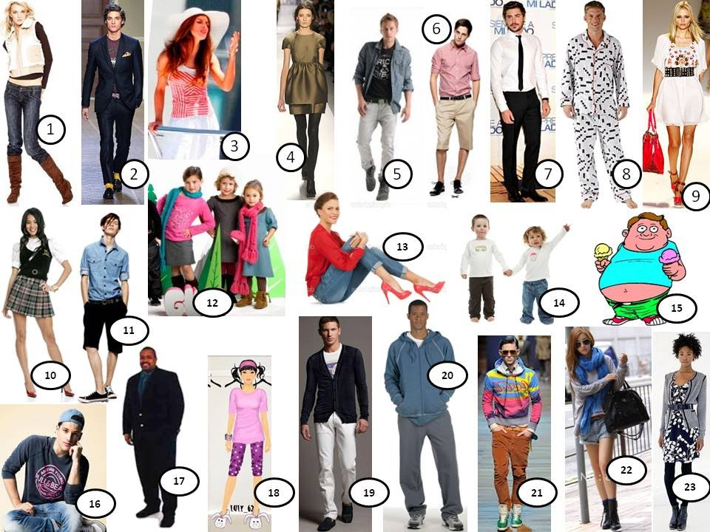

Task 1
Put the words in the box into the correct column. Some words can go in more than one column.
blue, tall, fair, thin, long, slim, green, short, brown, dark, fat
1.Eyes
2.Skin
3.Hair
4.Height and weight

Task 2
Answers these questions using the opposites.
1.Has your sister got long, fair hair?
2.Is your aunt short and overweight?
3.Is your dog young?
4.Is your uncle ugly?
5.Has your mother got blonde hair?
6.Is your brother thin?
7.Is your little sister beautiful?
8.Is your cousin tall?

Task 3

Complete five sentences describing this man.
1.He’s got a … .
2.He’s also got a … .
3.His skin is … .
4.He’s got … hair.
5.He is … .

Task 4
Make questions to match the answers on the right, using the words in brackets.
1.(you/tall/?) … 1 metre 56.
2.(the baby/heavy/?) … Nearly 5 kilos.
3.(the child/weigh/?) … Twenty kiols.
4.(your new teacher/look like/?) … She’s tall and slim.
5.(her hair/colour/?) … Blonde.

Task 5
Complete the sentences with the following words
beautiful, handsome, old, young, tall, short, fat, slim, thin, blond hair, ginger hair, dark hair
1. … is the opposite of short.
2. If you eat lots of junk food, you will get … .
3. … people are below average height.
4. … is the opposite of old.
5. You are … when you are 50 or 60 years old.
6. … is the opposite of fat.
7. A good-looking woman is … .
8. … is similar to thin.
9. You have … if your hair is a yellow colour.
10. A good-looking man is … .

Task 6
Look through two texts and fill the gaps with necessary information orally
A)
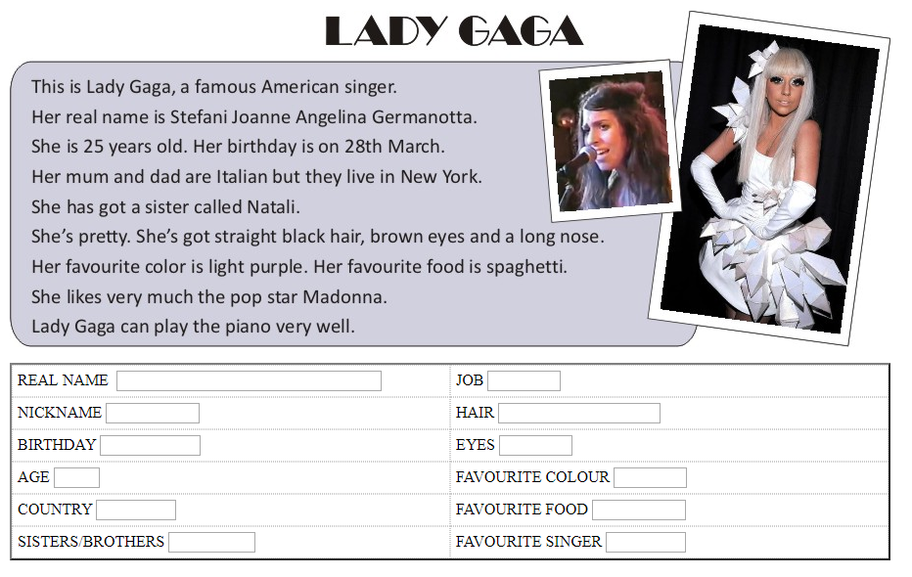

B)
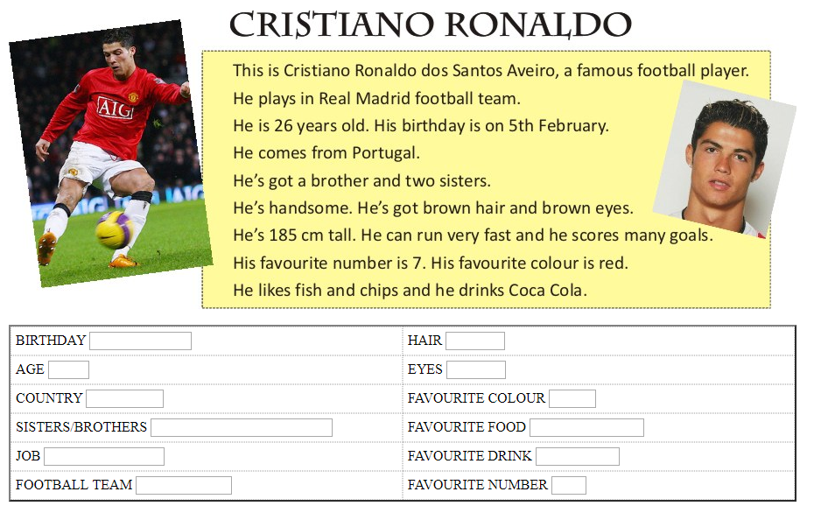

ANSWERS
Task 1

Task 2
Task 3
Task 4
Task 5
1. Tall 2. fat 3. Short 4. Young 5. old 6. Thin OR Slim 7. beautiful 8. Slim 9. blond hair 10. handsome

Task 6
- REAL NAME-Stefani Joanne Angelina Germanotta
JOB-singer
NICKNAME-Lady Gaga
HAIR-straight black hair
BIRTHDAY-28th March
EYES-brown
AGE-25
FAVOURITE COLOUR-purple
COUNTRY-America
FAVOURITE FOOD-spaghetti
SISTERS/BROTHERS-a sister
FAVOURITE SINGER-Madonna

- BIRTHDAY-5th February
HAIR-brown
AGE-26
EYES-brown
COUNTRY-Portugal
FAVOURITE COLOUR-red
SISTERS/BROTHERS-a brother and two sisters
FAVOURITE FOOD-fish and chips
JOB-football player
FAVOURITE DRINK-Coca Cola
FOOTBALL TEAM-Real Madrid
FAVOURITE NUMBER-7

