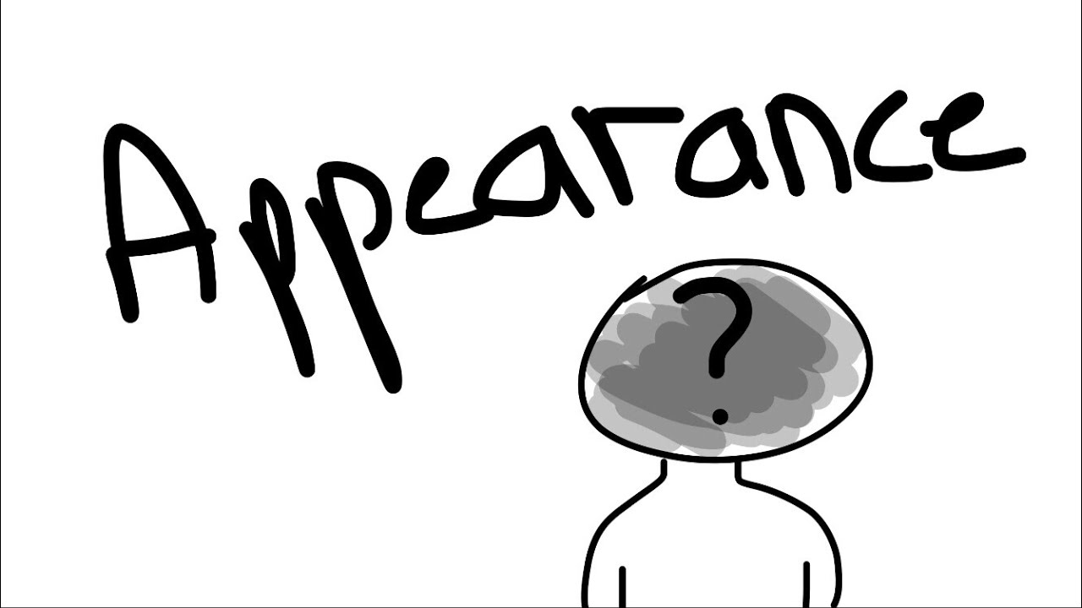

Ex 1. Listen to the conversation

http://learnenglishteens.britishcouncil.org/skills/listening/beginner-a1-listening/describing-people (аудио и 2 упражнения, которые там)

Ex 2. Choose the correct option to complete the sentences.

Ex 3. Write the word to fill the gaps.

Ex 5. Listen to the conversation
https://www.examenglish.com/A2/audio/aunit1listening3.mp3

Ex 6. Choose if the sentance true or false

1 Maria has brown, curly hair. T
2 Maria and Catherine have the same colour eyes. F
3 Maria’s face is longer than Catherine’s. F
4 Catherine’s nose and mouth look like Maria’s. T
5 Catherine is taller than Maria. F
6 Maria isn’t as outgoing as Catherine. T
7 Catherine is older than Maria. T
8 Both Catherine and Maria are independent. T

Ex. 7 Listen to the audio and click on the picture that is talked about
http://www.elllo.org/yeartwo/march20th/main_hair.htm

