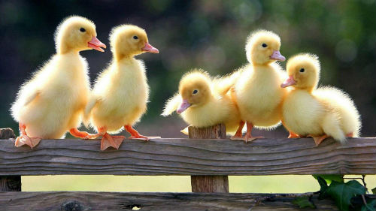

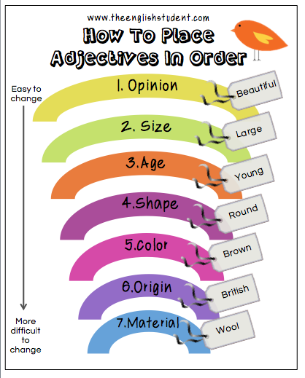

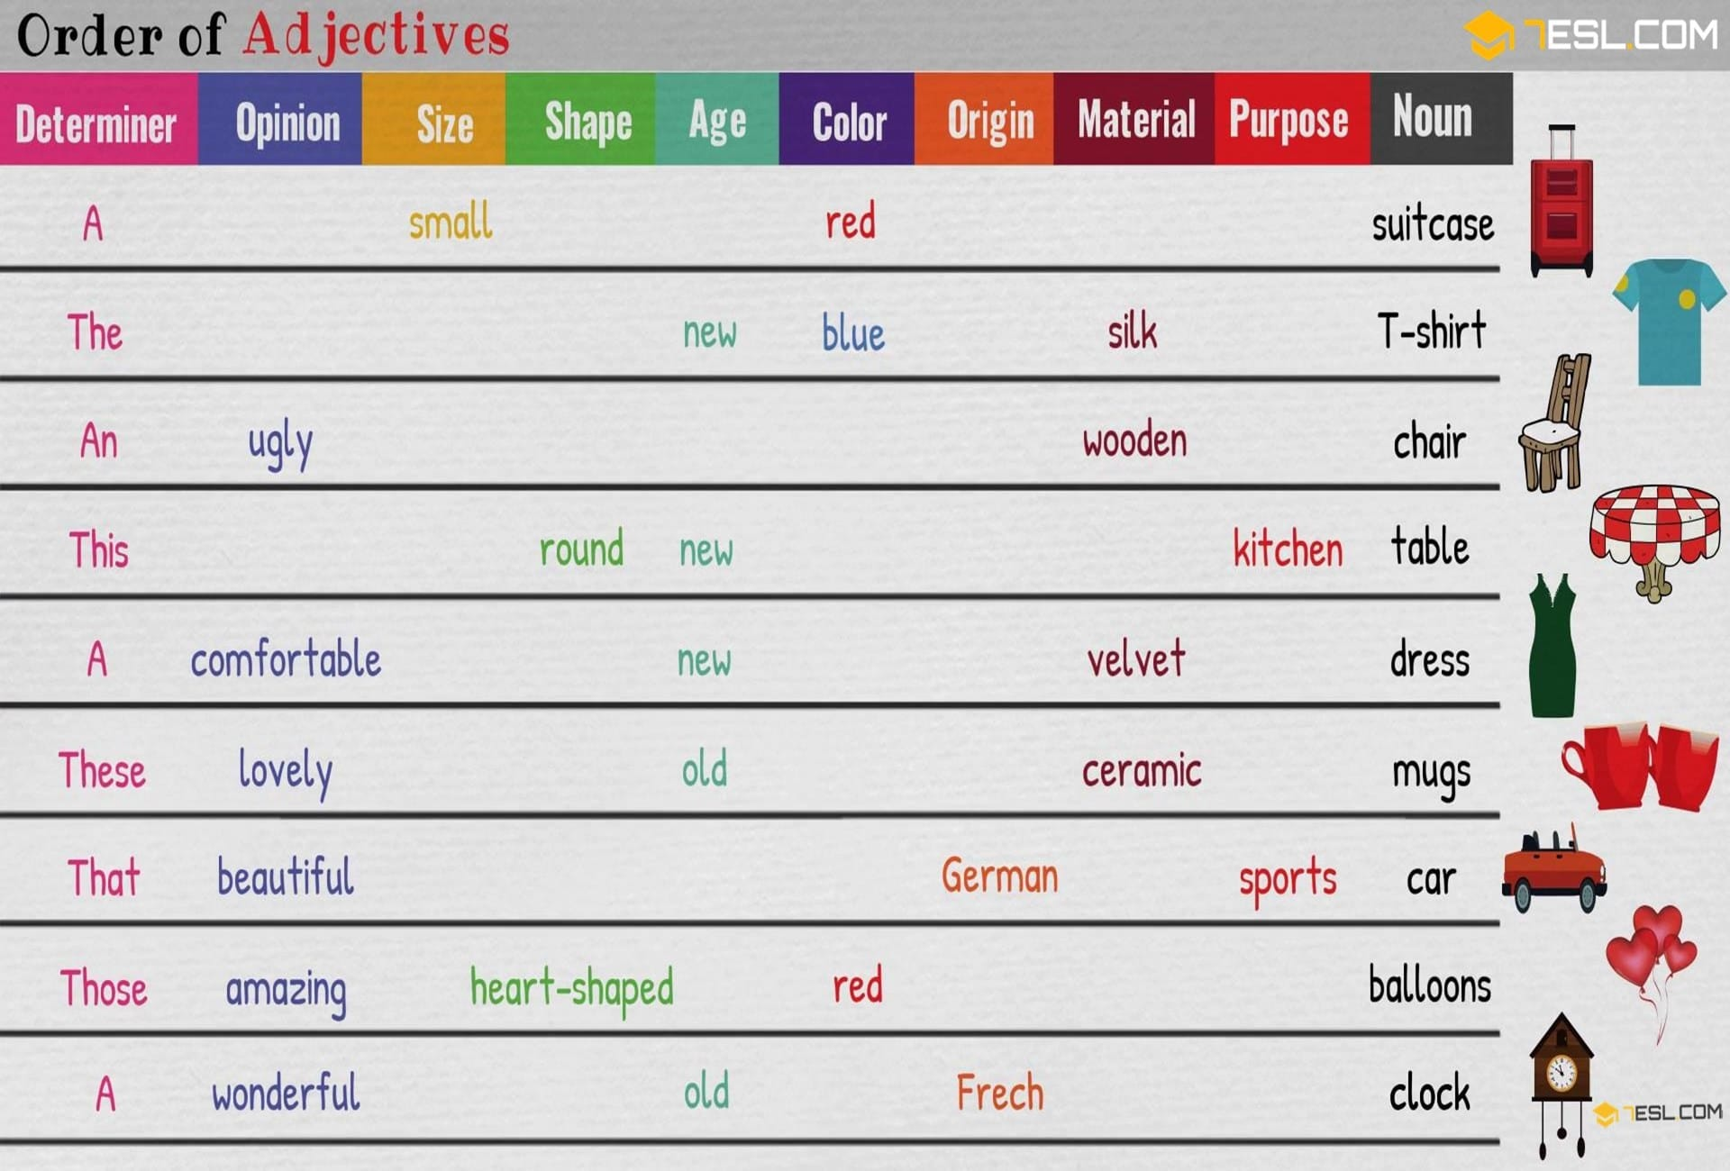

Ex 1. Put the adjectives in the correct order

- I wanted to buy a_______________________ table. (round/blue/Italian/dining/big)
- Does Miriam need that _________________ chair? (wooden-small-square)
- What is this _____________________ thing? (red/triangular/leather)
- Did you notice the brand of that ______________
_________________________ car? (green/ streamlined/splendid/sport)
- William can take care of your _______________ _________ cat. (Persian/naughty/white)
- This ________________________ scarf belongs to my brother. (woolen/long/multicolored)
- Are you sure this ___________________ sabre is Turkish? (curved/nice/steel)
- Press this ____________________ button never! (plastic/red/round)
- Mike will order a_________________ breakfast. (English/light/nice)
- This ____________________________ wardrobe is my friends’ gift. (elegantly-shaped /amazing/brown/wooden)

Ex 2. Correct or wrong?

 | Correct | Wrong
- Do you want this red sport bike?
- He wore long Italian old coat.
- Will you buy me a small pink hat?
- Matt saw a strange large blue ball.
- Don’t touch that green square box!
- Who took my Swiss army knife?
- My mum hates my blue velvet belt.
- This is a half-year-old English dog
- This woolen grey scarf suits you.
- I chose a nice green modern tint.

Ex 3. Make up sentences

- presented/my/me/white/ball/friend/round/fine/leather/a
_______________________________________________
- old/university/your/can/call/you/Italian/friend ?
_______________________________________________
- I’m/need/that/wooden/black/sure/I/this/stylish/chair
_______________________________________________
- Martha’s/violet/outfit/Dylan/didn’t/dance/see/bright

Ex.4 Put into the correct order
Dear Ann,
It's a shame you couldn't make it to the wedding, but thank you for the 1________________ (dessert / crystal / lovely) bowls which you sent us. The wedding was unforgettable and everyone looked beautiful, especially the bridesmaids in their 2 _________________________ (silk / long / cream) dresses. At the reception we had a 3 _______________________________( three-course / home-made / delicious ) meal and the best man gave a(n) 4 ________________( amusing / nice / short ) speech. In the evening more guests arrived and the hotel provided 5___________________________ (Irish / live / excellent) music. Before we left, we cut the 6________________________ (wedding / white /iced) cake.
Hope to see you soon!
Love,
Jane and Peter.

Ex 5 Which is the correct order?
A
a) a small thin Japanese lady
b) a small Japanese thin lady
c) a Japanese small thin lady
d) a thin small Japanese lady
_____

B
a) a steel new carving knife
b) a new carving steel knife
c) a new steel carving knife
d) a carving steel new knife
______
C
a) a new French exciting band
b) an exciting French new band
c) a French new exciting band
d) an exciting new French band
_______

D
a) a blue long attractive coat
b) an attractive blue long coat
c) an attractive long blue coat
d) a long attractive blue coat
______

Answer key
Ex 1. Put the adjectives in the correct order

- I wanted to buy a big, round, blue, Italian dining table. (round/blue/Italian/dining/big)
- Does Miriam need that small, square, wooden chair? (wooden/small/square)
- What is this triangular, red leather thing? (red/ triangular/leather)
- Did you notice the brand of that splendid, streamlined, green sport car? (green/ streamlined/splendid/sport)
- William can take care of your naughty white Persian cat. (Persian/naughty/white)
- This long, multicolored woolen scarf belongs to my brother. (woolen/long/multicolored)
- Are you sure this nice curved steel sabre is Turkish? (curved/nice/steel)
- Press this round red plastic button never! (plastic/red/round)
- Mike will order a nice, light English breakfast. (English/light/nice)
This amazing elegantly-shaped brown wooden wardrobe is my friends’ gift. (elegantly-shaped/ amazing/brown/wooden)

Ex 2. Correct or wrong?

 | Correct | Wrong
- Do you want this red sport bike? | +
- He wore long Italian old coat. |  | +
- Will you buy me a small pink hat? | +
- Matt saw a strange large blue ball. | +
- Don’t touch that green square box! |  | +
- Who took my Swiss army knife? | +
- My mum hates my blue velvet belt. | +
- This is a half-year-old English dog | +
- This woolen grey scarf suits you. |  | +
- I chose a nice green modern tint. |  | +

Ex 3. Make up sentences

- presented/my/me/white/ball/friend/round/fine/leather/a
My friend presented me a fine round white leather ball.
- old/university/your/can/call/you/Italian/friend ?
Can you call your old Italian university friend?
- I’m/need/that/wooden/black/sure/I/this/stylish/chair
I’m sure that I need this stylish black wooden chair.
- Martha’s/violet/outfit/Dylan/didn’t/dance/see/bright
Dylan didn’t see Martha’s bright violet dance outfit.

Ex 4
1 lovely dessert crystal
2 long cream silk
3 delicious three course homemade
4 excellent live Irish
6 white iced wedding

Ex 5 Which is the correct order?
A
a) a small thin Japanese lady
b) a small Japanese thin lady
c) a Japanese small thin lady
d) a thin small Japanese lady

B
a) a steel new carving knife
b) a new carving steel knife
c) a new steel carving knife
d) a carving steel new knife

C
a) a new French exciting band
b) an exciting French new band
c) a French new exciting band
d) an exciting new French band

D
a) a blue long attractive coat
b) an attractive blue long coat
c) an attractive long blue coat
d) a long attractive blue coat

