Ex. 1 Look at the words and translate them into Russian
https://quizlet.com/319213435/basic-lesson-20-appearance-speaking-flash-cards/?new

Ex. 2 Describe the picture and answer ther questions
- What do you think about the style of the girl in the picture? Don’t just say ”Cool” or ”Ridiculous.” Explain why you love it or why you find it appalling.
- What do you think about people who dress like her?

Ex. 3 Look at the picture below and complete the description

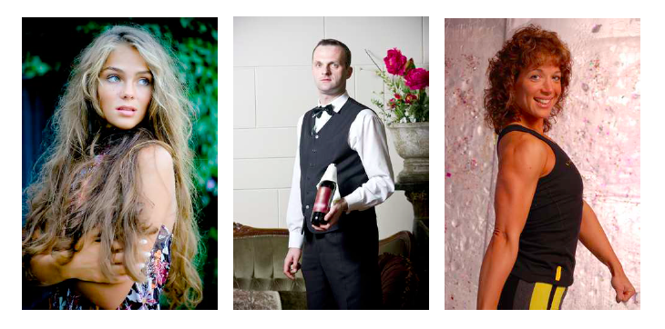

1. The girl in the picture on the left has got very straight/wavy, blond/black hair. She looks slim/overweight and her skin is quite pale/tanned.
2. The man in the middle looks slim/overweight. He has long/short, black/blond hair and his skin is quite pale/dark.
3. The woman on the right looks quite muscular/overweight. She has straight/curly blond/brown hair and her skin is rather pale/tanned.

Ex. 4 Answer the questions
Fashion to you is:
a) About looking cool and hip
b) About looking mature
c) About conforming to others/the general trend
d) A way to express my inner self
e) No, thx. Fashion is for superficial (=shallow, not deep) people.

- Have you ever bought clothes out of impulse and later regretted?
- Before buying a garment, do you need anyone to judge if it will suit you or not?
- In your view, who gets to decide on the next fashion craze?
- What is the style you like the most?
- What is the style you dislike the most?
- Do you pay attention to buy accessories, shoes and make up matching your clothes?
- How should you dress for a) theater, b) a Formula 1 party thrown by Red Bull with all their stars, c) a school hike in nature?
- What do you think about men who walk without a shirt in Budapest in the summer?
- In London this summer I saw a hip-looking woman walking barefoot. She wasn’t homeless. Why do you think she wasn’t wearing shoes? What do you think about it?

Debate Questions
- Does it make sense to you to wear the uniform at school ceremonies? Why or why not? [Why or why not? Give reasons, try to convince each other.]
- You know Lady Gaga’s song: ”Fashion?” Do you agree with the statement in the song: ”You are who you wear?” [Why or why not?]
- Do you know some teachers in the school who like to dress formally? Why do they prefer formal to casual?

