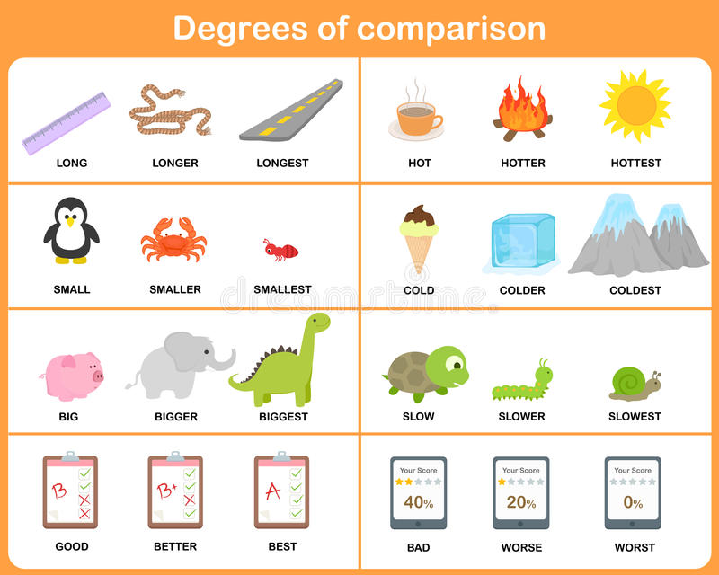
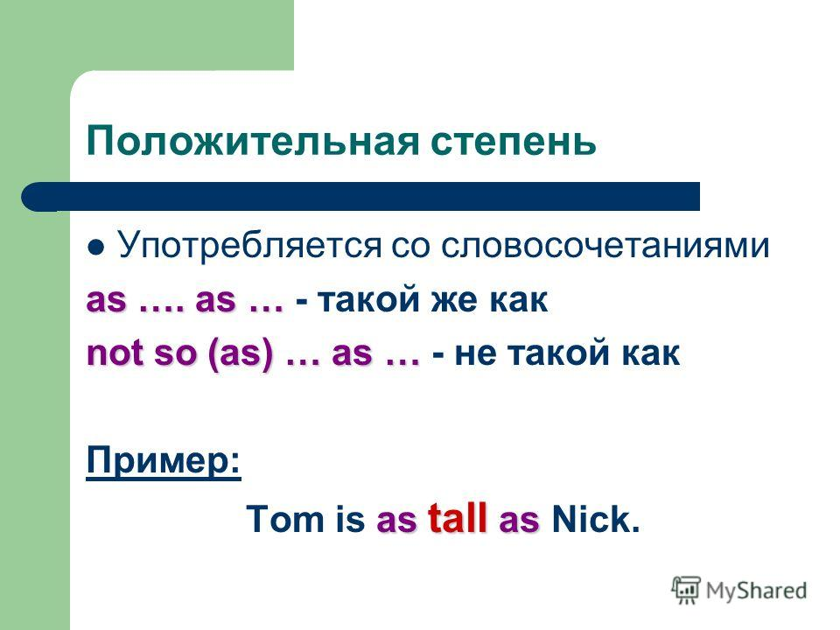
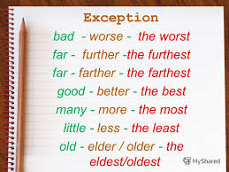
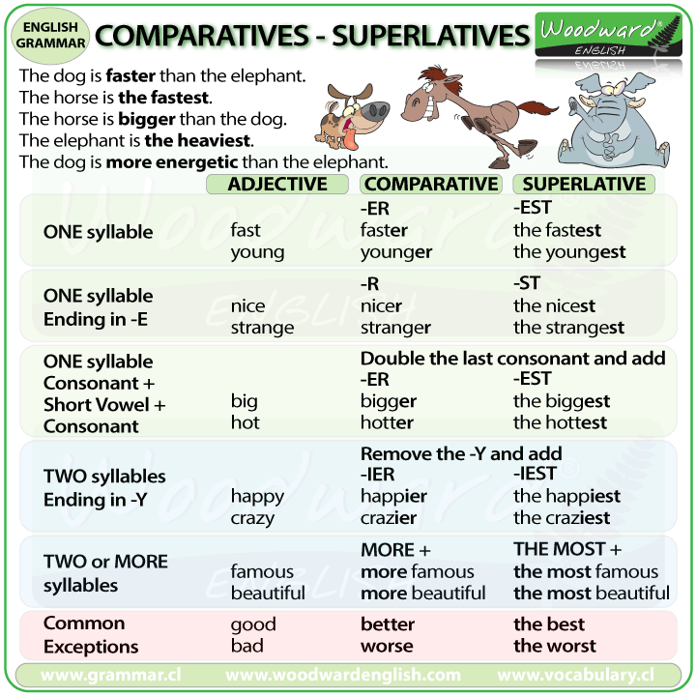

Ex.1 Practice degrees of comparison
big - _ _ _ _ _ _ _ _
thin - _ _ _ _ _ _ _ _
fat - _ _ _ _ _ _ _ _
happy - _ _ _ _ _ _ _ _
dark - _ _ _ _ _ _ _ _
famous - _ _ _ _ _ _ _
ridiculous - _ _ _ _ _ _
fantastic - _ _ _ _ _ _
narrow - _ _ _ _ _ _ _
lazy - _ _ _ _ _ _ _ _
good - _ _ _ _ _ _ _ _ _
bad - _ _ _ _ _ _ _ _ _
little - _ _ _ _ _ _ _ _ _
many/much -_ _ _ _ _ _ _
far - _ _ _ _ _ _

Ex.2 Fill in the gaps with the correct comparative or superlative form of the adjective

- My house is……………(big) than yours.
- John isn’t so…………………(tall) as Kevin.
- Mary is ……………..(good) student in the class.
- I invited all my classmates to my party. As the saying goes: the………….(many), the……………….(merry).
- Linda doesn’t feel ……………..(good) today.
- Our school is …………….(far) away than his.
- I’m calling to ask for some……………………(far) information on this package holiday.
- Sandra did ………………(bad) of all in the test.
- Their car is……………….(cool) in the neighbourhood.
- Do you really think that Tina is…………..(clever) than Sandra?
- He came to the party……………..(late) of all.
- John’s………………….(old) brother is a pilot.
- Monica has…………….(little) toys than Erin.
- Luke doesn’t have as……………..(much) free time as Bruce.
- Poor thing! That’s…………….(sad) thing I’ve ever heard!
- Luke’s shoes are………………(dirty) today than they were yesterday.
- I can for sure that it’s …………………….(interesting) movie I’ve ever seen.
- Tina is considered to be …………………(shy) person in class.
- John’s grades are getting…………………(good) and…………………..(good).
- Sally is much…………………..(pretty) than Kate.
- Dan feels much…………………(good) today.
- The…………..(old) she gets, the…………………….(beautiful) she becomes.
- This exercise is very……………………..(difficult).
- We have to hurry up as it’s getting………………(dark) and ………………..(dark).
- Everybody knows that Kevin is………………(strong) than Alan.

Ex.3. Fill in the gaps with the correct comparative or superlative form of the adjective

1) Kelly has got ____________(many) mince pies than Dorothy.
2) This bakery shop sells the____________(good) bread in our town.
3) Water in this lake is____________(clean) than in the pond.
4) Cheetahs can run_____________(fast) than pumas.
5) Mr. Barrow grows___________(beautiful) flowers than his neighbour.
6) Hanna's child is ____________(patient) child I've ever seen.
7) Mrs. Livid is_____________(strict) teacher in our school.
8) Who is______________(intelligent) student in your group?
9) Let's meet at 5! It's the_________________(convenient) time for me.
10) There's _____________(little) water in this jar than in that bottle.

Ex.4 Fill in the gaps with the correct form of the adjective.

1) Skyscrapers in New York are not so_______________(tall) as in Chicago.
2) Strawberry ice cream is as___________________(tasty) as cherry one.
3) White bread is not as___________________(wholesome) as cereal bread.
4) A cup is not so________________(big) as a mug.
5) This movie is as __________________( gripping)as any adventurous film.
Ex.5 Choose the correct answer
1. My brother is … and … than me.
a) Older, stronger
b) More older, more strong
c) More old, more strong
d) Older, more stronger
2. The train is … than the horse.
a) Fast
b) Faster
c) More fast
d) More faster
3. My mother is … than my father.
a) Serious
b) Seriouser
c) More serious
d) More seriouser
4. Please, come … not to be late.
a) Early
b) More early
c) Earlyer
d) Earlier
5. This book is … and … than that one on the left.
a) Cheaper, more beautiful
b) More cheap, more beautiful
c) More cheap, beautiful
d) Cheaper, beautifuler
6. Today you look ... and … than yesterday.
a) Better, more fresh
b) Better, fresher
c) Gooder, fresher
d) More good, more fresh
7. He reads … than this girl.
a) Bader
b) More bad
c) Worse
d) More worse
8. What is … day in the year in this part of the country?
a) The hotest
b) The hottest
c) The most hot
d) Hottest
9. What’s … film you saw last year?
a) Best
b) Goodest
c) The goodest
d) The best
10. What’s … subject for you in school?
a) The most easy
b) Easiest
c) The easyest
d) The easiest
11. This is ... way to the station.
a) short
b) shorter
c) the shortest
12. The cat is ... than the kitten
a) fat
b) fatter
c) the fattest
13. You are ... boy!
a) a happy
b) happier
c) happiest
14. Next time I'll do it ...
a) good
b) better
c) the best
15. You are ... student in the class.
a) bad
b) worse
c) the worst
16. It is ... book of all I have ever had.
a) interesting
b) more interesting
c) the most interesting
17. I'll find out the truth ...
a) soon or late
b) sooner or later
c) soonest or latest
18. He runs ... than I do.
a) fast
b) faster
c) fastest
19. Last time you did your work ... You had never done it like that.
a) correctly
b) more correctly
c) most correctly
20. You look tired. You should work ...
a) little
b) less
c) the least

Answer key

Ex.5 Choose the correct answer
1. My brother is … and … than me.
a) Older, stronger
b) More older, more strong
c) More old, more strong
d) Older, more stronger
2. The train is … than the horse.
a) Fast
b) Faster
c) More fast
d) More faster
3. My mother is … than my father.
a) Serious
b) Seriouser
c) More serious
d) More seriouser
4. Please, come … not to be late.
a) Early
b) More early
c) Earlyer
d) Earlier
5. This book is … and … than that one on the left.
a) Cheaper, more beautiful
b) More cheap, more beautiful
c) More cheap, beautiful
d) Cheaper, beautifuler
6. Today you look ... and … than yesterday.
a) Better, more fresh
b) Better, fresher
c) Gooder, fresher
d) More good, more fresh
7. He reads … than this girl.
a) Bader
b) More bad
c) Worse
d) More worse
8. What is … day in the year in this part of the country?
a) The hotest
b) The hottest
c) The most hot
d) Hottest
9. What’s … film you saw last year?
a) Best
b) Goodest
c) The goodest
d) The best
10. What’s … subject for you in school?
a) The most easy
b) Easiest
c) The easyest
d) The easiest
11. This is ... way to the station.
a) short
b) shorter
c) the shortest
12. The cat is ... than the kitten
a) fat
b) fatter
c) the fattest
13. You are ... boy!
a) a happy
b) happier
c) happiest
14. Next time I'll do it ...
a) good
b) better
c) the best
15. You are ... student in the class.
a) bad
b) worse
c) the worst
16. It is ... book of all I have ever had.
a) interesting
b) more interesting
c) the most interesting
17. I'll find out the truth ...
a) soon or late
b) sooner or later
c) soonest or latest
18. He runs ... than I do.
a) fast
b) faster
c) fastest
19. Last time you did your work ... You had never done it like that.
a) correctly
b) more correctly
c) most correctly
20. You look tired. You should work ...
a) little
b) less
c) the least

