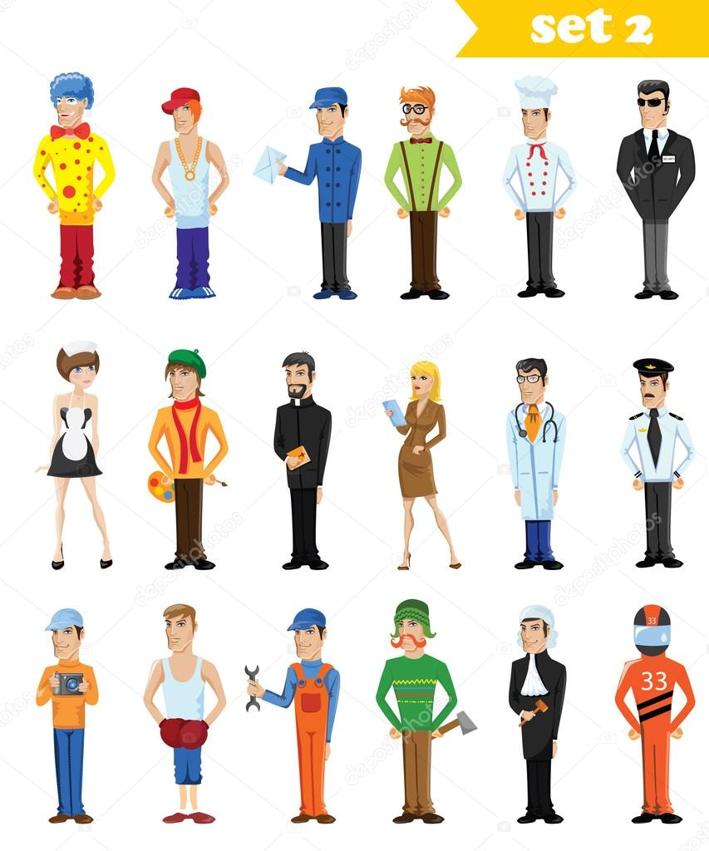
Look through the words in Quizlet
https://quizlet.com/38943571/english-character-adjectives-basic-flash-cards/

Task 1
Match adjectives with the correct definition.
beautiful, generous, handsome, happy, hard-working, intelligent, lazy, mean, miserable, polite, rude, stupid
1.He looks like a film-star. Every girl in the office wants to go out with him. He is very … .
2.She finds it very easy to learn things and has passed all her exams. She is extremely … .
3.She is always buying things for people. She is very … .
4.He hates working and would prefer to stay at home all day in front of the television. He is so… .
5.He doesn’t know anything. He can’t even add up two and four. He is so … .
6.The children next-door are so … . They never say ”Please” or “Thank you” and always shout back at their parents.
7.He is always smiling and thinks life is wonderful. He seems to be really … .
8.He starts work at 6.00 every day and often works overtime or at weekends. He is really … .
9.She works as a model. When she walks into a room every man turns and stares at her. She is really … .
10.He hates spending money and never buys anyone a drink at the pub. He is so … .
11.She always says “Please” and “Thank you”. She is a very … child.
12.She never has a smile on her face and always looks unhappy. She is so … .

Task 2
Match adjectives with the correct definition.
ambitious, boring, imaginative, impatient, jealous, patient, selfish, shy, sociable, tidy
1.Everything is always in the right place in his room and on his desk. He is really … .
2.She finds it very easy to make up stories to tell her children, and can always think of new ideas. She is so … .
3.He only ever thinks of himself. He is really … .
4.She wants to get a top job one day and even talks about becoming Prime Minister. She is extremely … .
5.He hates waiting for people or trains and can’t stand it when things don’t happen immediately. He is very … .
6.He loves going to parties and meeting people. He is very … .
7.The only thing she ever talks about is golf. I almost fell asleep listening to her. She is so … .
8.He never shouts at us and will explain things over and over again until we understand them. He is very … .
9.She doesn’t like meeting strange people and usually feels nervous and uncomfortable at parties. She is extremely … .
10.She gets very angry if her husband looks at or dances with another woman. She is extremely … .

Task 3
Answer the questions using the following words
kind,relaxed,serious,funny,friendly,stupid,horrible,intelligent,unfriendly,pleasant
What’s …
1.a synonym for nice?
2.the opposite of friendly?
3.a synonym for clever?
4.the opposite of nice?
5.the opposite of clever?

What do you call someone who …
6.likes meeting and talking to people?
7.makes you laugh?
8.thinks a lot and doesn’t laugh a lot?
9.is usually calm?
10.always wants to help others?

Task 4
Complete the conversation using words
clever/intelligent, kind, What, horrible/unfriendly, fun, are, serious, like
1.What’s Alex …? – He’s nice, but he’s very … . He doesn’t laugh much.
2.What … Ana’s parents like? – Well, her mother’s great …; like her very much. But her father doesn’t like people very much – he’s really … .
3. … was your grandmother like? – She was very … - she always helped everyone. And she was … too. She went to university.

ANSWERS
Task 1
beautiful, generous, handsome, happy, hard-working, intelligent, lazy, mean, miserable, polite, rude, stupid
1.He looks like a film-star. Every girl in the office wants to go out with him. He is very handsome.
2.She finds it very easy to learn things and has passed all her exams. She is extremely intelligent.
3.She is always buying things for people. She is very generous.
4.He hates working and would prefer to stay at home all day in front of the television. He is so lazy.
5.He doesn’t know anything. He can’t even add up two and four. He is so stupid.
6.The children next-door are so rude. They never say ”Please” or “Thank you” and always shout back at their parents.
7.He is always smiling and thinks life is wonderful. He seems to be really happy.
8.He starts work at 6.00 every day and often works overtime or at weekends. He is really hard-working.
9.She works as a model. When she walks into a room every man turns and stares at her. She is really beautiful.
10.He hates spending money and never buys anyone a drink at the pub. He is so mean.
11.She always says “Please” and “Thank you”. She is a very polite child.
12.She never has a smile on her face and always looks unhappy. She is so miserable.

Task 2
ambitious, boring, imaginative, impatient, jealous, patient, selfish, shy, sociable, tidy
1.Everything is always in the right place in his room and on his desk. He is really tidy.
2.She finds it very easy to make up stories to tell her children, and can always think of new ideas. She is so imaginative.
3.He only ever thinks of himself. He is really selfish.
4.She wants to get a top job one day and even talks about becoming Prime Minister. She is extremely ambitious.
5.He hates waiting for people or trains and can’t stand it when things don’t happen immediately. He is very impatient.
6.He loves going to parties and meeting people. He is very sociable.
7.The only thing she ever talks about is golf. I almost fell asleep listening to her. She is so boring.
8.He never shouts at us and will explain things over and over again until we understand them. He is very patient.
9.She doesn’t like meeting strange people and usually feels nervous and uncomfortable at parties. She is extremely shy.
10.She gets very angry if her husband looks at or dances with another woman. She is extremely jealous.

Task 3
kind,relaxed,serious,funny,friendly,stupid,horrible,intelligent,unfriendly,pleasant
What’s …
1.a synonym for nice? pleasant
2.the opposite of friendly? unfriendly
3.a synonym for clever? intelligent
4.the opposite of nice? horrible
5.the opposite of clever? stupid
What do you call someone who …
6.likes meeting and talking to people? friendly
7.makes you laugh? funny
8.thinks a lot and doesn’t laugh a lot? serious
9.is usually calm? relaxed
10.always wants to help others? kind

Task 4
clever/intelligent, kind, What, horrible/unfriendly, fun, are, serious, like
1.What’s Alex like? – He’s nice, but he’s very serious. He doesn’t laugh much.
2.What are Ana’s parents like? – Well, her mother’s great fun; like her very much. But her father doesn’t like people very much – he’s really horrible/unfriendly.
3. What was your grandmother like? – She was very kind - she always helped everyone. And she was clever/intelligent too. She went to university.

