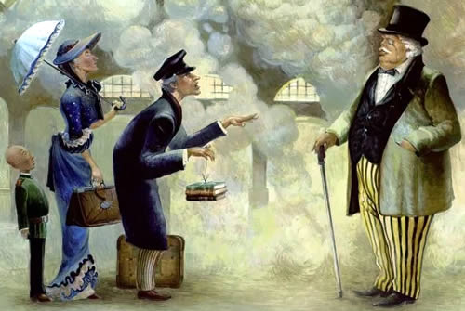

Ex.1 Write the comparative and superlative.
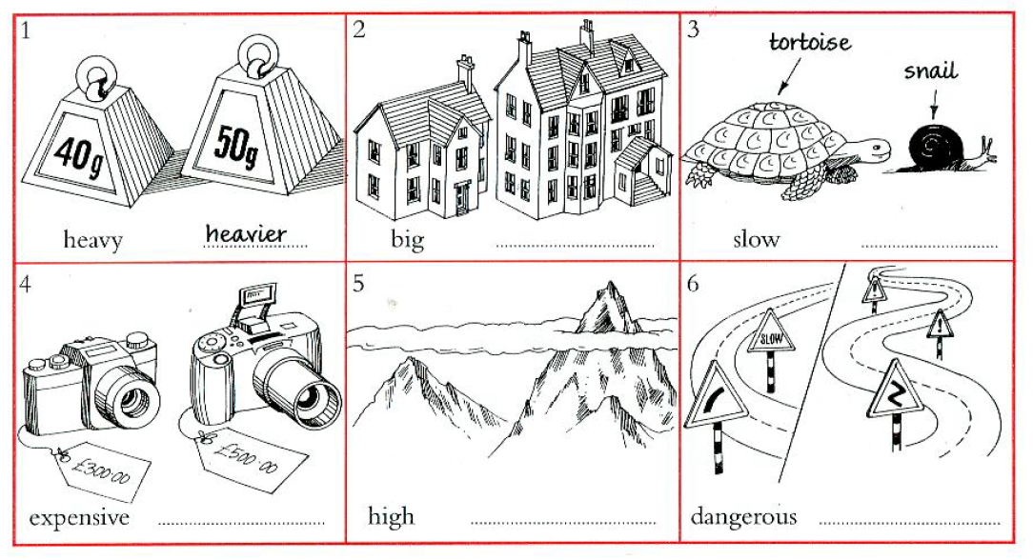

Ex.2 Complete the sentences. Use a comparative.

1 Helen's car isn't very big. She wants a ___________one.
2 My job isn't very interesting. I want to do something ____________.
3 You're not very tall. Your brother is ____________.
4 David doesn't work very hard. I work ____________.
5 My chair isn't very comfortable. Yours is ____________.
6 Your plan isn't very good. My plan is ____________.
7 These flowers aren't very nice. The blue ones are ____________.
8 My bag isn't very heavy. Your bag is ____________.
9 I'm not very interested in art. I'm ____________ in history.
10 It isn't very warm today. It was ____________ yesterday.
11 This building is very old. It's ____________ in the town.
12 It was a very happy day. It was ____________of my life.
13 It's a very good film. It's ____________ I've ever seen.
14 She's a very popular singer. She's ____________in the country.
15 It was a very bad mistake. It was ____________I've ever made.
16 It's a very pretty village. It's ____________ I've ever seen.
17 It was a very cold day. It was ____________ of the year.
18 He's a very boring person. He's ____________I've ever met.

Ex.3 Write sentences with as ... as ....
1 My mom is bigger than yours. Your room isn't ____________.
2 You got up earlier than me. I didn't ____________.
3 We played better than them. They ____________.
4 I've been here longer than you. You ____________.
5 She's more nervous than him. He ____________.

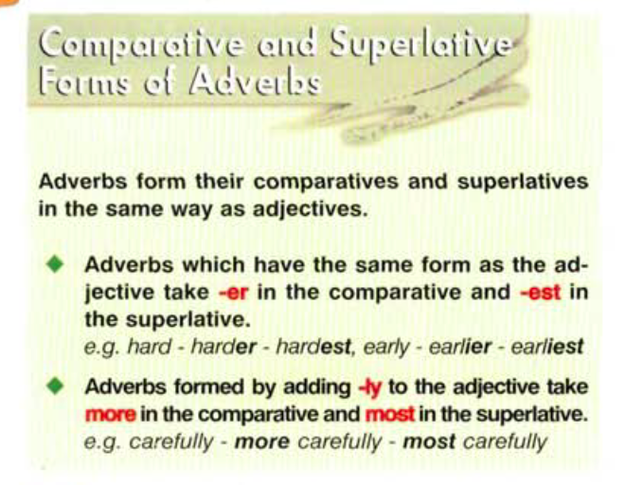

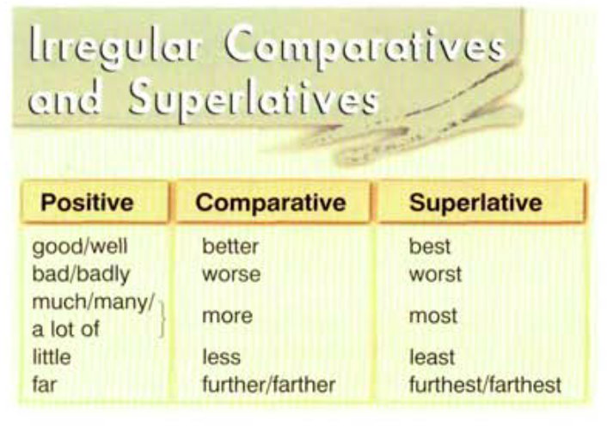

Ex. 4 Underline the correct word.

1 A: I'm going to the shops now.
B: Make sure you carry the eggs careful/carefully. Don't break them.
2 A: I'm going to Alison's house for dinner tonight.
B: You'll enjoy it Alison is a very good/well cook.
3 A: Have you finished that puzzle already?
B: Yes, it was really easy/easily.
4 A: Mr Jones shouted angry/angrily today.
B: I know. He was in a very bad/badly mood all day.
5 A: Your mother is always cheerful/cheerfully. Isn't she?
B: Yes, she is always in a well good mood.

Ex.5 Fill in the gaps with the comparative or superlative form of the adjectives/ adverbs in brackets.
- Excuse me, is there a 1) ________ (fast) way to get to Clovelly?
- It you take that road, which is 2) ________ (narrow) than the others, it's only 15 minutes' walk. That's the 3) ________ (quick) way.
- Ah, thanks. We've been walking for 35 minutes and we thought we would get there 4)
________ (soon). We can't even see Clovelly yet.
- It's hidden by the trees, they're 5) ________ (tall) than the houses. You'll like Clovelly. It's one of the 6) ________ (beautiful) villages in north Devon.
- That's what we've heard. It has some of the 7) ________ (pretty) houses, hasn't it?
- Yes, and the 8) ________ (tasty) fish you've ever eaten!
A: Thank you very much for your help. Bye.

Ex.6 Use the prompts below to make sentences, as in the example.

1 an ostrich / an owl (big) ________
2 gold / silver (expensive) ________
3 Canada / Brazil (cold) ________
4 feathers / stones (light) ________
5 a car / a bicycle (fast) ________

Ex.7 Fill in the gaps with the comparative or superlative form of the adverbs in brackets, adding any necessary words.
1 Al swims ________you do. (fast)
2 My sister drives ________ us all. (carelessly)
3 I left the party ________you did. (late)
4 Catherine dances all. (beautifully)
5 The leading actress speaks ________ all. (clearly)
6 My uncle gives to the poor my father does. (generously)
7 Jill Thomas works ________ all. (hard)
8 My best friend plays chess ________I do. (well)

Answer key

Ex. 4 Underline the correct word.

1 A: I'm going to the shops now.
B: Make sure you carry the eggs careful/carefully. Don't break them.
2 A: I'm going to Alison's house for dinner tonight.
B: You'll enjoy it Alison is a very good/well cook.
3 A: Have you finished that puzzle already?
B: Yes, it was really easy/easily.
4 A: Mr Jones shouted angry/angrily today.
B: I know. He was in a very bad/badly mood all day.
5 A: Your mother is always cheerful/cheerfully. Isn't she?
B: Yes, she is always in a well good mood.

